World Trade Center Building 7
and the Lies of the 9/11 “Truth Movement”

Did firefighters abandon their fallen brothers to help Larry Silverstein demolish a skyscraper that had sustained minor damage and fires?

9/11 “Truth Movement” leaders gather at Ground Zero and accuse Silverstein of murder and the FDNY of a
heinous crime and cover-up.

Do their claims stand up to examination?

By Mark Roberts email: nyctours@gmail.com October, 2006
Revised January, 2007

Table of Contents

Index.....3
Introduction: Are they “More to be pitied than censured?” .....4
Part I
Larry Silverstein’s “Pull it” quote butchered by leaders of “Truth Movement”.....8
Remedial reading at Ground Zero: Now That’s Denial! .....15
What really happened at WTC 7 on 9/11/01?.....16
Ny911truth.org members disparage the FDNY at Ground Zero.....17
Jason Bermas of Loose Change disparages the FDNY at Ground Zero.....22
Alex Jones vilifies the FDNY at Ground Zero.....26-34
Part II – Please read this section if you read no other
Is “Pull” used by demolitions pros to mean “demolish with explosives?”.....36
Is “Pull” used to mean “Withdraw firefighters from danger?”.....37
Eyewitness accounts of WTC 7 fires.....41-44
Eyewitness accounts of WTC 7 damage .....45-47
Eyewitness accounts of withdrawal and hold back from WTC 7 due to danger.....48-55
Part III
An in-depth look at conspiracist claims about WTC 7.....56
Details of damage to WTC 7.....59-66
Steven E. Jones’ Thermite / Thermate claims.....67
Larry Silverstein: Insurance profit motive? .....70
Can office fires cause large steel columns and beams to buckle?.....76-81
WTC 7 collapsed into a “Tidy pile?”.....82
Comparison of WTC 7 to controlled demolitions.....84
WTC 7 collapse videos.....88
Conspiracists misrepresent WTC 7’s condition.....90-95
What has become of the “Truth Movement” leaders?.....96
FDNY photos.....97
9/11 first responder fatalities.....100
Appendix: WTC 7 eyewitness accounts spreadsheet.....106
Index

9/11 Commission: Reason didn't mention WTC 7, 95
9/11 Truth Movement Protest at Ground Zero 9/11/06: Banners carried, 5; Organized for media attention, 8; Shouts Murderer at Silverstein's office, 7
911truth.org on importance of WTC 7, 8
America Rebuilds, PBS documentary, 8
Avery, Dylan: Misrepresents condition of WTC 7, 93; Reason for organizing protest, 8; Upset at lack of protest coverage, 25
Banfield, Ashleigh, MSNBC reporter video, 89
Barrett, Kevin, says Silverstein is murderer, traitor, 11
Bermas, Jason: Reason for organizing protest, 8; 'The firefighters are paid off!', 23; The many conspiracy theories of, 22
Blanchard, Brent: On thermite theory, 69; Protec paper–‘Pull’not CD term, 36; Spoke with CD experts who saw WTC 7 fall, 87
Blood, Jack 9/11 victim-bashing, 7
Collapse time, 27
Controlled Demolition: Experts saw WTC 7 fall, say no CD, 87; Experts say no evidence of at WTC 7, 84; Is LOUD, 84; Videos of, 84
FDNY: 9/11 fatalities, 100; Aftermath photos, 98; Carrying extra gear into north tower, 98; Ten House photos, 97; What it would mean if they 'obeyed orders' to 'pull', 17
FEMA: WTC 7 Report, 56
Fetzer, James, says Silverstein ‘absolutely’ in on it, 10
Ganci, Peter, FDNY Chief of Department, 9
Greening, Frank, Paler on sulfidation of WTC steel, 68
James Randi Educational Foundation (JREF), 5
Jamieson, Les: Botches Silverstein quote, 19; Contact info, 21; Misrepresents condition of WTC 7, 94; Says FDNY was in on it, 17
Jones, Alex: Accuses Giuliani & Port Authority of inside job, 29; Afraid to tell firemen what he thinks of them, 34; Argues with me at Ground Zero, 26; Blames "New World Order" for 9/11 attacks, 7; Fears U.S. gov't terrorism, 5; Gets Silverstein quote wrong, 26; Harrasses Marines in restaurant, 6; Is indignant at my ‘lies', 30; Lies about WTC building 6, 32; Links to websites, 5; Lyingest man east of the Pecos, 32; Says FDNY, NYPD think 9/11 was inside job, 34; Vilifies FDNY at Ground Zero, 26; Websites accuse FDNY, 31
Jones, Steven: Accused of lying, 93; Deceptive photos used, 72; Demonstrates conspiracist M.O., 86; Drops concrete block, 84; Misrepresents condition of WTC 7, 90; Misrepresents EPA report, 67; Removed from teaching position at BYU, 93; Thermite/Thermate theory, 67
Loose Change conspiracy video, 6
Loose Change Viewer Guide, 23
Molten metal in WTC basements, 71
Nigro, Daniel, FDNY Chief of Operations, 9; 'The building's integrity was in serious doubt', 16, 96
NIST: Considering hypothetical blast events, 56; Contract for failure analysis work, 56; Estimate of damage to south face, 60; Refutes Thermite theory, 67; Report on Emergency Response Operations, 16; Shyam Sunder, Lead Investigator, on damage, 59; Why hasn't report been completed?, 56; WTC 7 Interim Report, 56; WTC 7 working hypothesis, 56
'No modern steel skyscraper' argument, 75
Now That’s Denial! – CTs botch Silverstein's statement, 15
ny911truth.org: Claims made at Ground Zero, 4; False statements about WTC 7 on literature, 94; Foti, Tom, 27; Member says FDNY witnesses are liars, 18; Scan of pamphlet, 4
NYPD: 9/11 fatalities, 103
Popular Mechanics book Debunking 9/11 Myths, 36
Port Authority: 9/11 fatalities, 104
'Pull': Doesn't mean demolish with explosives, 36; Quotes from first responders, 37; Used 28 times at WTC to mean 'withdraw firefighters from danger’, 37
Rivera, Ray: Video; "9/11 Conspiracy Wars", 4
Rowe, Korey: Reason for organizing protest, 8; Speculates on Silverstein's ‘motive’, 94
Ryan, Kevin, lies about Silverstein quote, 14
Scholars for Truth, 10, 67; Accused of wrongdoing by membership secretary, 93
Scott, Abby: Video "9/11 Conspiracy Wars", 4
Seismic Data shows no explosions, 58
Silverstein, Larry: "Asbestos motive?", 94; Insurance motive?, 70; 'Pull it' quote, 8
Squibs show on videos?, 84
Steel in Fires: Barnett, Jonathan, On WTC 7 fireproofing, 77; Column buckling in 90 West St., 77; Links to studies & examples of failures, 81; Madrid Windsor bldg. fire, 79; Thermal Protection; Small loss = large effect, 78; Thermal protection damaged at 130 Liberty St., 78; Thermal protection on new WTC 7, 80; Unprotected steel fails quickly, 78; WTC bldg. 5 steel buckled, 76
Summary of eyewitness accounts to WTC 7's condition, 37
Thermite/Thermate theory, 67; Photo evidence of columns cut by?, 68
Why I confront the 9/11 deniers, 5
WTC 7: Alarm system signaled fire, 41; Damage & debris, eyewitness accounts, 45; Damage to surrounding buildings, 82; Demolished because of sensitive info inside?, 57; Difficulty of CD in buiding on fire, 75; Fell into a "Tidy pile?", 82; Fires, eyewitness accounts, 41; Map of debris damage, 59; New building–concrete core, thermal protection, 80; New building–tenants, 70; No evidence of explosives on exterior columns, 73; Photos of WTC 1 debris, 63; Rubble photos after collapse of north tower, 64; South face damage photos, 60; Videos from street don't show whole collapse, 88; Was diesel fuel a factor?, 74; Withdrawn & held back, eyewitness accounts, 48; Workers saw no evidence of CD work, 57
WTC building 6 'pulled?', 32

Introduction
For the past few months I’ve been going to the World Trade Center site on Saturdays with some friends. We go there to oppose the ignorance that’s spread by members of a group called NY911truth. These people say they have evidence that the terrorist attacks of 9/11 were an “inside job” perpetrated by elements within the US government. They haven’t shown any such evidence, but they argue passionately, aided by large laminated posters, that the hijackers are still alive, that no airliner hit the Pentagon or crashed in Pennsylvania, that there’s proof that explosives brought down WTC buildings 1, 2, and 7, that al Qaeda is run by the US government. And on, and on. They claim to be spreading the “truth” about 9/11, but they are unable to answer basic questions such as, “What did NIST (the National Institute for Standards and Technology, which investigated the tower collapses) conclude were the causes of the tower collapses,” and “On September 11, 2001, what big building was standing right where we’re standing?” None of them have answered these questions correctly.
I recently kept track of NY911truth’s statements at Ground Zero over a 3 ½ hour period. During that time I didn’t hear any of the 10 of them make a single true claim to the public. Recently they spent an hour arguing with an Air Force morgue technician who processed the remains from the Pentagon. Remember, this group claims that there were no remains of flight 77 passengers at the Pentagon, because that plane never crashed there. It takes a special kind of person to make that argument to the face of someone who personally handled those charred remains.
Abby Scott and Ray Rivera made a funny video based on some of these encounters, which captures a bit of the lunacy of the “Truthers:” http://tinyurl.com/jrhk8. When I’m around the Truthers I often have the refrain of the old song “She’s More to be Pitied Than Censured” running around in my head:
She is more to be pitied than censured,
She is more to be helped than despised.
She is only a lassie who ventured
On life's stormy path, ill-advised.
Then I snap out of it and remember that these people give absolution to terrorists while accusing innocent people of mass murder, all without a shred of evidence. And they do this at Ground Zero. They are the most delusional people I have ever met, and their delusions are dangerous.
Below is a scanned and reduced reproduction of the pamphlet that NY911truth hands out by the thousand to tourists from Mexico, Sweden, and Nebraska. I’ve highlighted all the false statements in red, and all the misleading statements and photos in purple.
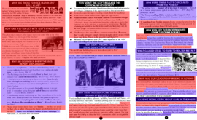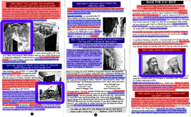
The area at lower right that’s unbesmirched by red and purple is the group’s contact information, which I’m afraid to check for accuracy. I’m not just interested in coloring, though. In May I took the time to write a 36-page analysis of this group’s single-sheet pamphlet. I sent it to their leader, Les Jamieson, and I’ve given links to it to all of the regular Saturday 9/11 deniers at Ground Zero, but as far as I know none of them have read any of it. Nor will most of them look at the evidence we provide when we make our points at Ground Zero. They are repulsed by evidence like a vampire is by a cross.
I met the two people who I go to Ground Zero with via an internet forum for critical thinkers that’s run by the James Randi Educational Foundation (JREF). http://forums.randi.org/forumindex.php Recently one of them wondered if our presence at Ground Zero wasn’t counterproductive, in drawing more attention to the 9/11 deniers, and in making Ground Zero less conducive to reflection than that bustling, noisy, touristy place already is. Here’s an excerpt from my response to his forum post “Why we fight...”
- So that on September 11, 2007, people can go to Ground Zero without running into a crowd of uniformed "patriots" marching behind a ranting charismatic leader to shout "Murderer!" outside the business of a Jewish "conspirator."
- Because these creeps have the nerve to call themselves a "truth movement."
- Because it's difficult for people who were more seriously affected by the attacks (than I was) to debate the creeps with dignity.
- Because firefighters (on 9/11) thanked us for learning about what they do and standing up for them. Because the creeps make it necessary to defend the people who would enter the maws of hell to save them.
The ugliness of the uniformed “patriots” chanting “murderer” outside the office of a man they claim is a “conspirator” really happened. On September 11, 2006, about a thousand members of the “9/11 Truth Movement” gathered at Ground Zero during memorial services to protest what they believe is the US government’s involvement in the attacks. They wore black shirts that said “Investigate 911” and carried banners that said “USA Did 9/11,” “The Bush Regime Engineered 9-11,” and the ever-popular “9/11 Was an Inside Job!”

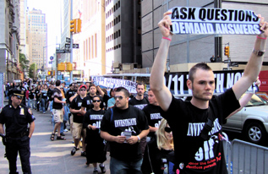

This throng of wrong was led by Alex Jones (not to be confused with journalist Alex S. Jones), a conspiracy salesman whose radio show, website, and videos make him the Prince of Paranoia to those who fear they’re being followed by silent black helicopters. Note how he works the Posse Comitatus Act of 1878 into this brief audio clip, in which he plays a scary arachnid that’s out to ensnare us and take our freedoms away. Jones claims, apparently in all seriousness, that members of the U.S. political and economic elite practice satanic occult rituals. He also claimed that:
They're preparing for new terrorist attacks that are much larger. & they're planning to bring in foreign armies....The U.S. government is going to engage in large terrorist attacks domestically & probably internationally...They may kill millions of Americans. (Alex Jones Radio Show, 7/11/02)
A good example of Jones’ paranoid grandstanding can be seen in a video shot in New York on September 9, 2006 by the Loose Change crew: http://tinyurl.com/r3sxl. They enter a buffet restaurant, and at 1:40 in the video Jones approaches a group of Marines at a table and begins harassing them. The Marines leave the restaurant, with Jones and two cameramen on their heels. Jones follows them down the street while lecturing them about WTC building 7 being “pulled” and “thermite” being found on steel at Ground Zero (more about these falsehoods later). The Marines walk on with dignity. Jones takes a parting shot while jabbing his finger in the air:
“The military-industrial complex tried to get this republic, but they failed!”
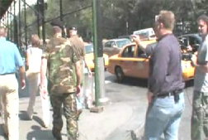
Jones then returns to the restaurant, where he apologizes to the manager for “running his guys off.” Ever the gentleman, Jones then “tips” the manager for his troubles. Conspiracy!
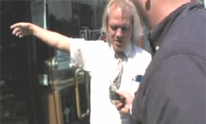

About the Marines, Jones says to the camera, “Yeah, that guy was Northcom. Those guys were Martial Law Officers. Hit ‘em with the codes!” Jones believes that the U.S. will soon be under martial law, and that citizens will be herded into FEMA-run concentration camps. Honest.
When Jones returns to the table, the Loose Change crew applauds him, their hero. His accomplishment? Harassing people who may be asked to put their lives on the line so that Alex Jones can remain free to make a public jackass of himself. “That’s martial law, Northcom,” said Jones, giddily. “He was just laughing at me (inaudible). I fired off a code – gave him a Northcom designation code! He was like, Whoa!” A restaurant employee, functioning as the only editor the Loose Change crew seems to have ever met, then asks the cameramen to stop shooting.
On his radio show on 9/11/01, Jones lapsed into paranoid hysteria and blamed the attacks on the “New World Order,” of which the aforementioned “occult-practicing elites” are supposedly members. That’s forgivable. I’m sure the shock of the attacks made many people say and do strange things. The problem is, Alex Jones still thinks that the “New World Order” perpetrated the attacks, and so do his followers.
In the hands of this Hyperion of hyperbole, a “bullhorn” truly lives up to its name. At Ground Zero on 9/11/06, Jones stood at the fence of historic St. Paul’s Chapel, which houses a 9/11 memorial and which served as the place of refuge and care for workers at Ground Zero, and screamed “9/11 was an inside job!” Then he led the crowd a few blocks away to another historic building on Broadway. This description by a protester reads like a parody, but isn’t (bolding mine).
Anywayz, that went on for a while, and then the movement began walking to 120 Broadway, where Larry Silverstiens office is. The police blocked off 2 lanes of traffic and the Truth Movement gathered in the middle of the street. Alex Jones got on the megaphone again and started speaking about WTC 7 and other things. In the hour or so we were there, we chanted "Pull it! pull it! pull it!" and "murderer! murderer! murderer!" among other sayings like "911 was an inside job, we have the proof, so face the truth!" After that, the Truth Movement marched to Police HQ, but me and my boy were both tired as shit and beat, so we decided to head back to Penn Station.
...Another thing I couldn't help but notice was the respect, concern, and love that the 9/11 Truth Movement represented. And on the other side, the hate and anger and wickedness of the so called "ordinary" people. They could not debate one fact, they couldn't talk without cursing or offending whoever they were talking to. To think that if it were them who died in the towers, and I had been there fighting for truth and wanting to know what happened to them, how unworthy they would be to protest for. I'm absolutely sure that there were good people that died in the towers, and not all evil hateful monsters like those there yesterday pretending to mourn. I dedicate my protest to any good person that died in the buildings, but it's sad to say, those people I encountered yesterday in mass, are not worth protesting for. Next time they're government kills them, I might just stay home and be quiet. http://tinyurl.com/npobs

Radio host and conspiracy-monger John C. Clayton, who goes by the name “Jack Blood,” was equally skeptical about the “ordinary people” at Ground Zero. As a bell tolled the number of the 9/11 dead and the memorial service was underway across the street, he told a videographer:
“I can only imagine how this would have gone if we weren't down here, if there wasn't a counter-message to the heartstring pulling and tying in knots” http://tinyurl.com/eaj7t
Yes, Jack, it’s too bad you can’t mobilize 1,000 people to protest at every memorial service for
murder victims. Fred Phelps would be proud of you.
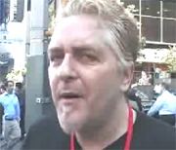
“Jack Blood” at Ground Zero
(To read more of Jack Blood’s 9/11 victim-bashing, see the first page of my document Loose Change Creators Speak: http://tinyurl.com/s8ouv)
Why were these protesters at Ground Zero during the memorial service? These quotes from the three creators of the 9/11 conspiracy video Loose Change, who organized the protest, say it all.
Dylan Avery, writer and director of Loose Change: “This is gonna be the mainstream media event of the year! The major media everywhere is gonna be there, and if they wanna cover the memorial, they're gonna have to cover us, because there's so many of us in numbers.”
Korey Rowe, producer of Loose Change: “They will have to cover us if they want to cover the memorial.”
Jason Bermas, production assistant and “researcher” of Loose Change: “There's gonna be every major media outlet in the world at Ground Zero, and if they want a wide shot, they're gonna have to cover us, and a hundred signs that say ‘9/11 Was an Inside Job!’” (Quotes and references appear in Loose Change Creators Speak P. 21)

Larry Silverstein’s “Pull It” Quote
“This building—the last to fall on 9-11—is key to all controlled-demolition theories. Its sudden fall onto its own footprint, and developer Larry Silverstein's reference on TV to telling the FDNY to "pull it," are seen as evidence that WTC7 was rigged to fall.”
–911truth.org http://tinyurl.com/z2n22 Keep in mind that this is one of the leading organizations of the 9/11 “Truth Movement.” (This is a national organization, not to be confused with ny911truth.org, already mentioned.)

Larry Silverstein was the owner of the 47-story WTC building 7, which collapsed on 9/11, and he owns the new 52-story building 7, which opened in May, 2006 on the site of the old building. He was the leaseholder on most of the other WTC buildings, including the Twin Towers (the property is owned by The Port of New York and New Jersey Authority). He won the right to the 99-year lease only six weeks before September 11, 2001, after a long public bidding process.

During an interview in 2002 for the PBS documentary America Rebuilds: A Year at Ground Zero, Mr. Silverstein said this about the fate of building 7 on 9/11:
"I remember getting a call from the fire department commander, uh, telling me that they were not sure they were gonna be able to contain the fire, and I said, 'We've had such terrible loss of life, maybe the smartest thing to do is pull it.' And they made that decision to pull and then we watched the building collapse." –Larry Silverstein
The conspiracy theorists (hereafter referred to as “CTs”) believe that Silverstein was ordering the FDNY to demolish, or to allow to be demolished, building 7.

In my experience, the CTs are in such a hurry to get to the “pull it” phrase that they neglect to read the whole statement. While I will provide much evidence in this paper that’s intended to convince the most hardcore CT, all that’s really necessary is to apply a bit of logic to the Silverstein statement, so I’ll start by doing that.

The setting: Larry Silverstein is being interviewed by a documentary crew from PBS. He calmly, clearly describes what happened. CTs would have us believe that Silverstein accidentally let it slip – twice, for a national TV audience – that he ordered his building to be demolished! Does that make any sense whatsoever? Can the CTs give an example of a similar “accidental confession” of a monumental crime in the history of the world? Keep in mind that if Silverstein thought he had said something wrong, he could simply have asked the crew to shoot that part again. Silverstein is a very smart guy who is in full possession of his mental faculties. He didn’t “slip up.”
"I remember getting a call from the fire department commander...”
That was 32-year-veteran Chief of Operations Daniel Nigro, who was in charge of the World Trade Center incident following Chief of Department Peter Ganci’s death in the collapse of the north tower. Silverstein was at home with his wife when he received the courtesy call from Chief Nigro in the afternoon.
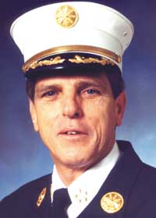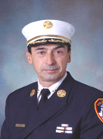
Peter Ganci Daniel Nigro

“...telling me that they were not sure they were gonna be able to contain the fire...”
That’s correct, as we will see in great detail below.

“...and I said, 'We've had such terrible loss of life, maybe the smartest thing to do is pull it.'”
Let’s use some logic. Was Silverstein saying,
“We’ve had such terrible loss of life that it would be wise to blow up my building,”
or was he saying,
“We’ve had such terrible loss of life that it would be wise to withdraw firefighters to prevent further loss of life”? Be honest, CTs. Which statement makes sense, and which is completely absurd?
Next, did Larry Silverstein, a real estate developer, have the world’s largest fire department at his beck and call? Of course not. Larry Silverstein had no say in how firefighting operations in New York City were conducted. He may have liked to think that Chief Nigro was calling him for a consultation, but that idea is laughable. It was a courtesy call.
“And they made that decision to pull and then we watched the building collapse."
Who made the decision to pull? They. The fire department. Not “Me,” not “We.” They. This is ridiculously obvious to anyone but a CT. Does the FDNY demolish buildings with explosives? No, they pull their people away from buildings that are too dangerous to be near. The “we” in “we watched the building collapse” is Silverstein and his wife. Silverstein was not at the WTC site.

Now that we’ve seen what Silverstein actually said, let’s see how his statement is represented by leaders of the “Truth Movement.”

James Fetzer
James Fetzer, co-chairman of “Scholars for 9/11 Truth,” and long-time JFK assassination conspiracy theorist, interviewed on Alan Colmes’ radio show, June, 2006:
Fetzer: Larry Silverstein, in New York, actually directed the World Trade Center Number 7 be pulled, meaning brought down by controlled demolition.
Colmes: Wasn’t he the landlord? Why would he want that to happen?
Fetzer: Well, it’s recorded. He admitted it in an interview that he had it pulled. Now, just to make an obvious point, Alan, it can’t have been pulled unless there were pre-positioned explosives in World Trade Center 7—
Colmes: What would be Larry Silverstein’s interest in destroying his own building?
Fetzer: He had insured it for $3.5 billion against a terrorist attack six weeks previous.
Colmes: So he’s in on this?
Fetzer: Absolutely. Later in that interview: I can prove all of these things, it’s the only hypothesis that makes any sense and in many cases we have direct evidence, we have Silverstein’s admission that he directed that the building be pulled. That was at 5:20 in the afternoon, it had been hit by no aircraft, it had only very modest fires, that was an extremely robustly built building— Keep in mind that Jim Fetzer is one of the leaders of the 9/11 “Truth Movement.”
James Fetzer has split with “Scholars” co-chairman Steven E. Jones, and has been promoting the claim that “high-energy beams” destroyed the WTC buildings. I couldn’t make this up if I tried.
Kevin Barrett
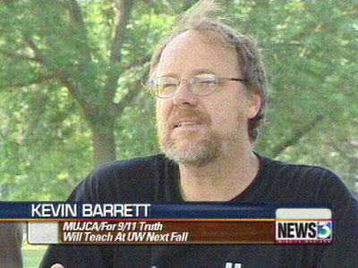
Kevin Barett, who is on the Board of Directors of Fetzer’s “Scholars for 9/11 Truth,” starts his website with the words “Thou shalt not bear false witness against thy neighbor.” But within that site, Barrett repeatedly bears false witness against Larry Silverstein, and he has refused to correct his errors. Following is a summary of communications I’ve had with Barett:

From: Mark Roberts nyctours@gmail.com Date: Oct 12, 2006
Subject: Serious errors on your website.
To: kevin@mujca.com

Dear Kevin,

In reviewing your website mujca.com, I noticed a particularly baffling passage on the first page:

"9/11 insurance-fraudster Larry Silverstein, like the Poe narrator, was apparently confounded by the noise of his own lying heartbeat when he confessed on national TV to making "a decision to pull (WTC-7)...and we made that decision to pull, and we watched the building collapse." Silverstein's inability to get anything built on the site during the past five years, leaving a gigantic bomb crater screaming silently to the world that the WTC was destroyed by bombs, not by planes, is another, far more eloquent confession. To borrow a phrase from the Loose Change logo, Larry's bomb crater is "louder than words." Perhaps the best possible memorial would be to leave the site exactly the way it is, and hold a ribbon-cutting ceremony for the Larry Silverstein Memorial Bomb Crater.

Several corrections need to be made here:

1) "Insurance-fraudster." I am not aware of Silverstein having done anything illegal involving WTC insurance, and apparently neither are the insurance companies. If you have evidence of such wrongdoing, which would be front-page news in New York, please present it. If not, you should retract the accusation.

2) "We made that decision to pull." Kevin, this is a particularly egregious error. I shouldn't have to remind you that the quote is "And they made that decision to pull." Here is the exact quote:

"I remember getting a call from the fire department commander, uh, telling me that they were not sure they were gonna be able to contain the fire, and I said, 'We've had such terrible loss of life, maybe the smartest thing to do is pull it.' And they made that decision to pull and then we watched the building collapse."

With the sentence 'We've had such terrible loss of life, maybe the smartest thing to do is pull it," Silverstein is obviously referring to saving lives, not blowing up buildings.

"They," of course, was the Fire Department of New York, and particularly Chief Daniel Nigro, who was in charge of operations on 9/11 after Chief Peter Ganci was killed. Nigro:

"The biggest decision we had to make was to clear the area and create a collapse zone around the severely damaged [WTC 7] building. A number of fire officers and companies assessed the damage to the building. The appraisals indicated that the building's integrity was in serious doubt." [Fire Engineering magazine, 10/2002]…

3) "Silverstein's inability to get anything built on the site during the past five years, leaving a gigantic bomb crater screaming silently to the world that the WTC was destroyed by bombs, not by planes, is another, far more eloquent confession."

I'll avoid the "bomb" comment for now. My paper will disabuse you of that notion. As I'm sure you know, Silverstein's new, 52-story WTC 7 has been open since May, 2006. To state that he has built nothing on the site is to ignore one of the largest skyscrapers in New York City. Delays in building the rest of the site have been due primarily to problems with design and planning that are not Silverstein's province.

I look forward to hearing from you that your site will be corrected of these errors as soon as possible. I am revising my WTC 7 paper that's linked above and would prefer not to include your name amongst those who have chosen politics above honesty and so badly misrepresented this part of the tragic story.

Sincerely,
Mark Roberts
I received no reply to that email, so I sent another in December:
Dear Kevin,

In October I sent you the email below, which refers to this page on your website: http://www.mujca.com/anniversaries.htm
Why have you not corrected your egregious errors? Please do so now.

Sincerely,
Mark Roberts
This time I did hear from Barrett (well, he replied as "Khidria," but I assume it's him). In a two-sentence email, he said that he would be saving my email as evidence against me, and that I would be standing on the gallows beside the traitor, mass murderer, and insurance fraudster Larry Silverstein.
My reply:
First, please identify yourself. Are you Kevin Barrett?
Next, please provide evidence of Larry Silverstein's
1) Treason
2) Mass murdering
3) Insurance fraud
You have not done so on your website or anywhere else that I've seen.

Thank you.
Mark Roberts
I received another two-sentence reply, which said that the information I seek is publicly available and that I should figure it out for myself.

My reply:

Since the information I seek is in your imagination only, I have turned to you for clarification. Most people understand that serious accusations, such as yours against Larry Silverstein, require proof. Since there is no evidence that Larry Silverstein has done anything wrong, much less murdered people or committed treason or insurance fraud, you should retract your accusations. Beyond the legal issue of libel, it's simply the right thing to do.

Do you really want to live in a world in which an accuser's baseless, hateful ranting is an acceptable standard of evidence? Please think about that, Mr. Barrett. Do the responsible and adult thing and withdraw your accusations against Larry Silverstein. The truth demands it.

Sincerely,
Mark Roberts

Keep in mind that Kevin Barrett is one of the leaders of the 9/11 “Truth Movement.”
Kevin Ryan
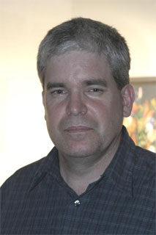
After Steven Jones and Jim Fetzer had their great schism (each accusing the other of promoting claims that are not based on evidence), Jones formed the similarly-named “Scholars for 9/11 Truth & Justice” His partner in this venture is Kevin Ryan, a former employee in Underwriters Laboratories water testing department. Ryan was fired for publicly making false claims about the WTC investigations. Since then he has given several presentations that rank with the worst of the 9/11 conspiracists in terms of deliberate misrepresentation. The following is one small example.
In his March, 2006 presentation “9/11 - A Closer Look,” Ryan misrepresents Silverstein’s statement “And I said, 'We've had such terrible loss of life, maybe the smartest thing to do is pull it. And they made that decision to pull and then we watched the building collapse."
Kevin Ryan, March, 2006
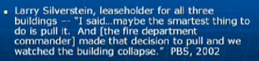
What could be Ryan’s reason for omitting “We’ve had such terrible loss of life,” which was the basis for Silverstein’s statement?
Quoting Silverstein incompletely and out of context apparently didn’t satisfy Ryan’s needs. Two months later, in a presentation remarkably subtitled “A New Standard of Deception,” Ryan makes a significant change and says, "Larry Silverstein, the leaseholder for all three buildings, essentially admitted to demolishing the building." Meanwhile, this slide appears on screen, to include Silverstein as a decision-maker:
Kevin Ryan, May, 2006
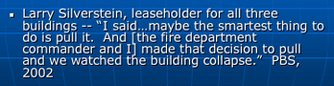
Ryan changed “They” to “He,” and then to “We.” He is blatantly lying to try to support his claim.
Keep in mind that Kevin Ryan is one of the leaders of the 9/11 “Truth Movement.”
Kevin Ryan has declined my challenge of a public debate, despite my offer that he can choose the time, the place, the moderators, and the debate topics.

Now That’s Denial!

We’ve seen how some prominent 9/11 “Truthers” deliberately change Silverstein’s quote. Now let’s see if the rank-and-file of the “Truth Movement” does any better.

Before I went to Ground Zero on 9/11 this year, I printed out Silverstein’s “pull it” statement from a conspiracist website. I know it by heart, but I thought the printout would come in handy. It wasn’t long before I heard a gentleman telling several camera crews about how Larry Silverstein ordered his building to be demolished. “I even know the quote verbatim,” he said, as I pulled out my printout in anticipation of him getting it wrong.
Sure enough, when he got to “they made that decision to pull,” he said “I made that decision to pull,” meaning Silverstein. I corrected him. He disagreed, so I asked him to read the quote.
When he got to “they made that decision...” he said “we made that decision.” He said “we” while reading the quote I had given him. So we went through another round of corrections.
That encounter was the first of four times on 9/11/06 when a conspiracist at Ground Zero said “I” or “we” instead of “they” while reading the statement I had provided. All of these encounters were captured on videotape, but I believe that most of the camerapeople were in the conspiracist camp, so I don’t know if those tapes will ever be aired.
Later in the day I had another encounter during which I asked a woman to read the quote, but first I told her what had happened the previous four times. She got the “they” right, but then said, “What difference does it make if Silverstein made the decision or if the Fire Department made it? She didn’t take my explanation well.

That’s the “Truth Movement” at Ground Zero on 9/11/06.

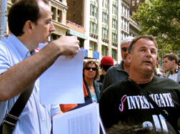
The author teaching remedial reading class at Ground Zero

What Really Happened at WTC building 7 on 9/11?
Let’s take a look at a summary of the events at WTC 7 on 9/11, according to the NIST report.

Essential Reading: NIST NCSTAR 1-8 Federal Building and Fire Safety Investigation of the World Trade Center Disaster: The Emergency Response Operations http://tinyurl.com/zemur

Excerpt: Summary of World Trade Center Building 7 Emergency Response

• The building had sustained damage from debris falling into the building, and they were not sure about the structural stability of the building.
• The building had large fires burning on at least six floors. Any one of these six fires would have been considered a large incident during normal FDNY operations.
• There was no water immediately available for fighting the fires.
• They didn’t have equipment, hose, standpipe kits, tools, and enough handie talkies for conducting operations inside the building.
At approximately, 2:30 p.m., FDNY officers decided to completely abandon WTC 7, and the final order was given to evacuate the site around the building. The order terminated the ongoing rescue operations at WTC 6 and on the rubble pile of WTC 1. Firefighters and other emergency responders were withdrawn from the WTC 7 area, and the building continued to burn. At approximately 5:20 p.m., some three hours after WTC 7 was abandoned the building experienced a catastrophic failure and collapsed.

Here’s a much-reprinted quote from FDNY Chief of Operations Daniel Nigro:
The biggest decision we had to make was to clear the area and create a collapse zone around the severely damaged [WTC 7] building. A number of fire officers and companies assessed the damage to the building. The appraisals indicated that the building’s integrity was in serious doubt. [Fire Engineering magazine, 10/2002]
In another interview, Chief Nigro says,
The most important operational decision to be made that afternoon was [that] the collapse [Of the WTC towers] had damaged 7 World Trade Center, which is about a 50 story building, at Vesey between West Broadway and Washington Street. It had very heavy fire on many floors and I ordered the evacuation of an area sufficient around to protect our members, so we had to give up some rescue operations that were going on at the time and back the people away far enough so that if 7 World Trade did collapse, we [wouldn't] lose any more people. We continued to operate on what we could from that distance and approximately an hour and a half after that order was [given], at 5:30 in the afternoon, 7 World Trade Center collapsed completely. http://tinyurl.com/g8c6y
That’s certainly straightforward. Building 7 was severely damaged and had severe, uncontrollable fires, and the FDNY withdrew its firefighters to protect their safety.

Now let’s look at those events through the eyes of conspiracy theorists.

“NY 911 Truth” Leader Les Jamieson and Members
Disparage the FDNY at Ground Zero

At the beginning of this paper I introduced the group NY911truth, which me and some stalwart friends confront on Saturdays at Ground Zero. In my first appearance there, in June or July, 2006, the first thing the group’s leader Les Jamieson said to me was, “We should have a debate.” I’m sure he didn’t know then that I knew far more of the facts of 9/11 than he, although I had only been looking into the CT claims for three months and he had been doing so since November, 2001. We did have an impromptu mini-debate before the video camera of documentarian Fletcher Holmes. The subject was the collapse of WTC 7, which Jamieson believes is one of the best pieces of evidence in favor of the “inside job” theory.
I reminded Jamieson that all the firefighters on the scene reported massive damage and raging, uncontrolled fires, and that the chiefs, specifically Chief Nigro, gave the order to withdraw the firefighters from the area long before the building collapsed. He replied that perhaps they had been ordered to withdraw by someone higher up, such as Nicholas Scoppetta, the FDNY Commissioner, who presumably got his orders from someone who was in on the plot.
That made me very angry. It was the first time I had heard someone blame the FDNY for the collapse of WTC 7. Since then, I’ve heard at least three other members of Jamieson’s organization make the same claim while standing on the ground where so many heroes died.
Let’s keep in mind what it would mean (only as far as the FDNY’s involvement is concerned) if
Jamieson was correct:
- The top people in the FDNY were so corrupt that they called off a search for hundreds of fallen firefighters in order to participate in a crime.
- The FDNY Chiefs who claim to have made an agonizing decision to stop rescue operations in the area around WTC 7, based on the desire to save lives, are lying.
- All the people on the scene who claim to have seen massive damage and uncontrolled fires on many floors at building 7, and who claim that they believed the building would collapse (we’ll read their reports later), were coerced into inventing those stories in order to cover up the crime of deliberate demolition of a skyscraper.
- The massive amount of smoke seen billowing from nearly every floor on WTC 7’s south side did not indicate massive fires.
- None of the 16,000 uniformed or civilian members of the FDNY, or anyone else who was involved in this huge conspiracy, has come forward about these issues in the past 5 years.


Les Jamieson, leader of NY 911 Truth
In addition to making brief appearances in Abby Scott and Ray Rivera’s tragicomic video, Jamieson has appeared twice on the NYC-area television show Hardfire, where his arguments were eviscerated by host Ron Wieck. Watch it here http://tinyurl.com/ellal and here http://tinyurl.com/gnroy.

Firefighters’ Statements: “Of Course They’re Lies!”
Following is a transcription of an audio recording I made at Ground Zero on September 16, 2006. Bold type indicates shouting. The participants are me, Les Jamieson, and a particularly volatile and ignorant member of his organization named Jack, who is a regular on Saturdays.
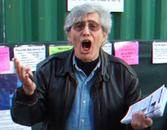
Jack, member of NY 911 Truth
A substantial crowd had gathered. First, I read the Daniel Nigro quote above to Mr. Jamieson. Here it is again. It bears repeating:
“The biggest decision we had to make was to clear the area and create a collapse zone around the severely damaged building. A number of fire officers and companies assessed the damage to the building. The appraisals indicated that the building’s integrity was in serious doubt.”
Me, to Jamieson: Chief of Operations, right here, who gave the order to start clearing this area three hours beforehand. And you’re saying that Larry Silverstein gave that order? Why?
I pull out a sheaf of quotes from FDNY eyewitnesses that detail the fire, damage, and suspected collapse of building 7.
Me: I’ve got page after page corroborating that. Page after page corroborating the damage, page after page corroborating that he gave the order, page after page saying that they did pull the men out starting at about 3 o’clock. But you blame Larry Silverstein. Why?
Jack, interrupting: BECAUSE HE SAID “PULL THE BUILDING!”
Me: Oh, did he?
JACK: PULL is the operative word! You say “they” was the operative word? IT WAS PULL. P-U-L-L!
I hand him the printout of Silverstein’s statement.
Me: Here, read this to the people. Are you afraid to? Let’s see if you get it right. On 9/11, I gave this quote to four different people of your persuasion, and every single one of them said, when they were reading it, said “He” decided to pull. Now you read it. See what it says.
JACK: We went through this before. This is a reprise of a previous episode. [True: from about an hour earlier!] He asked me to read this paragraph. I’ll read the paragraph, and let’s see if it’s going to register as funny, okay? I read the whole paragraph, and he says to me “read the last sentence.” I say, “Okay, ‘And they made that decision to pull.’ “
Me: And who was “they?”
JACK: No, wait a minute! Here’s the punch line. I say to him, “What’s the operative word here?” He says to me “They.” NO. IT’S PULL. P-U-L-L!
Me: Okay, I’ve got 15 different quotes here where fire department– (JACK starts to walk away) You gonna stand here and listen? –Where Fire Department people use the word “pull,” meaning pull their people out.
JACK: You don’t even understand English grammar! He said “IT!” “IT!”
Me: Yeah, the operations. The firefighting operations. I don’t understand English grammar?
Jamieson: People were pulled out at 11:30, weren’t they?
Me: No, sir, they weren’t. As you know – because I’m sure you’ve read the quotes – it started at about 2:30, the pullout. Before that they were trying to rescue their people who were under the rubble here.
Jamieson: I have 11:30. So even if it’s 2:30, why are they saying to pull it at 5:20?
Me: When did the conversation with Silverstein happen? Hours beforehand.
Jamieson: No.
Me: Yes, sir. You’re saying that Chief Daniel Nigro is lying? You’re saying the Fire Department is lying?
Jamieson: Silverstein is lying, maybe. Could that be?
Me: About what? His story corroborates perfectly with what the Fire Department says.
Jamieson: ‘Cause he says “We agreed to pull the building, then we watched it collapse.”
Reminder: Les Jamieson is the leader of one of the major 9/11 “Truth” organizations, and he claims to have been investigating these matters since 2001. Also, Jamieson was listening attentively 30 seconds earlier when JACK read “And they made that decision to pull.”
Me: No, sir. He says “They made that decision to pull.” Who’s “they?” He’s on the phone with the Fire Department.
Jamieson: Right.
Me: So you’re saying the Fire Department’s lying, when they’re saying that they made the decision?
Jamieson: How does the Fire Department have the ability to pull?
Me: To pull? To pull their men out. (I shake my sheaf of quotes) Fifteen different times they use the quote “pull,” meaning pull their men away from the building–
JACK: NO! THEY SAID PULL IT!
Me: –and thank God they did, because no one was killed when building 7 collapsed.
JACK: PULL IT!
Me: Was that a good decision or not?
Unidentified Truther: PULL IT!
Me: And they did that three hours before the building collapsed.
Jamieson: What about–
Me: I’m asking you a question. Is the Fire Department lying? You’re saying Larry Silverstein gave the order. I have page after page of quotes. Are they lying?
JACK: This is total obfuscation! Total obfuscation! What difference does it make if the time is plus or minus two hours? He said “Pull the building! Pull the building!”
Jamieson: PULL THE BUILDING! And it fell straight down! Not south!
JACK: PULL IT! I-T!
Me (reading from FDNY quotes): Fire Department Chief Daniel Nigro: “The biggest decision we had to make–“
JACK: HE’S OBFUSCATING! WITH TOTAL BULLSHIT!
Me: “–was to create a collapse zone around the severely damaged building. A number of fire officers and companies assessed the damage to the building. The appraisals indicated that the building’s integrity was in serious doubt.”
How about this: “There had to be a hole 20 stories tall in the building, with fire on several floors. Debris was falling down on the building and it didn’t look good. But they had a hose line operating. Like I said, it was hitting the sidewalk across the street, but eventually they pulled back too.”
And this: “The building didn’t look good. I was figuring probably the standpipe systems were shot. There was no hydrant pressure. I wasn’t really keen on the idea. Then this other officer I’m standing next to said, that building doesn’t look straight. So I’m standing there. I’m looking at the building. It didn’t look right, but, well, we’ll go in, we’ll see.
So we gathered up rollups and most of us had masks at that time. We headed toward 7. And just around we were about a hundred yards away and Butch Brandeis came running up. He said forget it, nobody’s going into 7, there’s creaking, there are noises coming out of there, so we just stopped.”
Here’s another: “They told us to get out of there because they were worried about 7 World Trade Center, which is right behind it, coming down. ... Finally they pulled us out.”
Here’s another: “Seven World Trade was burning from the ground to the ceiling, fully involved.“
Here’s another: “There was a huge gaping hole and it was scattered through there. It was a huge hole. I would say it was probably a third of it, right in the middle of it.”
JACK: HAHAHA!
Me: Yeah, it’s a lie? These are all lies the Fire Department is telling? I’m recording this, by the way.
JACK: OF COURSE THEY’RE LIES! TOTAL FABRICATIONS! TOTAL FABRICATIONS!
JACK walks away, shaking his head. Jamieson makes no objection to his statements.

Please let Les Jamieson know what you think about what he and his organization’s members say at Ground Zero. His 9/11-related email address is jazzyday@earthlink.net

Jason Bermas of Loose Change Disparages the FDNY at Ground Zero

I have never encountered anyone in any sphere of endeavor as thoroughly misinformed as Jason Bermas, another “9/11 Truth Movement” leader, the most defiantly outspoken of Loose Change’s three creators, and its chief “researcher.” On the subject of 9/11, he seems to be completely incapable of getting anything right. Bermas has apparently spent a lot of time watching Alex Jones videos. In my compilation Loose Change Creators Speak, Bermas mentions 18 conspiracy theories in a single interview, not because he’s reciting a list of them, but because that’s the way he talks. The following is a bit of an “aside,” but I think it’s important to show just how twisted the thinking of the leaders of the “9/11 Truth Movement” can be. Here is a sample of Bermas’ lunacy (pun intended):
“I contend that we may have been to the Moon, not with rocket technology, but with something else and it's secret. Definitely not the Apollo landings – they're a joke.”
“I really do feel like the evidence is there that these guys [U.S. political and religious leaders] are in the occult.”
On politician John Kerry: “This guy practices the occult. He had to in order to get into Skull & Bones [the not-so-secret Yale University club whose membership rolls are published each year by the school]. What ELSE is he capable of?”
Radio host: “And the 9/11 attack itself, is that the European group, or is that more the Americans, like Bush and Cheney?”
Bermas: “These guys in America are able to become billionaires, but they're not the multi-trillionaires that are in countries, basically with a free license to print money. So their power [the Americans' power] can only go so far.”
Host: “So you see it [The people behind the 9/11 attacks] as more of a European-type thing?”
Bermas: “Absolutely. I mean when you look at how bizarre some of these rituals are, and where these things come from...Helmut Schmidt, for instance, former German Chancellor, talks about all the things he used to do, all these Germanic death cults, and he talks about, you know, Bohemian Grove being a sex event and loving the rituals there, it's suspicious to me, man! I mean, I can see that with my own eyes. [I would like to read his eyewitness accounts! –MR] ...You look at things like the Montauk Project, and Boys' Town, and they definitely used, you know, drug addicts, sexual deviants. It's mind control! It's absolute mind control.”
“There was a report out in the past couple of days [on Alex Jones’ website, of course] that the government has been actually recruiting pastors and ministers to go around and say, you know, if something like the bird flu hits, it'll be good to go with, like, FEMA into camps and all these other federally-regulated areas, and they're actually being paid to say this stuff. And taking inoculations, and that is SCARY!”
“Unfortunately, in this country if there is another major event, and if it is incrementalized and larger than the last one, they could declare martial law at any moment, and have forced inoculations, and who's to say what they put in your body?”
“Believe it or not, TIVO was working on a brain chip, so that with your TIVO box there it would record what you want, when you want it, and it will base it on your brain patterns.”

Prophetic logo according to Jason Bermas?

If Bermas and other 9/11 “Truth” leaders are so obviously divorced from reality, why am I spending my time doing this? Why not leave them alone to bark at the moon and be laughed at by sensible people?
Answer: because they have been effective at spreading their message. Millions and millions of people have viewed at least part of Loose Change, which is freely available on the internet. I get several emails a week thanking me for my Loose Change Viewer Guide (a major revision – with twice the information and better sourcing – is in the works), because for a time they had bought Loose Change’s propaganda. In August, that guide, which I don’t advertise, had a peak viewer ship of over 30,000 people in one day. That means many, many more people are out there with this stuff rattling around in their heads. Now I understand the meaning of “viral video.”
Even people who aren’t taken in by the more extreme claims of the 9/11 Denier Movement can find themselves thinking that there must be some evidence of US government involvement in the attacks, based on the sheer volume of conspiracist claims. I have yet to see any such evidence, and it’s not for lack of trying.

Back to Jason Bermas at Ground Zero.

As mentioned above, the purpose of the protest at Ground Zero on 9/11/06 was to get the attention of the mainstream media. Two days earlier, on 9/09/06, the Loose Change guys and Alex Jones visited Ground Zero. Their cameramen filmed the visit. You can watch it here: http://tinyurl.com/onbrq. It begins with a preamble by Jason Bermas:
You can just imagine just the flurry of people who are going to be here in memoriam of all those that died on September 11th. Really, we’re gearing up, we’re giving out 10,000 DVDs, we’ve got 1,100 shirts. We’re really gonna make our presence known. Finally the mainstream media is going to have to stop attacking us and start reporting on us fairly, and that’s really our goal.
Bermas then strolls past, and comments on, the large bronze relief of 9/11 firefighting operations, which is on the side of Firehouse 10, across Liberty Street from the World Trade Center.
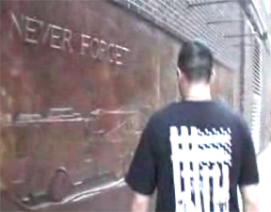
Jason Bermas outside Firehouse 10. He forgot.

At 40:33 in the same video, speaking at Ground Zero on the same day, Bermas expresses his opinion of the low character of FDNY firefighters, in answer to a question by Abby Scott:
“The firefighters ARE paid off.”
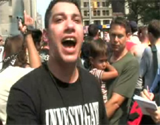
Remember, this video is promoted by the creators of Loose Change. They’re proud of it

After I brought attention to his statement, Jason Bermas posted the following bizarre “apology” on the Loose Change Blog (bolding mine):

I would just like to apologize for the comment I made to one Abby Scott on September 9th of this past year. I made the MISTAKE of saying that the firefighters were paid off, I did not mean this, and am convinced some sort of Jedi Mind trick was pulled on me. I was discussing how if you have a government job and want to keep it, aka Controlled Demolition Inc. you keep your mouth shut. It then moved to the firefighters and some how I said "The firefighters are paid off", and then cited how many of them discussed the bombs in the days after.

I DO NOT BELIEVE THE FIREFIGHTERS WERE PAID OFF! I hold them as heroes in the highest regard, and I truly believe that they were threatened in the aftermath of the event that not only traumatized a country, but still affect their lives deeply to this very day. Many of these men have families, and would do anything to keep them safe. I also believe many of them do not, and can not think the worst of their country. I know it was very difficult for me.

So, Mr. Bermas believes, not that the firefighters were paid to keep quiet about what they know, but that they are being threatened to keep quiet. He does not present any evidence to back this absurd claim. He also seems to be implying that the respected firm Controlled Demolitions Inc. was somehow involved in this conspiracy.

Did the 9/11/06 Ground Zero protest achieve its goal of garnering massive media attention? Dylan Avery, writer and director of Loose Change:
And shame on the mainstream media in general for participating in what can only be described as a media blackout. Those that did mention it marginalized it dramatically.
We are not conspiracy theorists by any stretch.
We are a growing body of concerned Americans who have both investigated the events and experienced them first-hand, and we are absolutely convinced that our government is hiding the truth from us, whatever the truth may be.
Dylan Avery, October 3: “I find it extremely telling that this article from Mexico gives us more coverage [of 9/11] than anything we experienced from American Mainstream Media combined.” http://loosechange911.blogspot.com/
I believe Mr. Avery is complaining about the lack of positive mainstream media coverage, not about the lack of coverage such as that hilariously dished out by Matt Taibbi of Rolling Stone on Sept. 26:
I challenge a 9/11 Truth leader like Loose Change writer Dylan Avery to come up with a detailed, complete summary of the alleged plot -- not the bits and pieces, but the whole story, put together -- that would not make any fifth grader anywhere burst out in convulsive laughter. http://tinyurl.com/oagtw

You can watch a two-part debate between Bermas and Avery of Loose Change, and myself and Ronald Wieck, on the TV show Hardfire. Part 1: http://tinyurl.com/tkfhj Part 2: http://tinyurl.com/yfkqeo
“Oh, Massive Evidence! We Have Total Evidence!”
Alex Jones Vilifies the FDNY and Larry Silverstein at Ground Zero
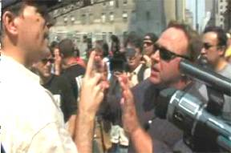
The author having words with conspiracist Alex Jones at Ground Zero. Watch Jones accuse the FDNY of following orders to pull back so that building 7 can be “blown,” then watch him rant, cheerlead, move goalposts, and otherwise jump through hoops to avoid answering simple questions about that topic, from 26:30 to 48:40 in the video: http://tinyurl.com/onbrq. This section also features The Jason Bermas/Abby Scott conversation noted above. It’s worth watching the segment immediately following, in which a “Truth” protester displays his total ignorance of why the towers collapsed. Keep in mind that this video was shot by, and is promoted by, leading members of the “9/11 Truth Movement!”

We’ll pick up the video at 28:33. It’s Jones and me.
AJ I’ve only seen a little bit of your work, but I’m just gonna tell you this: we’re not gonna be defeated, we’re gonna stop government-sponsored terror!
MR You can talk all you want. That doesn’t make it true.
AJ We’re gonna defeat government-sponsored terror!
MR Facts are what make something true.
AJ LIKE BUILDING SEVEN EXPLODES! THAT’S WHY FACTS CANNOT BE DEFEATED!
MR Oh, really? Ha-ha. That’s funny. Where’s your evidence?
AJ Oh, massive evidence! We have total evidence!
MR Why did they evacuate the area three hours beforehand?
AJ Larry Silverstein says he pulled the building.
Reminder: Alex Jones is a major 9/11 “Truth Movement” leader, and he claims to have been investigating these matters since 2001.
MR No. No, Larry Silverstein says they decided to pull. They. (pointing to the fire trucks parked down the block) Are they in on it?
(crosstalk)
MR They evacuated the area, and he said they decided to pull.
Cameraman He said “We.”
MR Do you want the quote?
Cameraman I know the quote.
MR No you don’t. He said they decided to pull the building and then we watched it come down.
[Ha! I screwed up there and said “pull the building.” That’s what I get for listening to the CTs blow that line every time!]
(Crosstalk: see below)
MR Who made the decision? “They.”
Cameraman “We.”
MR He said “We watched.” I’ll bet you a six-pack of beer, my friend. (We shake. When I later tried to claim my beer money, he claimed it was only for a beer. Can’t these people ever tell the truth?)

The little guy in black, wearing sunglasses, is Tom Foti, a regular on Saturdays at Ground Zero. He’s the most reprehensible person I’ve met in years, but we’ll wait to see if the video from 9/11 appears in which I explain why that’s so. In the present video, while Alex Jones falsely accuses me of introducing strawman arguments, Tom Foti actually introduces strawman arguments, by shouting them out while I’m trying to talk to Jones and his cameraman. Here Foti claims that I said there were no cameras at the Pentagon. Never mind that he’s trying to bail Jones out by changing the subject, I’ve never said anything like that. Foti is referring to an email I sent to him and many others in August, which quotes a Pentagon employee as follows:
“Why isn't there more video? Without telling too much of what I know of Pentagon security, you would be surprised how few cameras there are outside the building. Humans actively patrolling a building's perimeter are a tad more effective than dozens of monitors which may or may not be watched at any given moment. Given the limited number of entrances to the facility (all highly controlled areas), cameras are generally only needed in high traffic areas like vehicle control points (such as the one this video came from).”
Tom Foti turns that into “Mark Roberts says there are no cameras at the Pentagon.” He’s lying, which is par for his course. The saddest thing is – and this happens all the time with Foti – I had corrected him about this misconception at Ground Zero a week or two earlier. Later, Foti brings up another strawman. He says I claim that building 7 collapsed in 18 seconds. No, that’s the time of the seismic rumbling recorded by Lamont-Doherty Earth Observatory when WTC 7 collapsed, which may indicate internal collapses before the external collapse becomes visible. LDEO says that is not to be taken as conclusive. The time I quote for the visible collapse of WTC 7 is at least 13.5 seconds from the start of the fall of the east mechanical penthouse. This is easily checked by reviewing my internet forum posts from before I met Foti. The CTs don’t count the east penthouse as part of building 7’s collapse, although that structure covers an area equal to four apartment buildings on my block, and was caused by collapses on the lower floors. Later in this paper we’ll see a video that shows this collapse clearly. To justify their fabricated time of 6.5 seconds, the CTs show video clips of building 7 that do not show the roof or that are edited to omit the start of the collapse.
29:38
AJ Listen, we’re gonna defeat the New World Order, don’t worry.
MR The New World Order, sir? Tell me more about building 7. Why did they evacuate–
AJ –Do you believe, hold on, hold on. (changing the subject) Do you believe they found WMDs in Iraq?
MR Answer the damn question! You brought it up!
AJ Yeah.
MR Why did they evacuate this area three hours beforehand? Why did every fireman who was here say, “The building’s about to collapse?”
AJ Because they told the firemen– you’re not letting me talk.
MR Why was it making noises? Why was it leaning?
AJ See, he won’t let me talk.
MR There you go. Now you can talk.
AJ They told them to get out because they were gonna blow it!
MR So the Fire Department’s in on it?
AJ No, they were told to get out.
MR Why don’t you tell the Fire Department. The New York City Fire Department. They’re right there (pointing).
AJ (To the crowd, changing the subject again) Oh, I guess there wasn’t poisonous dust, either, like they said.
MR They’re right there. Tell them they were in on it. You just said they were in on it.
AJ No, I didn’t say, I said they were told to, they were told to pull out.
Stop the presses! That’s the first “9/11 Truth” leader I’ve seen get the “pull” part right. Congratulations, Alex!
MR Oh, and they just obeyed because they were gonna blow up the building?
AJ No, because they were given orders!
MR Who? Who gave them orders?
AJ They don’t ask questions. They don’t say, “Port Authority, why are we supposed to pull out?”
MR Chief Daniel Nigro, who was in command here, gave the orders. Are you gonna say he’s a liar?
AJ See, guys, this is all “strawman.” We never said the firemen were involved. He just claimed we said it. He’s a liar! That’s what liars do. They build straw men.
MR Who gave the order? Chief Daniel Nigro. You want to see the order? (I had the quote with me)
AJ Yes, he’s told to pull them. It doesn’t mean he’s involved. He’s given an order.
MR Who told him? Where’s your evidence? Where’s your evidence?
AJ We – the firemen reported that they heard and saw explosions going off in all these buildings.
MR Name one explosion they heard going off there (pointing to building 7). You know there were demolitions experts here? (Inaudible)
AJ See, folks, this is straw men. He isn’t having a real debate.
Good timing Alex. Now Tom Foti pipes in with his second strawman argument.
31:45
AJ There’s no point talking to him. It’s all straw men. Just like you heard it: he claimed we blamed the firemen. We never said that. He just made it up.
MR Oh, they just followed orders to pull out?
AJ Yeah.
MR They didn’t give the orders, they followed the orders? They didn’t give the orders? You’re saying the Fire Department did not give the order to pull out?
AJ No, they were given an order. They followed the order.
MR By whom? By whom?
AJ Oh, it’s admitted! The Port Authority...Giuliani.
Let’s keep in mind what Jones is saying. He’s saying that Larry Silverstein, the Port Authority, and Rudy Giuliani were ultimately in charge of firefighting operations at the WTC, not the FDNY. These people (and this organization: note that Jones doesn’t say who in the Port Authority was involved) planned to demolish WTC 7 with explosives. Therefore, when the Chiefs on the scene say that their inspection of the building led them to withdraw their men to keep them alive, they’re lying. Jones says the FDNY pulled away from building 7 because they were ordered to, not because they determined that damage and fires in the building made it unsafe. Therefore all the eyewitness accounts from the FDNY (which we will see shortly) that say otherwise, are wrong. And the agonizing decision to cease rescue operations in the area was not the FDNY’s decision. And all this has been covered up by everyone involved. Heinous crimes, massive deception. The conspirators, at minimum: Silverstein, the Port of New York and New Jersey Authority (which lost 40 employees on 9/11), Rudy
Giuliani, and the FDNY, which lost 343 men.
MR Who admitted it?
AJ I’ve got the newspaper articles.
MR No you don’t. (to crowd) See, look at this (evasion?). (To Jones) You don’t know what the hell you’re talking about! You’re lying to people at Ground Zero.
AJ See, all he does is sit here and act confident. He blamed us for saying the firefighters were in on it.
MR I’m asking where your facts are. Where are they? You’re saying an order was given. Who gave it? Tell me. Give me the name. Right now. With the cameras here. Who? Who did it?
AJ See, this is how the spin works. This is a lawyer technique. Number one, he doesn’t let me talk.
MR I’m a tour guide, I’m not a lawyer! You can’t take on a tour guide from New York City?
AJ No, I, I said you’re using a lawyer, lawyer tactic.
MR Yeah, facts. Give me facts. Give me evidence, give me facts. How about that?
AJ He’s claiming I blame firefighters. He’s claiming (inaudible)
MR Sure you do.
AJ And none of it’s true.
MR You’re saying they didn’t give the order to pull out. You’re saying they didn’t survey the building, and determine it was too damaged to stand, not safe to be in? You’re saying that? You’re saying the Fire Department did that.
AJ No modern building had ever fallen–
MR Yes or no? Are you saying that the Fire Department did not survey the building?
AJ See I just brought a question up. He doesn’t answer it.
MR Did you say the Fire Department did not survey the building?
AJ See, he won’t even let me answer.
MR Did you say the Fire Department did not survey the building?
AJ He just repeats the same thing over and over again.
MR Did you? Yes or no?
AJ (Shouting) HEY FOLKS, HOW MANY OF YOU KNOW 9/11’s AN INSIDE JOB?
About 4 people, and mainly Tom Foti, shout YEAH!
AJ That’s right, it’s an inside job, brother!
MR (To crowd) This guy’s a well-known radio personality. He’s got lots of videos out there. He does not even know the basics. All he can do is change the subject.
AJ I know all the basics.
MR All he can do is change the subject.
AJ He set the subject, he made up that we blame the firefighters.
MR You brought up this building. You said it was blown up! Where’s your evidence?
AJ He’s lying again. See, that’s what they do. [Lying? Allow me to refer you to this AJ quote above: “They told them to get out because they were gonna blow it!”]
MR Where’s your evidence? What I do is ask for evidence, sir.
AJ See, I could make up a claim that he said George Bush did it....(more strawman accusations)
Cameraman who owes me a six-pack Do you know what a squib mark is?
MR Do you know what air pressure is?
AJ (Strawman, etc.)
MR All I ask for is your evidence.
And on and on. That’s the pathetic Alex Jones, the hero of the “Truth Movement,” at Ground Zero. Accusing people of horrible crimes without a shred of evidence.

A review of the indignation of Alex Jones at Ground Zero:
“See, guys, this is all ‘strawman.’ We never said the firemen were involved. He just claimed we said it. He’s a liar! That’s what liars do. They build straw men.” [“We?”]
“Just like you heard it: he claimed we blamed the firemen. We never said that. He just made it up.”
“He blamed us for saying the firefighters were in on it.”
“He’s claiming I blame firefighters. ...And none of it’s true.”
“He set the subject, he made up that we blame the firefighters.”
“See, I could make up a claim that he said George Bush did it....”

A review of Alex Jones’ active websites, October, 2006.

Alex Jones’ PrisonPlanet.com: Silverstein, FDNY Decided to “Pull WTC 7”

Alex Jones’ Infowars.com:
“World Trade Center Imploded by Silverstein, FDNY And Others”

http://www.infowars.com/print/Sept11/FDNY.htm

Alex Jones’ Infowars.com: “Update: People Died in WTC 7: This Makes Silverstein and the FDNY Guilty of AT LEAST Manslaughter”

No, no one died in WTC 7. Jones’ ignorance leads to insult.

These lies are still posted on Jones’ websites as of January 20, 2007.

Could “Truth Movement” leader Alex Jones be any more dishonest?

Actually, yes.

Here’s the story from the PrisonPlanet.com article that headlines the page above, with my comments.
Professional Demolition of World Trade Center Building 7 False. See below.

Larry Silverstein, the owner of the WTC complex, admitted on a September 2002 PBS documentary, ‘America Rebuilds’ that he and the NYFD decided to ‘pull’ WTC 7 on the day of the attack. False, as we’ve already seen. The word ‘pull’ is industry jargon for taking a building down with explosives. False. See below.
We have attempted to call Larry Silverstein’s office on several occasions. Silverstein has never issued a retraction for his comments. Because he never said anything wrong.
Photos taken moments before the collapse of WTC 7 show small office fires on just two floors. Wait until we see the south side of the building at the same time, and read the quotes from the firefighters about how involved the building was....
Firefighters were told to move away from the building moments before it collapsed. False. See below.
In February of 2002 Silverstein Properties won $861 million from Industrial Risk Insurers to rebuild on the site of WTC 7. Silverstein Properties’ estimated investment in WTC 7 was $386 million. So: This building’s collapse resulted in a profit of about $500 million! A motive is stated! Unfortunately for Jones, it’s hilariously false. See section 3.
Jason Bermas certainly learned from a master, and the lyingest man east of the Pecos isn’t through yet.

Didn’t they “Pull” WTC building 6 with explosives?
Alex Jones says they did, on the Infowars.com page that’s linked above:
We know that the term 'pull it' means to bring the building down by means of explosives because in the same documentary (America Rebuilds) a cleanup worker (in December 2001) refers to the demolition of WTC Building 6 when he says, "...we're getting ready to pull building six."
We are directed to this brief video clip: http://www.infowars.com/Video/911/pull-it2_lo.wmv
Yes, that worker certainly does say they’re getting ready to “pull” building six. Then we have a quote from Luis Mendes, from the NYC Department of Design and Construction:
“We had to be very careful about how we demolished building 6. We were worried about building 6 coming down and damaging the slurry walls, so we wanted that particular building to fall within a certain area.”
Interesting. They needed to be sure that building 6 came down in a “controlled” way. But wait a second: the video clip that Alex Jones presents – the clip that’s shown on all the conspiracist websites –ends abruptly at this point. Huh? Where’s the money shot? Why’d they cut it there?
Here’s why:
Because the following scene shows how building 6 was “pulled”: with cables attached to the hydraulic arms of four excavators, not with explosive charges.
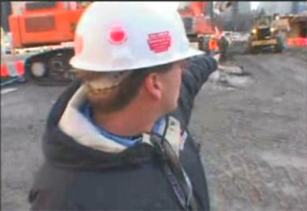
“We’ve got the cables attached in four different locations going up. Now they’re pulling the building to the north. It’s not every day you try to pull down a eight story building with cables.”

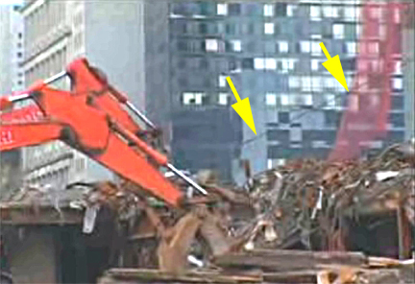

Narrator Kevin Spacey: “The use of explosives to demolish World Trade Centers 4, 5 and 6 was rejected for fear workers would risk their lives entering buildings to set the charges.”
A final, disgraceful lie from Alex Jones

Alex Jones’ Prison Planet.com, September 11, 2006
Documentary film maker and radio host Alex Jones, coordinating today's 9/11 truth movement events in downtown New York City, says that the atmosphere around ground zero has dramatically changed, with the majority of firefighters and police officers now sympathetic to the claim that 9/11 was an inside job.

Mark Roberts to Alex Jones at Ground Zero, September 11, 2006: “Let’s go, Mr. Jones. You and me are going to (FDNY) Ten House, and you can tell them what you told me the other day. Are you man enough? Or are you a coward?”
Jones: “I’m not talking to you.”

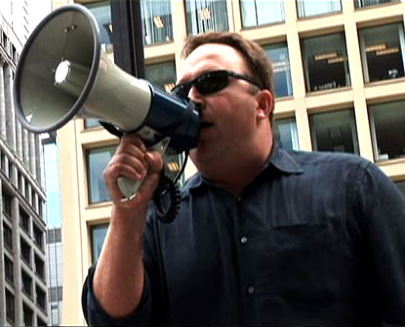

We finally take our leave of this hero of the “Truth Movement.”

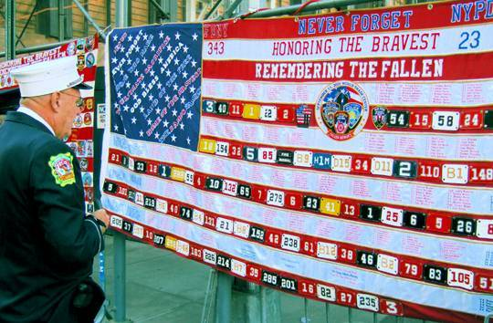
Ground Zero, September 11, 2006

Part II

Is “Pull” Used by Demolitions Professionals to Mean
“Demolish a Structure With Explosives?”
No.

Brent Blanchard, a demolitions expert with Protec, and contributor to ImplosionWorld.com, weighs in with his expert opinion:
We have never once heard the term 'pull it' being used to refer to the explosive demolition of a building, and neither has any blast team we've spoken with. The term is used in conventional demolition circles, to describe the specific activity of attaching long cables to a pre-weakened building and maneuvering heavy equipment (excavators, bulldozers etc) to 'pull' the frame of the structure over onto its side for further dismantlement. This author and our research team were on site when workers pulled over the six story remains of WTC6 in late fall 2001, however we can say with certainty that a similar operation would have been logistically impossible at Ground Zero on 9/11, physically impossible for a building the size of WTC7, and the structure did not collapse in that manner anyway.
In the weeks following 9/11, several Protec building inspectors and staff photographers, including this author, were contracted by demolition teams to document the deconstruction and debris removal processes at Ground Zero. These processes included the mechanical pull-down of the remains of the U.S. Customs Building (WTC 6) and various other activities occurring simultaneously throughout the site. http://tinyurl.com/z6zyc

From the Popular Mechanics book Debunking 9/11 Myths: Why Conspiracy Theories Can't Stand Up to the Facts http://tinyurl.com/pkeqq
Four demolition and engineering experts tell Popular Mechanics that pull it is not slang for controlled demolition. "I've never heard of it," says Jon Magnusson of Magnusson Klemencic Associates.
Ron Dokell, retired president of Olshan Demolishing Company, says the same thing. Mark Loizeaux of Controlled Demolition, Inc. adds that the only way he can imagine the term being used is in reference to a process where the legs of a structure are precut and attached to cables, and then large machines are used to literally pull the building to the ground.

Is “Pull” Ever Used to Mean “Withdraw Firefighters from Danger?”
Yes.

It certainly was used that way on 9/11. Again and again, “pull” is how firefighters and EMTs describe the afternoon withdrawal from the area in and around WTC 7. In the accounts I’ve read, excluding Larry Silverstein’s, “pull” is used 26 times to refer to the withdrawal of WTC firefighting operations. 23 of those references are about WTC 7. Add Silverstein’s statement and we’ve got 28 references to “pull” meaning “withdraw.” Details are in the appendix. My survey was by no means exhaustive.

Here’s a summary of the first-person accounts I’ve read:

People who specifically mention the severity of the WTC 7 fires 35
People who specifically mention the extensive damage to WTC 7 25
People who mention the FDNY order to withdraw from WTC 7 area 93
Number of times “Pull” is used to mean “withdraw rescuers” 29
Number of people who use “Pull” to mean “withdraw rescuers” 16
Other witnesses who say the collapse of WTC 7 was expected 29
Total 211
Doubters, please read the following accounts. Names in bold are those whom the accounts indicate gave orders to withdraw from the area around WTC 7.

7 World Trade Center was roaring. I remember being pulled off the pile like just before. It wasn't just before. It was probably an hour before 7 came down. –Firefighter Kevin Howe
http://graphics8.nytimes.com/packages/pdf/nyregion/20050812_WTC_GRAPHIC/9110469.PDF

Hayden: By now, this is going on into the afternoon, and we were concerned about additional collapse, not only of the Marriott, because there was a good portion of the Marriott still standing, but also we were pretty sure that 7 World Trade Center would collapse. Early on, we saw a bulge in the southwest corner between floors 10 and 13, and we had put a transit on that and we were pretty sure she was going to collapse. You actually could see there was a visible bulge, it ran up about three floors. It came down about 5 o’clock in the afternoon, but by about 2 o’clock in the afternoon we realized this thing was going to collapse.
Firehouse Magazine: Was there heavy fire in there right away?
Hayden: No, not right away, and that’s probably why it stood for so long because it took a while for that fire to develop. It was a heavy body of fire in there and then we didn’t make any attempt to fight it. That was just one of those wars we were just going to lose. We were concerned about the collapse of a 47-story building there. We were worried about additional collapse there of what was remaining standing of the towers and the Marriott, so we started pulling the people back after a couple of hours of surface removal and searches along the surface of the debris. We started to pull guys back because we were concerned for their safety.
Firehouse: Chief Nigro said they made a collapse zone and wanted everybody away from number 7— did you have to get all of those people out?
Hayden: Yeah, we had to pull everybody back. It was very difficult. We had to be very forceful in getting the guys out. They didn’t want to come out. There were guys going into areas that I wasn’t even really comfortable with, because of the possibility of secondary collapses. We didn’t know how stable any of this area was. We pulled everybody back probably by 3 or 3:30 in the afternoon. We said, this building is going to come down, get back. It came down about 5 o’clock or so, but we had everybody backed away by then. –Deputy Chief Peter Hayden http://tinyurl.com/zwtrs

There was a big discussion going on at that point about pulling all of our units out of 7 World Trade Center. Chief Nigro didn't feel it was worth taking the slightest chance of somebody else getting injured. So at that point we made a decision to take all of our units out of 7 World Trade Center because there was a potential for collapse.
Q. It was on fire, correct, Captain?
A. Yes, it was on fire at that time. Then they said it suffered some form of structural damage. These things were going on at the same time. The fact that we thought we found Ganci and Feehan and his place at 7 World Trade Center. Made the decision to back everybody away, took all the units and moved them all the way back toward North End Avenue, which is as far I guess west as you could get on Vesey Street, to keep them out of the way. –Captain Ray Goldbach
http://graphics8.nytimes.com/packages/pdf/nyregion/20050812_WTC_GRAPHIC/9110150.PDF

So we go there and on the north and east side of 7 it didn’t look like there was any damage at all, but then you looked on the south side of 7 there had to be a hole 20 stories tall in the building, with fire on several floors. Debris was falling down on the building and it didn’t look good. But they had a hose line operating. Like I said, it was hitting the sidewalk across the street, but eventually they pulled back too. – Capt. Chris Boyle http://tinyurl.com/e7bzp

Someone gave a Mayday. I guess it was someone trapped under one of the pedestrian bridges. We started to go under there to look. One of the Chiefs pulled us out of there. He said don't go under there. ..We searched that building and then we started making another move in and we got pulled out again, because I guess the Chiefs were getting more in control of the situation. They pulled everybody out of there. ...that was probably like four or five o'clock before we stopped. –Firefighter Todd Fredrickson http://graphics8.nytimes.com/packages/pdf/nyregion/20050812_WTC_GRAPHIC/9110403.PDF

When the third building came down that's where we were (Stuyvesant High School). We were actually -- they pulled us all back. Actually they pulled us all the way back that far at the point because they didn't want any -- they didn't want us anywhere near it. Everyone was just running around. When the third building came down, we were on that corner in front of the school, and everybody just stood back.

They pulled us all back at that time, almost an hour before it, because they were sure -- they knew it was going to come down, but they weren't sure. So they pulled everyone back, and everybody stood there and we actually just waited and waited until it went down, because it was unsafe. They wouldn't let anyone next to I guess the two piles, we would call them, where one and two was. We stood back. We waited. –EMT Joseph Fortis http://graphics8.nytimes.com/packages/pdf/nyregion/20050812_WTC_GRAPHIC/9110200.PDF

After that they decided to pull everybody out and I know -- what building was it? Building 5, I believe [sic], the other tall building there, the third building that came down, they were evacuating people. So everyone just pushed up West Street all the way up towards the high school there. I forget the name of the high school. –Firefighter Brian Russo http://graphics8.nytimes.com/packages/pdf/nyregion/20050812_WTC_GRAPHIC/9110450.PDF

Then approximately I guess maybe two hours before number 7 came down, we went into Ground Zero and helped dig around and was there when they located Chief Feehan and one of the chiefs pulled us all out because they said 7 was going to come down. –Firefighter Kevin Quinn
http://graphics8.nytimes.com/packages/pdf/nyregion/20050812_WTC_GRAPHIC/9110339.PDF

So then they aborted us from setting up the tower ladder because they were worried about now Seven coming down. So then they pulled us away. This is where I kind of start remembering a lot.

We came around, I think we took Murray Street down the west side, and we stopped the rig and pulled over to the side and we all got out of the rig. We were standing, waiting for Seven to come down. We were there for quite a while, a couple hours.

During that time a couple of the members felt like we were being useless just standing around. We wanted to do something. So we started trying to walk down, trying to get into the pile. We kept on being turned around from chiefs, because they didn't want us near Seven.

As we were walking, we had to actually get a little closer to Seven. So we turned and looked at Seven, and that's when all the marble siding started popping off the side because it was starting to go down.

We worked our way putting out the car fires, which I don't know if there was ammunition, because there was a lot of cop cars, but there was explosions. Tires were exploding. There had to be about 15 or 20 car fires. We put them out as we worked our way down. –Firefighter Thomas Donato http://graphics8.nytimes.com/packages/pdf/nyregion/20050812_WTC_GRAPHIC/9110471.PDF

They told us to get out of there because they were worried about 7 World Trade Center, which is right behind it, coming down. We were up on the upper floors of the Verizon building looking at it. You could just see the whole bottom corner of the building was gone. We could look right out over to where the Trade Centers were because we were that high up. Looking over the smaller buildings. I just remember it was tremendous, tremendous fires going on.

Finally they pulled us out. They said all right, get out of that building because that 7, they were really worried about. They pulled us out of there and then they regrouped everybody on Vesey Street, between the water and West Street. They put everybody back in there.

Finally it did come down. From there -- this is much later on in the day, because every day we were so worried about that building we didn't really want to get people close. They were trying to limit the amount of people that were in there. Finally it did come down. That's when they let the guys go on. I just remember we started searching around all the rigs. –Firefighter Richard Banaciski
http://graphics8.nytimes.com/packages/pdf/nyregion/20050812_WTC_GRAPHIC/9110253.PDF

Then we were instructed to search through two or three buildings to make sure they were stable, and then they pulled everybody out because of the pink building. Was it 7 World Trade, that was going?
Q: Right. –Firefighter Adrienne Walsh
http://graphics8.nytimes.com/packages/pdf/nyregion/20050812_WTC_GRAPHIC/9110353.PDF

We operated until they finally started pulling people back. ...They pulled us back, I think it was like probably between 4 and 6, because of Seven. Seven was the concern at the time. –Firefighter Fred Marsilla http://graphics8.nytimes.com/packages/pdf/nyregion/20050812_WTC_GRAPHIC/9110399.PDF

They put another engine company in there which augmented us. And the stream was even good enough to almost reach Tower 7. And then what happened was, we heard this rumbling sound and my father pulled us all back and then with that Tower 7 came down. –Firefighter Peter Blaich http://www.firehouse.com/terrorist/911/magazine/gz/blaich.html

These firefighters mention being withdrawn from a different part of the WTC site because other buildings were believed to be in danger of collapse:
So we were in there just for a few minutes maybe and the chiefs pulled us out. They told us we had to get out, so we got out, and then later on we went back in again, and they pulled us out once more, and that was it. –Firefighter Peter Giammarino http://hosted.ap.org/specials/interactives/_national/sept11_fdny_transcripts/9110436.PDF

We proceeded to go back one block to that post then slowly but surely every two minutes or so
when we started to regroup we were pulled back further and further and further until we were behind – until we were past Stuyvesant High School –Firefighter Dean Beltrami http://graphics8.nytimes.com/packages/pdf/nyregion/20050812_WTC_GRAPHIC/9110359.PDF

In this video of smoke billowing from WTC 7, several men (presumably firemen judging from their conversation, proximity to the site, and radio calls) speak about WTC 7:
"It's hot enough for the [Inaudible]"
"That's why he's pulled everybody outta here."
"That building's 50 stories, definitely reaching over here."
"[Inaudible] get everybody outta there, that's for sure." http://www.youtube.com/watch?v=sYlVmTHjHe8

Waiting for WTC Building 7 to Fall
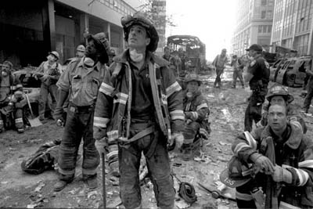
Shepard Sherbell

Some Eyewitness Accounts of the WTC 7 Fires

Finding 2.25: The fire alarm system that was monitoring WTC 7 sent to the monitoring company only one signal (at 10:00:52 a.m. shortly after the collapse of WTC 2) indicating a fire condition in the building on September 11, 2001. This signal did not contain any specific information about the location of the fire within the building. [The alarm had been set to “test” mode due to maintenance work] http://wtc.nist.gov/progress_report_june04/chapter1.pdf (pg28)

1. We walked over by number Seven World Trade Center as it was burning and saw this 40-plus story building with fire on nearly all floors. –FDNY Lieutenant Robert LaRocca
http://graphics8.nytimes.com/packages/pdf/nyregion/20050812_WTC_GRAPHIC/9110081.PDF

2. ...Just when you thought it was over, you're walking by this building and you're hearing this building creak and fully involved in flames. It's like, is it coming down next? Sure enough, about a half an hour later it came down. –FDNY Lieutenant James McGlynn
http://graphics8.nytimes.com/packages/pdf/nyregion/20050812_WTC_GRAPHIC/9110447.PDF

3. I walked out and I got to Vesey and West, where I reported to Frank [Cruthers]. He said, we’re moving the command post over this way, that building’s coming down. At this point, the fire was going virtually on every floor, heavy fire and smoke that really wasn’t bothering us when we were searching because it was being pushed southeast and we were a little bit west of that. I remember standing just where West and Vesey start to rise toward the entrance we were using in the World Financial Center. There were a couple of guys standing with me and a couple of guys right at the intersection, and we were trying to back them up – and here goes 7. It started to come down and now people were starting to run. –FDNY Deputy Chief Nick Visconti http://www.firehouse.com/terrorist/911/magazine/gz/visconti.html

4. All morning I was watching 7 World Trade burn, which we couldn't do anything about because it was so much chaos looking for missing members. –Firefighter Marcel Klaes http://graphics8.nytimes.com/packages/pdf/nyregion/20050812_WTC_GRAPHIC/9110018.PDF

5. When the building came down it was completely involved in fire, all forty-seven stories.
–FDNY Assistant Chief Harry Myers (Smith, Dennis, 2002. Report From Ground Zero: The Heroic Story of the Rescuers at the World Trade Center. New York: Penguin Putnam. p. 160)

6. The concern there again, it was later in the afternoon, 2, 2:30, like I said. The fear then was Seven. Seven was free burning. Search had been made of 7 already from what they said so they had us back up to that point where we were waiting for 7 to come down to operate from the north back down. –Captain Robert Sohmer http://graphics8.nytimes.com/packages/pdf/nyregion/20050812_WTC_GRAPHIC/9110472.PDF

7. Then we had to move because the Duane Reade, they said, wasn't safe because building 7 was really roaring. –FDNY Chief Medical Officer Kerry Kelly.
http://graphics8.nytimes.com/packages/pdf/nyregion/20050812_WTC_GRAPHIC/9110207.PDF

8. At this point Seven World Trade was going heavy, and they weren't letting anybody get too close. Everybody was expecting that to come down. –Firefighter Vincent Massa
http://graphics8.nytimes.com/packages/pdf/nyregion/20050812_WTC_GRAPHIC/9110222.PDF

9. Chief Cruthers told me that they had formed another command post up on Chambers Street. At this point there were a couple of floors burning on Seven World Trade Center. Chief McNally wanted to try and put that fire out, and he was trying to coordinate with the command post up on Chambers Street. This is after searching for a while. He had me running back and forth trying to get companies to go into Seven World Trade Center. His radio didn't seem to be working right either because he had me relaying information back and forth and Chief Cruthers had me --

Q. So everything was face-to-face? Nothing was by radio?

A. Yeah, and it was really in disarray. It really was in complete disarray. We never really got an operation going at Seven World Trade Center. –FDNY Captain Michael Donovan
http://graphics8.nytimes.com/packages/pdf/nyregion/20050812_WTC_GRAPHIC/9110205.PDF

10. Building #7 was still actively burning and at that time we were advised by a NYFD Chief that building #7 was burning out of control and imminent collapse was probable. –PAPD P.O. Edward McQuade http://www.thememoryhole.org/911/pa-transcripts/pa-police-reports02.pdf page 48.

11. At Vesey St. and West St., I could see that 7 WTC was ablaze and damaged, along with other buildings.
–M. DeFilippis, PAPD P.O. http://www.thememoryhole.org/911/pa-transcripts/pa-police-reports03.pdf page 49

[Note: the fires in 7 were probably not mainly due to damage from the south tower, but from the north.]
12. So yeah then we just stayed on Vesey until building Seven came down. There was nothing we could do. The flames were coming out of every window of that building from the explosion of the south tower. So then building Seven came down. When that started coming down you heard that pancaking sound again everyone jumped up and starts.

Q: Why was building Seven on fire? Was that flaming debris from tower two, from tower two that fell onto that building and lit it on fire?

A: Correct. Because it really got going, that building Seven, saw it late in the day and like the first Seven floors were on fire. It looked like heavy fire on seven floors. It was fully engulfed, that whole building. There were pieces of tower two [sic: he probably means tower one] in building Seven and the corners of the building missing and whatnot. But just looking up at it from ground level however many stories -- it was 40 some odd -- you could see the flames going straight through from one side of the building to the other, that’s an entire block. –Firefighter Tiernach Cassidy
http://graphics8.nytimes.com/packages/pdf/nyregion/20050812_WTC_GRAPHIC/9110413.PDF

13. "We were down about a block from the base of the World Trade Center towers about an hour ago. And there was a great deal of concern at that time, the firemen said building number 7 was going to collapse, building number five was in danger of collapsing. And there's so little they can do to try to fight the fires in these buildings, because the fires are so massive. And so much of the buildings continues to fall into the street. When you're down there, Dan, you hear smaller secondary explosions going off every 15 or 20 minutes, and so it's an extremely dangerous place to be."
–CBS-TV News Reporter Vince DeMentri http://terrorize.dk/911/witnesses/911.wtc.secondary.explosions.wmv

14. Well, they said that's (7) fully involved at this time. This was a fully involved building. I said, all right, they're not coming for us for a while. Now you're trapped in this rubble, and you're trying to get a grasp of an idea of what's going on there. I heard on the handy talky that we are now fighting a 40-story building fully involved.

Now you're trapped in the rubble and the guys who are there are fighting the worst high-rise fire in the history of New York or history of the world, probably, I don't know, 40, story building fully involved, I guess that was probably the worst.

I was, needless to say, scared to death that something else was going to fall on us, that this building was going to come down and we were all going to die, after surviving the worst of it. [Note: I deleted the link this account, and searching the net for the text doesn’t turn up anything. This sounds like an account from north tower stairwell B survivor. Anyone who knows for sure, let me know.]

15. And 7 World Trade was burning up at the time. We could see it. ... the fire at 7 World Trade was working its way from the front of the building northbound to the back of the building. There was no way there could be water put on it, because there was no water in the area. –Firefighter Eugene Kelty Jr.
http://graphics8.nytimes.com/packages/pdf/nyregion/20050812_WTC_GRAPHIC/9110261.PDF

16. The time was approximately 11a.m. Both of the WTC towers were collapsed and the streets were covered with debris. Building #7 was still standing but burning. ...We spoke to with a FDNY Chief who has his men holed up in the US Post Office building. He informed us that the fires in building 7 were uncontrollable and that its collapse was imminent. There were no fires inside the loading dock (of 7) at this time but we could hear explosions deep inside. –PAPD P.O. William Connors http://www.thememoryhole.org/911/pa-transcripts/pa-police-reports04.pdf page 69

17. "There's number Seven World Trade. That's the OEM bunker." We had a snicker about that. We looked over, and it's engulfed in flames and starting to collapse.
We're kind of caught in traffic and people and things, and everything's going on. We hear over the fire portable, "Everybody evacuate the site. It's going to collapse." Mark Steffens starts yelling, "Get out of here! Get out of here! Get out of here! We've got to go! We've got to go! It's going to collapse." I turned around, and I piped up real loud and said, "Stay in the frigging car. Roll the windows up. It's pancake collapsing. We'll be fine. The debris will quit and the cloud will come through. Just stay in the car." We pulled the car over, turned around and just watched it pancake. We had a dust cloud but nothing like it was before. –Paramedic Louis Cook http://graphics8.nytimes.com/packages/pdf/nyregion/20050812_WTC_GRAPHIC/9110103.PDF

Building 7 fire makes rescuer of NT stairwell victim’s route impassable (just before collapse):
I remember it was bad and I'm going to get to a point where we came back that way on the way up. We couldn't even go that way, that's how bad the fire was, but by the time I was coming back it was rolling, more than a couple of floors, just fully involved, rolling.
...So now it's us 4 and we are walking towards it and I remember it would have at one point been an easier path to go towards our right, but being building 7 -- that must have been building 7 I'm guessing with that fire, we decided to stay away from that because things were just crackling, falling and whatnot.
So as I’m going back, that fire that was on my right is now on my left. I’m backtracking and that fire is really going and on the hike towards there, we put down our masks, which at this point started to realize maybe it would have been good thing if we had this mask on the way back, but then again between the fire and about halfway when I was on the way back, I got a radio call from the guys that we left and it was Johnny Colon the chauffeur of 43, who was effecting a different rescue. He was carrying somebody out.
He had called me and said “Hey Jerry don’t try and get back out the way you went in which was big heads up move because he said that building was rolling on top of the building that we were passing. That building was on fire and likely to collapse more too.
Between Picciotto asking me are you sure we can get out this way because it really didn’t look good with that fire and my guy telling me that you better not because of the area we crawled in was unattainable now too. ...we started going back the other way.
Q: Would that be towards West Street?
A: That would have been back towards what I know is the Winter Garden....[west]
–Firefighter Gerard Suden http://graphics8.nytimes.com/packages/pdf/nyregion/20050812_WTC_GRAPHIC/9110022.PDF

18. I remember Chief Hayden saying to me, "We have a six-story building over there, a seven-story building, fully involved." At that time he said, "7 has got fire on several floors." He said, "We've got a ten-story over there, another ten-story over there, a six-story over there, a 13-story over there." He just looked at me and said, "Fuck 'em all. Let 'em burn." He said, "Just tell the guys to keep looking for guys. Just keep looking for the brothers. We've got people trapped. We've got to get them out." –Lieutenant William Ryan http://graphics8.nytimes.com/packages/pdf/nyregion/20050812_WTC_GRAPHIC/9110117.PDF

19. I walked around the building to get back to the command post and that's when they were waiting for 7 World Trade Center to come down. ...They had three floors of fire on three separate floors, probably 10, 11 and 15 it looked like, just burning merrily. It was pretty amazing, you know, it's the afternoon in lower Manhattan, a major high-rise is burning, and they said 'we know.' –FDNY Chief Thomas McCarthy
http://graphics8.nytimes.com/packages/pdf/nyregion/20050812_WTC_GRAPHIC/9110055.PDF

20. We were champing at the bit," says WCBS-TV reporter Vince DeMentri of his decision to sneak behind police barricades and report from 7 World Trade Center a half-hour before it collapsed. "I knew the story was in there." But after he and his cameraman slipped past officers, they lost all sense of direction. "From outside this zone, you could figure out where everything was," he says. "But inside, it was all destruction and blown-out buildings, and we had no clue. I walked into one building, but I had no idea where I was. The windows were all blown out. Computers, desks, furniture, and people's possessions were strewn all over." He found a picture of a little girl lying in the rubble. Then he realized that No. 7, aflame, was about fifteen to twenty feet ahead of him. "I looked up Barclay Street," he says. "There was nobody out. No bodies, no injured. Nobody. There were mounds of burning debris. It was like opening a broiler." http://nymag.com/nymetro/news/sept11/features/5183/index.html

21. They are worried that number 7 is burning and they are talking about not ceasing operations.
–Deputy Commissioner Frank Gribbon http://graphics8.nytimes.com/packages/pdf/nyregion/20050812_WTC_GRAPHIC/9110167.PDF

22. There were hundreds of firefighters waiting to -- they were waiting for 7 World Trade Center to come down as it was on fire. It was too dangerous to go in and fight the fire. –Assistant Commissioner James Drury http://graphics8.nytimes.com/packages/pdf/nyregion/20050812_WTC_GRAPHIC/9110098.PDF

23. We assisted some FDNY personnel who were beginning to attempt to fight the fire at 7 WTC. We assisted in dragging hose they needed to bring water into the building. –Kenneth Kohlmann PAPD P.O. http://www.thememoryhole.org/911/pa-transcripts/pa-police-reports04.pdf page 26

24. My first thoughts when I came down a little further into the site, south of Chambers Street, was, "Where am I?" I didn't recognize it. Obviously, the towers were gone. The only thing that remained standing was a section of the Vista Hotel. Building 7 was on fire. That was ready to come down. –Charlie Vitchers, Ground Zero Superintendent http://www.pbs.org/americarebuilds/profiles/profiles_vitchers_t.html

Some Eyewitness Accounts of the WTC 7 Damage & Surrounding Debris

1. The major concern at that time was number Seven, building number Seven, which had taken a big hit from the north tower. When it fell, it ripped steel out from between the third and sixth floors across the facade on Vesey Street. We were concerned that the fires on several floors and the missing steel would result in the building collapsing. –FDNY Chief Frank Fellini
http://graphics8.nytimes.com/packages/pdf/nyregion/20050812_WTC_GRAPHIC/9110217.PDF

2. At that time, other firefighters started showing up, Deputy Battalion Chief Paul Ferran of the 41 Battalion, and James Savastano of the First Division assigned to the Second Battalion showed up and we attempted to search and extinguish, at the time which was small pockets of fire in 7 World Trade Center. We were unaware of the damage in the front of 7, because we were entering from the northeast entrance. We weren't aware of the magnitude of the damage in the front of the building. – FDNY Captain Anthony Varriale
http://graphics8.nytimes.com/packages/pdf/nyregion/20050812_WTC_GRAPHIC/9110313.PDF

3. [Shortly after the tower collapses] I don’t know how long this was going on, but I remember standing there looking over at building 7 and realizing that a big chunk of the lower floors had been taken out on the Vesey Street side. I looked up at the building and I saw smoke in it, but I really didn't see any fire at that time. Deputy ––Chief Nick Visconti http://tinyurl.com/paqux
4. A few minutes after that a police officer came up to me and told me that the façade in front of Seven World Trade Center was gone and they thought there was an imminent collapse of Seven World Trade Center. –FDNY Lieutenant William Melarango
http://graphics8.nytimes.com/packages/pdf/nyregion/20050812_WTC_GRAPHIC/9110045.PDF

5. I think they said they had seven to ten floors that were freestanding and they weren't going to send anyone in. –FDNY Chief Thomas McCarthy
http://graphics8.nytimes.com/packages/pdf/nyregion/20050812_WTC_GRAPHIC/9110055.PDF

6. So we go there and on the north and east side of 7 it didn’t look like there was any damage at all, but then you looked on the south side of 7 there had to be a hole 20 stories tall in the building, with fire on several floors. Debris was falling down on the building and it didn’t look good. But they had a hose line operating. Like I said, it was hitting the sidewalk across the street, but eventually they pulled back too.
Then we received an order from Fellini, we’re going to make a move on 7. That was the first time really my stomach tightened up because the building didn’t look good. I was figuring probably the standpipe systems were shot. There was no hydrant pressure. I wasn’t really keen on the idea. Then this other officer I’m standing next to said, that building doesn’t look straight. So I’m standing there. I’m looking at the building. It didn’t look right, but, well, we’ll go in, we’ll see.
So we gathered up rollups and most of us had masks at that time. We headed toward 7. And just around we were about a hundred yards away and Butch Brandeis came running up. He said forget it, nobody’s going into 7, there’s creaking, there are noises coming out of there, so we just stopped. And probably about 10 minutes after that, Visconti, he was on West Street, and I guess he had another report of further damage either in some basements and things like that, so Visconti said nobody goes into 7, so that was the final thing and that was abandoned.
Firehouse Magazine: When you looked at the south side, how close were you to the base of that side?
Boyle: I was standing right next to the building, probably right next to it.
Firehouse: When you had fire on the 20 floors, was it in one window or many?
There was a huge gaping hole and it was scattered through there. It was a huge hole. I would say it was probably a third of it, right in the middle of it. And so after Visconti came down and said nobody goes in 7, we said all right, we’ll head back to the command post. – Capt. Chris Boyle http://tinyurl.com/e7bzp

7. After the initial blast, Housing Authority worker Barry Jennings, 46, reported to a command center on the 23rd floor of 7 World Trade Center. He was with Michael Hess, the city's corporation counsel, when they felt and heard another explosion. First calling for help, they scrambled downstairs to the lobby, or what was left of it. "I looked around, the lobby was gone. It looked like hell," Jennings said.
http://www.record-eagle.com/2001/sep/11scene.htm

8. Anyway, I was looking at WTC7 and I noticed that it wasn’t looking like it was straight. It was really weird. The closest corner to me (the SE corner) was kind of out of whack with the SW corner. It was impossible to tell whether that corner (the SW) was leaning over more or even if it was leaning the other way. With all of the smoke and the debris pile, I couldn’t exactly tell what was going on, but I sure could see the building was leaning over in a way it certainly should not be. I asked another guy looking with me and he said “That building is going to come down, we better get out of here.” So we did. –M.J., Employed at 45 Broadway.

9. So we left 7 World Trade Center, back down to the street, where I ran into Chief Coloe from the 1st Division, Captain Varriale, Engine 24, and Captain Varriale told Chief Coloe and myself that 7 World Trade Center was badly damaged on the south side and definitely in danger of collapse. Chief Coloe said we were going to evacuate the collapse zone around 7 World Trade Center, which we did. – FDNY Lieutenant Rudolph Weindler http://graphics8.nytimes.com/packages/pdf/nyregion/20050812_WTC_GRAPHIC/9110462.PDF

10. Just moments before the south tower collapsed and, you know, when it happened we didn't know it was the south tower. We thought it was the north tower. There was a reporter of some sort, female with blond hair and her cameraman, an oriental fellow. They were setting up outside 7 World Trade Center, just east of the pedestrian bridge. I told them it would probably be better off to be set up under the bridge. At least it was protected. I was just about to enter a dialogue with her when I heard a sound I never heard before. I looked up and saw this huge cloud. I told him run. I grabbed the female, I threw her through the revolving doors of number 7.
We were proceeding inside. She fell to the ground. I helped her out, I pushed her towards the direction of where we were all in the south corner and there was a little doorway behind that desk which led into the loading bays. Everybody started to run through that. Never made it to that door. The next thing that I remember was that I was covered in some glass and some debris. Everything came crashing through the front of number 7. It was totally pitch black.
Q. Were you injured?
A. Yes, I saw some stuff had fallen on me. I didn't believe that I was injured at that time. I discovered later on I was injured. I had some shards of glass impaled in my head, but once I was able to get all this debris and rubble off of me and cover my face with my jacket so that I could breathe, it was very thick dust, you couldn't see. We heard some sounds. We reached out and felt our way around. I managed to find some other people in this lower lobby. We crawled over towards the direction where we thought the door was and as we approached it the door cracked open a little, so we had the lights from the loading bay. We made our way over there. The loading bay doors were 3-fourths of the way shut when this happened, so they took a lot of dust in there, but everyone in those bays was safe and secure. We had face to face contact with Chief Maggio and Captain Nahmod. They told me – I said do whatever you need to do, get these people out of here. Go, go towards the water. –EMS Division Chief Jon Peruggia
http://graphics8.nytimes.com/packages/pdf/nyregion/20050812_WTC_GRAPHIC/9110160.PDF

11. You could see the damage at 7 World Trade Center, the damage into the AT&T building.
–FDNY Firefighter Vincent Palmieri
http://graphics8.nytimes.com/packages/pdf/nyregion/20050812_WTC_GRAPHIC/9110258.PDF

12. At this point, 7, which is right there on Vesey, the whole corner of the building was missing. I was thinking to myself we are in a bad place, because it was the corner facing us. –Fred Marsilla, FDNY
http://graphics8.nytimes.com/packages/pdf/nyregion/20050812_WTC_GRAPHIC/9110399.PDF

13. The way we got into the loading dock [of WTC 7] was not the way we were getting out. It was obstructed.
Q. The door was blocked?
A. Yeah, and we found our way -- we walked across the loading dock area, and we found there was another door. We went in that door, and from there we were directed to -- I really guess it was like a basement area of the building, but we were directed to an opposite door. –Dr. Michael Guttenberg , NYC Office of Medical Affairs http://graphics8.nytimes.com/packages/pdf/nyregion/20050812_WTC_GRAPHIC/9110005.PDF

14. We eventually ended up meeting after the second explosion, three of us met up here, but I didn't see a lot of the people that were with me until two, three days later. I got word that they were okay. For instance, Dr. Guttenberg and Dr. Asaeda, who were at 7 World Trade Center, they got trapped in there and had to like climb in and out and get out because that building also became very damaged supposedly and they were there. We thought they were dead. I guess he was in an area where Commissioner Tierney might have been, I believe. I think she was in 7 also. –Paramedic Manuel Delgado
http://graphics8.nytimes.com/packages/pdf/nyregion/20050812_WTC_GRAPHIC/9110004.PDF

(After collapse of south tower)
15. The decision was either to go left or right and we ended up going right, between the two buildings, in the alleyway on the north, which turned out to be the right direction because apparently there was a lot of debris and part of 7 down already. Also, I did notice as I was making my exit the sound of the firefighters' alarms indicating that they were down. I did remember that as well but just could not see anything.
–Dr. Glenn Asaeda http://hosted.ap.org/specials/interactives/_national/sept11_fdny_transcripts/9110062.PDF

16. I saw the firefighter. There were people screaming out of one of these two buildings over here saying they couldn't get out, and my partner took one straggler fireman, the one that we had with us, and was trying to break the door because the door obviously had shifted or something. They couldn't get the door open.
Q. That was 7 World Trade Center?
A. I believe it was 7. Maybe it was 5. It was at the back end of it because I do remember the telephone company [which is next to building 7]. So I think it was the back end of 7, I think right over here at that point, and they couldn't get out. Then I had ran down the block and I flagged a ladder company and they brought the ladder, which they had like a vestibule that you couldn't like really reach the people because the ladder wouldn't reach. So they went and got other resources, they went inside the building, and I told my partner that it wasn't safe and that we need to go because everything around us was like falling apart.
–EMT Nicole Ferrell http://graphics8.nytimes.com/packages/pdf/nyregion/20050812_WTC_GRAPHIC/9110304.PDF

Some Eyewitness Accounts of Rescuers being Withdrawn and
Held Back from WTC 7 due to Danger of Collapse

1. They backed me off the rig because Seven was in dead jeopardy, so they backed everybody off and moved us to the rear end of Vesey Street. We just stood there for a half hour, 40 minutes, because Seven was in imminent collapse and finally did come down. –Firefighter Thomas Smith
http://graphics8.nytimes.com/packages/pdf/nyregion/20050812_WTC_GRAPHIC/9110246.PDF

2. Chief Nigro directed me to continue monitoring conditions at the site. Specifically to monitor number 7 World Trade Center. We were very concerned with the collapse potential there, and to do whatever I could do to ensure site safety in that no additional people became injured. –FDNY Deputy Chief Harold Meyers
http://graphics8.nytimes.com/packages/pdf/nyregion/20050812_WTC_GRAPHIC/9110382.PDF

3. We were concerned that the fires on several floors and the missing steel would result in the building collapsing. So for the next five or six hours we kept firefighters from working anywhere near that building, which included the whole north side of the World Trade Center complex. –Chief Frank Fellini
http://graphics8.nytimes.com/packages/pdf/nyregion/20050812_WTC_GRAPHIC/9110217.PDF

4. We made searches. We attempted to put some of the fire out, but we had a pressure problem. I forget the name of the Deputy. Some Deputy arrived at the scene and thought that the building was too dangerous to continue with operations, so we evacuated number 7 World Trade Center. –Captain Anthony Varriale
http://graphics8.nytimes.com/packages/pdf/nyregion/20050812_WTC_GRAPHIC/9110313.PDF

5. I remember him screaming about number 7, No. 7, that they wanted everybody away from 7 because 7 was definitely going to collapse, they don't know when, but it's definitely going to come down, just get the hell out of the way, everybody get away from it, make sure you're away from it, that's an order, you know, stuff like that. –Firefighter Edward Kennedy http://graphics8.nytimes.com/packages/pdf/nyregion/20050812_WTC_GRAPHIC/9110502.PDF

6. Early on, there was concern that 7 World Trade Center might have been both impacted by the collapsing tower and had several fires in it and there was a concern that it might collapse. So we instructed that a collapse area --
Q. A collapse zone?
A. Yeah -- be set up and maintained so that when the expected collapse of 7 happened, we wouldn't have people working in it. There was considerable discussion with Con Ed regarding the substation in that building and the feeders and the oil coolants and so on. And their concern was of the type of fire we might have when it collapsed. They shut down the power, and when it did collapse, the things that they were concerned with would have been [sic]. That's about it. –Chief Frank Cruthers
http://graphics8.nytimes.com/packages/pdf/nyregion/20050812_WTC_GRAPHIC/9110179.PDF

7. There was concern. I had gone up to take a look at it, because I knew that the telephone company building, which is 140 West Street, was next to 7 World Trade Center, and there was a concern that if 7 World Trade came down, what would happen to this building? We went in there, we checked it out. There were some people in there. We made them evacuate and I went in the back to see what was happening. I went back and I reminded whoever the chief was, I don't know if it was Chief McKavanagh or Chief Blaich, that with 7 World Trade Center in danger of collapsing, you had to be careful, because Con Edison had big transformers in the back that supplied the lower half of Manhattan. So we had to be concerned about electricity, that this may be energized or not be energized. –Firefighter Eugene Kelty Jr.
http://graphics8.nytimes.com/packages/pdf/nyregion/20050812_WTC_GRAPHIC/9110261.PDF

8. "We heard reports all day long of 7 World Trade possibly coming down. ...We heard that all day long, all the warnings." –Firefighter Christopher Patrick Murray
http://graphics8.nytimes.com/packages/pdf/nyregion/20050812_WTC_GRAPHIC/9110327.PDF

9. It could have been an hour, hour and a half we were doing that before we were ordered to move away from that part of Tower No. 1 because there was an imminent danger of collapse of World Trade Center No. 5 and 7. –Firefighter Vandon Williams http://graphics8.nytimes.com/packages/pdf/nyregion/20050812_WTC_GRAPHIC/9110282.PDF

10. Civilian photographer Tom Franklin: “Much of what happened to me on September 11 is a blur, but this moment I clearly remember: It was 4:45 p.m., and all the firemen and rescue workers were evacuating Ground Zero after word came that a third building -- WTC 7 -- was ready to fall.” http://archives.cjr.org/year/02/2/franklin.asp

11. Unidentified speaker in video: "Keep your eye on that building, it'll be coming down soon."
http://www.whatreallyhappened.com/IMAGES/wtc7_blow_up.wmv

12. CBS-TV Reporter Vince DeMentri, who sneaked past security barriers to get close to the scene:
...Building 7 was going to collapse. That appears to be what has happened now. I don't know exactly how many stories the building is, Dan, but standing at the base of the building and watching it burn about an hour ago, it looked to be on the order of 50, 60 stories. [If anyone has the audio leading up to “...Building 7 was going to collapse,” let me know. I’m curious to know why the CT websites include only this much of the clip.] http://www.911podcasts.com/view.php?cat=4&med=0&ord=Name&strt=0&vid=24&epi=216&typ=0&form=0

13. So that was basically we watched that one come down. It was on fire first, I think the fourth floor was on fire they said. We were like are you guys going to put that fire out? I was like, you know, they are going to wait for it to burn down and it collapsed. So that's when I knew high rise buildings you know (inaudible).
Q: You were still there?
A: Yes, so basically they measured out how far the building was going to come, so we knew exactly where we could stand.
Q: So they just put you in a safe area, safe enough for when that building came down?
A: 5 blocks. 5 blocks away. We still could see. Exactly right on point, the cloud just stopped right there. Then when that building was coming down, that same rumbling. –EMT Decosta Wright
http://graphics8.nytimes.com/packages/pdf/nyregion/20050812_WTC_GRAPHIC/9110054.PDF

14. We went to get the car. We were inside the perimeter, more or less -- that's where the car was -- of where Seven World Trade Center was. We started back going east, I guess it is. ...We were inside this perimeter although we didn't realize it at the time we saw a rig with the compartments opened. We stopped. They were actually reversing. I kind of pulled up along side them. Murray yelled out the window “Your compartments are open.” The guy yelled something back at us. They kept backing up.
We went forward to imagine it’s the corner of Murray and West Street. Just as we were approaching it, we saw person run north in front of the car, and then Joe Mazzarella who was sitting in the passenger seat just started screaming “Reverse! Reverse! Reverse! Reverse!” I didn’t even look. I just threw it in reverse and punched it. We flew backwards without being able to see out the rear, and building Seven came down in front of us.
–Fire Marshal John Coyle http://graphics8.nytimes.com/packages/pdf/nyregion/20050812_WTC_GRAPHIC/9110406.PDF

15. At this point, I moved up all the way to stairwell B. We got the lady out, passed her down, then they were trying to dig out, I believe it was a second Battalion Chief and I waited and stayed there with them until we were ordered—well, we were ordered several times, but the Captain of, I think it was a rescue company or a squad refused to leave. Finally he gave up, he said there was nothing he could do and we all left that area. This is in the collapse zone of tower 7.
At this point, I went down back to the middle area of the pile and I proceeded to make my way to the north side of the towers. At that point, I ran into Lieutenant Simms, who had another complement of Ladder 20 there. At this point, I guess I had formally reported into Deputy Chief Visconti. He was up on the North End. We waited until tower 7 collapsed and at this point, we went into the area and assessed the damage that was done to the buildings and to see if we could control the fires that resulted from the collapse of tower 7.
–Captain Richard Weldon http://graphics8.nytimes.com/packages/pdf/nyregion/20050812_WTC_GRAPHIC/9110307.PDF

16. At that time Seven World Trade Center was burning and in was danger of collapsing. ...I guess it was a Chief was saying clear the area, because they were worried about number Seven World Trade Center coming down and burying guys who were digging. So basically we went back to the rig because they were clearing that area out. It took about three hours for Seven World Trade Center to actually come down. –Firefighter Kevin McGovern http://graphics8.nytimes.com/packages/pdf/nyregion/20050812_WTC_GRAPHIC/9110301.PDF

17. I remember later in the day it was getting close that they were more concerned about Seven coming down. I remember later on in the day as we were waiting for Seven to come down, they kept backing us up Vesey, almost like a full block. They were concerned about Seven coming down, and they kept changing us, establishing a collapse zone and backing us up.
As soon as it came down, everybody got up and tore ass west down Vesey Street. Everybody was trying to get into this building. I remember there were 150 guys trying to get through two revolving doors with full gear. Everyone is screaming. Guys were trying to smash the glass with their halogens to get through and ended up freaking out. Everybody was shell-shocked.
That’s when Salka came up and he said all right now that Seven was down you can start getting closer and down things. There was no collapse threat anymore. –Firefighter Vincent Massa
http://graphics8.nytimes.com/packages/pdf/nyregion/20050812_WTC_GRAPHIC/9110222.PDF

18. Eventually they had ordered everybody away from the area again because of building 7.
–Lieutenant James Walsh http://graphics8.nytimes.com/packages/pdf/nyregion/20050812_WTC_GRAPHIC/9110459.PDF

19. We stayed in this area for a while, and we started wandering around, and we came around to where 6 and 7 were, and actually 7, we were coming down this corner going trying to find something to do, and that's when they were telling us 7 is going to go, 7 is going to go, so we kind of backed away.
–Firefighter Paul Vasquez http://graphics8.nytimes.com/packages/pdf/nyregion/20050812_WTC_GRAPHIC/9110397.PDF

20. Q: Did 7 collapse yet?
A: 7 hasn’t collapsed yet. We were being told by -- I guess everybody was being little insubordinate that day. Everyone wanted to do as much as they could, but we were told 5 minutes [to cease rescue operations on the pile], I don't know how many times. –Firefighter Gerard Suden
http://graphics8.nytimes.com/packages/pdf/nyregion/20050812_WTC_GRAPHIC/9110022.PDF

21. They had figured they knew that building was going to come down. It was just a question of time, and everybody was awaiting that. –Firefighter Russ Stroebel
http://graphics8.nytimes.com/packages/pdf/nyregion/20050812_WTC_GRAPHIC/9110497.PDF

22. A Battalion Chief was assigned to us. We took our apparatus to West Street to the north bridge, on that side over there, where we began to operate. We had identified different members who were deceased and trapped in rigs. We were about to proceed our operation there and this was in the afternoon, I would say approximately maybe 2:00 roughly, where we started to operate and then they asked us to fall back again due to the potential of 7 World Trade Center collapsing.
At that time, we had fallen back to probably opposite Stuyvesant High School, I believe it was on the west side there.
Q. That's uptown a little bit.
A. Right. They had us fall back to there. We stayed at that position until exactly when 7 collapsed. When 7 collapsed, we responded again. We had an Engine Company, a spare Engine Company with us and ourselves. We responded to just behind 7, which was, I think it was Greenwich, was it Washington or Greenwich? I think it was Greenwich. Is this Greenwich?
Q. It could be. I don't have a bigger map.
A. We turned the corner, 7 had just collapsed, the block that led into 7.
Q. Pretty sure that's Greenwich.
A. Greenwich and Park was covered with debris, there were burning autos and all debris. It was starting to extend into the buildings on both sides of the block. We went to hydrants in that area. We had off duty guys in our cells, but the hydrants had no water. We did whatever we could. The rigs actually were starting to become in danger of lighting up themselves.
We called trying to get water returned to us over here. Finally one of the members thought, we used it for a good period of time, we forced the door on one of the buildings there and used the water from the roof tanks. It was left in the gravity tanks. We took a two and a half line out of one of the doors. We were able to advance down Greenwich, stopping, putting fire out in the street, the cars and from getting into exposures.
They were worried about 7 at the time. The decision was made not to do it, not to get anybody else hurt. That's when we backed up and they said let's wait for this other building before we continue any work, because where the bridge was in the direct path of 7. It was the north bridge where we were looking initially.
We operated with the Tower Ladder there effectively on those buildings that were within our reach. Then the other part was unfortunately we couldn't do anything at the pedestrian bridge but the concern of 7, which they had no idea which way it was going to collapse and they just knew it was going to collapse and they positioned us outside of it.
The company to the south of us was -- it was a double digit -- I don't know if it was 14. I'm just stabbing at numbers now. It was just so much debris between cars, it was hard to see what was good and bad, stuff like that. But that was our main position right there. I would say from approximately about at least an hour, hour and a half between 4 and 5. They made us evacuate due to the fear of 7 coming down.
The Chief and myself went down to that area where we they wanted us to work. Seeing what we would need; torches, air bags, anything else like that to operate at that bridge.
The concern there again, it was later in the afternoon, 2, 2:30, like I said. The fear then was Seven. Seven was free burning. Search had been made of 7 already from what they said so they had us back up to that point where we were waiting for 7 to come down to operate from the north back down. –Captain Robert Sohmer http://graphics8.nytimes.com/packages/pdf/nyregion/20050812_WTC_GRAPHIC/9110472.PDF

23. I remember finding Engine Company 6's rig, stripping that rig of fittings and hose to hook up to anybody else. I remember at that time also they were worried about Building 7 because when the second tower came down, they were worried about parts of – actually, when the first tower came down, they were worried about parts of Building 7 collapsing, so I remember getting into Building 7 and searching. I got separated from the crew that I had gone down with, because I stayed at the pump panel. They had gone around the West Street side of the building and into the rubble.

I remember coming out of the building now because they were afraid of Building 7 coming down, and all the other buildings around it getting knocked down. So they took us out of the building. –Firefighter Anthony Salerno http://graphics8.nytimes.com/packages/pdf/nyregion/20050812_WTC_GRAPHIC/9110309.PDF

24. Then we found out, I guess around 3:00 o'clock, that they thought 7 was going to collapse. So, of course, we've got guys all in this pile over here and the main concern was get everybody out, and I guess it took us over an hour and a half, two hours to get everybody out of there.
So it took us a while and we ended up backing everybody out, and that's when 7 collapsed. Basically, we fell back for 7 to collapse, and then we waited a while and it got a lot more organized, I would guess. –Lieutenant William Ryan http://graphics8.nytimes.com/packages/pdf/nyregion/20050812_WTC_GRAPHIC/9110117.PDF

25. But anyway, more to the point, a rumor started to develop that tower 7 was going to fall on us or nearby us. Having just lived through the collapse and having Dr. Kelly just live through the collapse with both of us getting buried, this was not a very pleasing feeling. It really does make me understand a lot about psychological stress that can occur in these events because I would not have had the same worry about this if I hadn't just come through one of them. We went outside to speak to the Chief, the head Chief. His name is Chief Haring. Great guy. But he said, you know, it's not going to be a problem. Tower 7 may collapse. It's not going to be anywhere near here. It's not going to be a problem. But we were really concerned about this.

By the time we were about done with this, we interacted with Chief Haring again. He basically was incredulous and said: "What are you crazy? You've moved into the collapse zone, and if this collapse occurs, the dust cloud is going to knock out that entire park. You're going to be useless there. You've made it worse."

About midway into setting up physically the second triage area, hanging the IV bags and everything, a tremendous noise occurs, and it's so loud that everybody rushes to the rear of the Pace University building, all the doctors, all the nurses. When the noise was over, we went to the front. The dust cloud from tower 7, just like Chief Haring said, wiped out that park. If we had had any supplies there, any doctors there, they wouldn't have been killed. I mean, it wasn't that massive the debris that fell on the park, but they would have been useless. The dust cloud went all the way up to the door of Pace University, up the stairs, across the street, right up to the door, the lobby door. –Dr. David Prezant
http://graphics8.nytimes.com/packages/pdf/nyregion/20050812_WTC_GRAPHIC/9110212.PDF

26. "Then we were just hanging out watching building 7 ready to go." –Firefighter Steve Piccerill
http://graphics8.nytimes.com/packages/pdf/nyregion/20050812_WTC_GRAPHIC/9110330.PDF

27. We were down there for a while until we were ordered off, because they were worried about Seven coming down. –Firefighter Michael Palone http://graphics8.nytimes.com/packages/pdf/nyregion/20050812_WTC_GRAPHIC/9110314.PDF

28. I know when the Lieutenant told us where to go, that wasn’t the correct staging area, cause we were still too close to the buildings. They wanted everyone away from it. That’s when there was a third building that collapsed around that time.
Q: Building Seven, which would be over here.
A: Okay, 7 World Trade, that one collapsed.
Q: 7 World Trade collapsed a little later.
A: Yeah, a lot later. –EMT Alwish Moncherry
http://graphics8.nytimes.com/packages/pdf/nyregion/20050812_WTC_GRAPHIC/9110127.PDF

29. From there, I think that's when 7 was going to come down. So they backed everybody out, somewhere near Church & Trinity, I guess. –Firefighter Peter Metzger
http://graphics8.nytimes.com/packages/pdf/nyregion/20050812_WTC_GRAPHIC/9110424.PDF

30. Eventually later in the day we had to evacuate that site because number Seven collapsed. Prior to its collapse, we evacuated all the supplies, the doctors, and moved over to Pace University into the lobby, and they set up another medical area. Most injuries we treated were eye injuries from the debris, basically cleaning out people's eyes. –EMS Lieutenant John Mendez
http://graphics8.nytimes.com/packages/pdf/nyregion/20050812_WTC_GRAPHIC/9110175.PDF

31. I think they were fearing about 7 World Trade coming down. –Lt. Anthony Mancuso.
http://graphics8.nytimes.com/packages/pdf/nyregion/20050812_WTC_GRAPHIC/9110399.PDF

32. At that point they were worried that 7 was coming down so they were calling for everyone to back out.
–Firefighter Matthew Long http://graphics8.nytimes.com/packages/pdf/nyregion/20050812_WTC_GRAPHIC/9110021.PDF

33. 7 World Trade Center? I couldn’t even watch that. I said that’s enough. I refused to watch that. I took R-and-R. I said you guys can watch that one. But they got streams and they contained the fire. I mean, the objective was nobody else got killed, the fire did not jump the street. –Battalion Chief Frank Vallebuona http://www.firehouse.com/terrorist/911/magazine/gz/vallebunoa.html

34. We were starting to gather over there, and we heard that there was a building in danger of collapse. This was a couple hours later, maybe, and that huge building -- it was on that block. When that came down, we all ran down to the west side. –Firefighter Stephen Jezycki
http://graphics8.nytimes.com/packages/pdf/nyregion/20050812_WTC_GRAPHIC/9110050.PDF

35. Lieutenant Lowney spoke to, asked us to leave the area, they were concerned about 7 World Trade Center Collapsing. –Firefighter George Holzman
http://graphics8.nytimes.com/packages/pdf/nyregion/20050812_WTC_GRAPHIC/9110467.PDF

36. Then at one point they chased us out of there for fear of collapse of a building; I believe it was Seven World Trade. So they got us out of there because they didn't know which way that building was going to collapse.
When Seven World Trade did collapse, we were in the Woolworth Building. You couldn't even see. It was unbelievable. You couldn't even see your hand in front of your face. That's how much dust and debris was flying around. –FDNY Captain John Henricksen
http://graphics8.nytimes.com/packages/pdf/nyregion/20050812_WTC_GRAPHIC/9110069.PDF

37. We heard a mayday for everybody to get out of the building (Verizon Bldg., next to WTC 7) -- no, I'm sorry, an "urgent," three "urgents," and we came out of the building. I'd say that was like an hour and a half, two hours later. We were then positioned on Vesey Street between North End and the West Side Highway because there was an imminent collapse on 7 World Trade, and it did collapse.
–Firefighter Brian Fitzpatrick http://graphics8.nytimes.com/packages/pdf/nyregion/20050812_WTC_GRAPHIC/9110256.PDF

38. The only thing that had me really frustrated was they wasn't really trying to let us go back down there. (After the collapse of the second building). I understand after it was unsafe. Cause I guess after that 7 came down. Well 7 didn't come down until like 4, 5 o'clock. So I was just wondering, they just kept us cooped in there for a long time. –EMT Jarjean Felton
http://graphics8.nytimes.com/packages/pdf/nyregion/20050812_WTC_GRAPHIC/9110041.PDF

39. During the search we were ordered by one of the battalions to move north above -- towards Stuyvesant High School -- under the overpass at Chambers Street, because at that point it was feared that Six [sic: Seven] World Trade Center was going to collapse. It did so later in the afternoon. –Lieutenant Francis Farrington
http://graphics8.nytimes.com/packages/pdf/nyregion/20050812_WTC_GRAPHIC/9110320.PDF

40. Captain Michael Currid, the president of the Uniformed Fire Officers Association, said that some time after the collapse of the Twin Towers, “Someone from the city's Office of Emergency Management” told him that building 7 was “basically a lost cause and we should not lose anyone else trying to save it," after which the firefighters in the building were told to get out (Murphy, Dean E., 2002. September 11: An Oral History. New York: Doubleday pp. 175-76)

41. While we were searching the subbasements (of building 6) they decided that Seven World Trade Center which was across the street was going to collapse, so they called us out. We were so far down we couldn’t hear them, but we came out after we searched the subbasements. Actually we came out on the Seven World Trade Center parkway street when came out they were calling us on the radio to tell us to get out. I then reported that the search was negative and then they wouldn’t let anybody near the site pretty much because Seven World Trade Center was going to come down. –Battalion Chief Frank Congiusta
http://graphics8.nytimes.com/packages/pdf/nyregion/20050812_WTC_GRAPHIC/9110425.PDF

42. We were ordered down from the tower ladder because of a possible collapse at Tower 7.
–Firefighter Pete Castellano http://graphics8.nytimes.com/packages/pdf/nyregion/20050812_WTC_GRAPHIC/9110398.PDF

43. The reason we were given for why we were moving was that 7 World Trade Center was going to collapse or was at risk of collapsing. –Paramedic Joseph Cahill
http://graphics8.nytimes.com/packages/pdf/nyregion/20050812_WTC_GRAPHIC/9110085.PDF

44. The rest of the day we were unloading trucks we were just doing whatever little things we could do, but they were waiting for 7 World Trade Center to fall. –Firefighter Timothy Burke
http://graphics8.nytimes.com/packages/pdf/nyregion/20050812_WTC_GRAPHIC/9110488.PDF

45. "We were asked to go out of that area due to a risk of collapse in 7 WTC. "
–PAPD P.O. Thomas Johnson http://www.thememoryhole.org/911/pa-transcripts/pa-police-reports02.pdf page 10.

46. ..And that was one of the directions from the command post, to make sure we clear the collapse zone from 7 and this is a 600-foot-tall building, so we had to clear a 600-foot radius from that building. –Battalion Chief John Norman http://www.firehouse.com/terrorist/911/magazine/gz/norman.html

47. "The three of us along with 2 firemen searched that area until we were told to leave due to 7 possibly collapsing." –PAPD P.O. Thomas Hering http://www.thememoryhole.org/911/pa-transcripts/pa-police-reports02.pdf p.13.

48. All later attempts to return to the WTC were stopped by the pending, and eventual collapse of Building 7 and the uncontrolled fires. –PAPD P.O. Lawrence Guarneri http://www.thememoryhole.org/911/pa-transcripts/pa-police-reports03.pdf page 34

49. A while later, an NYFD supervisor approached and ordered the rescuers away from the area because 7 WTC was in danger of collapse also. –M. DeFilippis, PAPD P.O.
http://www.thememoryhole.org/911/pa-transcripts/pa-police-reports03.pdf page 49

50. At about 1300 hrs between repeating officers fruitless efforts to locate fellow officers and the warning of building number Seven's possible collapse I started to walk uptown on West Street in hope of locating the PAPD Command Center. –Christopher Bergmann, PAPD P.O. http://www.thememoryhole.org/911/pa-transcripts/pa-police-reports03.pdf page 52

51. An FDNY supervisor deemed the area we were in unsafe, and assisted people out of the immediate area. –M. McAdams, PAPD P.O. http://www.thememoryhole.org/911/pa-transcripts/pa-police-reports03.pdf page 72

52. Reports of gas main leaks, bombs, small arms fire and buildings about to collapse forced us to again relocate further north on West Street. –Daniel A. Carbonaro, PAPD Lieutenant http://www.thememoryhole.org/911/pa-transcripts/pa-police-reports03.pdf page 76

[The next three quotes are similar...from written reports by officers in the same command]
53. Due to fire and instability of buildings at the WTC site we were directed to the MCC gym.
– PAPD P.O. Thomas Mancini, http://www.thememoryhole.org/911/pa-transcripts/pa-police-reports03.pdf page 86

54. Due to fire and instability at the WTC site we were redirected to the MCC gym.
–PAPD P.O. Quirk http://www.thememoryhole.org/911/pa-transcripts/pa-police-reports03.pdf page 88

55. Due to the fire and instability of the buildings at the WTC site we were directed to the MCC gym.
–PAPD P.O. Christensen http://www.thememoryhole.org/911/pa-transcripts/pa-police-reports03.pdf page 89

56. Several attempts were made to assist the trapped, but we were kept out due to the uncontrolled fires and other building collapsing around us. –PAPD P.O. Patrick Versage http://www.thememoryhole.org/911/pa-transcripts/pa-police-reports03.pdf page 95

57. Returned to the site on 2-3 occasions...in an effort to help with evacuation but was stopped due to the imminent collapse of 7 WTC. –PAPD LT. William Oorbeek http://www.thememoryhole.org/911/pa-transcripts/pa-police-reports03.pdf page 97

58. Unfortunately we could not do much more because of fear that other buildings surrounding the Trade Center were going to come down. –PAPD P.O. John McClain http://www.thememoryhole.org/911/pa-transcripts/pa-police-reports04.pdf page 33

59. For the remainder of the day , we made trips to the scene to assist in the search. Due to confusion and the threat of damaged buildings falling we were forced to retreat each time. We were on West & Vesey when # 7 collapsed. –PAPD Sgt. Stone http://www.thememoryhole.org/911/pa-transcripts/pa-police-reports04.pdf page 60

60. So we were doing searches, stretching lines, we were doing everything that we could possibly do. We were kind of overwhelmed at the task at hand. Like I said we operated for about three and half hours and then we went to take breather, and as we moved out of the area we weren’t permitted back in the area by that time by a number of Chiefs that were in charge. –FDNY Lieutenant Brendan Whelan
http://graphics8.nytimes.com/packages/pdf/nyregion/20050812_WTC_GRAPHIC/9110360.PDF

61. Once they got us back together and organized somewhat, they sent us back down to Vesey, where we stood and waited for Seven World Trade Center to come down. –Firefighter Frank Sweeney http://graphics8.nytimes.com/packages/pdf/nyregion/20050812_WTC_GRAPHIC/9110113.PDF

62. But they weren’t really getting [sic] guys get too deep into it because of the possible pending collapse of Seven World Trade. ...We were staged there a good part of the afternoon until Seven finally did collapse. –Firefighter David Moriarty http://graphics8.nytimes.com/packages/pdf/nyregion/20050812_WTC_GRAPHIC/9110228.PDF

63. …they told us to evacuate the area for tower number Seven, building Seven, when they knew that was coming down… –Firefighter Dominick Muschello http://graphics8.nytimes.com/packages/pdf/nyregion/20050812_WTC_GRAPHIC/9110249.PDF

64. …Captain Verraile from 24 Engine said, “Hey, let’s just back everything off here because this building is coming down.” –Firefighter Howie Scott http://graphics8.nytimes.com/packages/pdf/nyregion/20050812_WTC_GRAPHIC/9110365.PDF

65. Then they said that the 47 story hotel building—I think it’s number Seven—was about to come down. ...We were around for the rest of the afternoon. At about 5:30 that did come down. –Firefighter Edward Mecner http://graphics8.nytimes.com/packages/pdf/nyregion/20050812_WTC_GRAPHIC/9110391.PDF

66. They were saying building Seven was going to collapse, so we regrouped and went back to our rig. We waited for building Seven to come down. –Firefighter James Wallace http://graphics8.nytimes.com/packages/pdf/nyregion/20050812_WTC_GRAPHIC/9110409.PDF

67. At 5:20, No. 7 finally falls. They've been waiting for it to go so they can move the firemen and search-and-rescue teams in. With the thunderous collapse, firemen bolt up from where they've been camped, on the south side of the Embassy Suites. Some have been sitting on plush hotel furniture carted into the street, eating food from the Mexican restaurant next door. There's a stampede over pickaxes and oxygen tanks. They head out toward the crushed fire trucks. "They're looking for their brothers," says an ambulance driver. http://nymag.com/nymetro/news/sept11/features/5183/index.html
Waiting for 7 to Fall
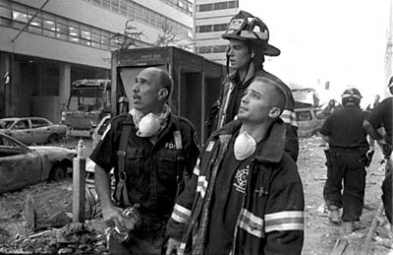
Part III An in-depth look at conspiracist claims about WTC 7
This section comprises excerpts from my Loose Change Viewer Guide, an update of which is a work in progress. I’ve deleted most of the first responder quotes, which we’ve seen above, but there may be some other duplication of information here.
Essential reading: NIST's WTC 7 Interim Report: http://tinyurl.com/klmvd
NIST’s final report on WTC 7 is due out in early 2007. Why hasn’t this report been completed? From the NIST FAQ:
When NIST initiated the WTC investigation, it made a decision not to hire new staff to support the investigation. After the June 2004 progress report on the WTC investigation was issued, the NIST investigation team stopped working on WTC 7 and was assigned full-time through the fall of 2005 to complete the investigation of the WTC towers. With the release and dissemination of the report on the WTC towers in October 2005, the investigation of the WTC 7 collapse resumed. Considerable progress has been made since that time, including the review of nearly 80 boxes of new documents related to WTC 7, the development of detailed technical approaches for modeling and analyzing various collapse hypotheses, and the selection of a contractor to assist NIST staff in carrying out the analyses. It is anticipated that a draft report will be released by early 2007.
The current NIST working collapse hypothesis for WTC 7 is described in the June 2004 Progress Report on the Federal Building and Fire Safety Investigation of the World Trade Center Disaster (Volume 1, page 17, as well as Appendix L), as follows:
- An initial local failure occurred at the lower floors (below floor 13) of the building due to fire and/or debris-induced structural damage of a critical column (the initiating event) which supported a large-span floor bay with an area of about 2,000 square feet
- Vertical progression of the initial local failure occurred up to the east penthouse, and as the large floor bays became unable to redistribute the loads, it brought down the interior structure below the east penthouse; and
- Triggered by damage due to the vertical failure, horizontal progression of the failure across the lower floors (in the region of floors 5 and 7 that were much thicker and more heavily reinforced than the rest of the floors) resulted in a disproportionate collapse of the entire structure.
This hypothesis may be supported or modified, or new hypotheses may be developed, through the course of the continuing investigation. NIST also is considering whether hypothetical blast events could have played a role in initiating the collapse. While NIST has found no evidence of a blast or controlled demolition event, NIST would like to determine the magnitude of hypothetical blast scenarios that could have led to the structural failure of one or more critical elements.
Announcement of NIST’s Award of a contract to ARA for failure analysis work on WTC 7: http://tinyurl.com/emnw4
Essential reading: FEMA’s WTC 7 report: http://www.fema.gov/pdf/library/fema403_ch5.pdf

There are glaring flaws with the idea that WTC 7 was brought down by explosives.
Many of these points will be examined in detail below.

The building suffered severe structural damage from the debris from the north tower collapse. Firemen described a gaping hole in the south face. We will see glimpses of south face damage through the smoke in photos below and will see clear images of the massive damage to the southwest corner.

No one reports having seen work that might involve the planting of demolitions charges. I’m not aware of anyone who has provided a rational explanation of how this work might have been done and remained unobserved, before, during, and after the building’s collapse. An employee of Solomon Smith Barney who worked in WTC 7 says,
I actually worked at WTC7 and was there on 9-11. From the minute the first plane hit the towers, WTC7 was getting hit with debris.
In fact, when I finally got down to the lobby 45 minutes later, we were all forced to leave through the back since so much debris had hit the building and blocked the entrance.
I also would love to have someone tell me how the 28-44th floors were wired for demolition, when we packed like sardines after the merger with Smith Barney and most floors had people on them 7 days a week. ( A few floors were trading floors so it was 24x7 and many worked 6-7 days a week), and I never saw one construction crew in my time there doing anything significant.
Why won't CT's talk to people who worked at WTC7? My friends and I who worked with at Salomon are eager to talk but I'm guessing you won't like the answers. http://tinyurl.com/n5xap

Some CTs contend that WTC 7 was demolished to conceal sensitive information that was stored there by some of its tenants. This is one of the silliest of all 9/11 CT claims. Sure: whenever I have information on my hard drives or documents that I don’t want anyone to get their hands on, I always wire my building with explosives, set it on fire, and blow it up. In addition, keep in mind that information was recovered from many computer hard drives found in the WTC rubble. http://tinyurl.com/nmgmc Investigators were keen to have this information, to trace any transactions that may have indicated foreknowledge of the attacks. As the 9/11 Commission report details, these transactions turned out to not have suspicious origins. http://tinyurl.com/k659n pg. 145-152
Fires raged uncontrolled on many floors for hours. Lack of hydrant pressure due to broken water mains left firemen nearly helpless to extinguish the blazes.

The building was visibly bulging and was making groaning noises: when a steel-framed building does that it’s in very serious trouble. Reports of the damage from firefighters inside and outside of the building are consistent.

Demolitions experts who saw WTC 7 collapse from nearby neither saw nor heard anything indicating an explosive demolition.

Nothing can be seen or heard in videos that resembles explosive charges going off before the collapse. See below.

Seismic data from multiple sources indicates that, as with the Twin Towers, the collapse of WTC 7 began slowly, completely unlike an explosive demolition but consistent with internal failures leading to global collapse.
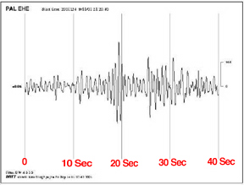
Source: Lamont-Doherty Earth Observatory
Any detonation of explosives within WTC 7 would have been detected by multiple seismographs monitoring ground vibration in the general area. No such telltale “spike” or vibratory anomaly was recorded by any monitoring instrument. –Brent Blanchard of Protec http://tinyurl.com/z6zyc

Explosive demolitions would not be very controlled, or likely to work at all, if they involved slamming tons of skyscraper debris through a building and then setting it on fire for seven hours. Precision explosives, timers, and wiring don’t like that sort of treatment.
Details of damage to WTC 7 from the tower collapses
NIST’s lead investigator Shyam Sunder weighs in on the damage to WTC 7:
Many conspiracy theorists point to FEMA's preliminary report, which said there was relatively light damage to WTC 7 prior to its collapse. With the benefit of more time and resources, NIST researchers now support the working hypothesis that WTC 7 was far more compromised by falling debris than the FEMA report indicated. "The most important thing we found was that there was, in fact, physical damage to the south face of building 7," NIST's Sunder tells PM. "On about a third of the face to the center and to the bottom--approximately 10 stories--about 25 percent of the depth of the building was scooped out." NIST also discovered previously undocumented damage to WTC 7's upper stories and its southwest corner. http://tinyurl.com/j7vrn
Note: According to theDecember, 2006 NIST presentation “WTC 7 Technical Approach and Status Summary,” NIST has updated its assessment of the south face damage. Details were not given.

Here’s the area of major debris damage from the tower collapses (source: FEMA)
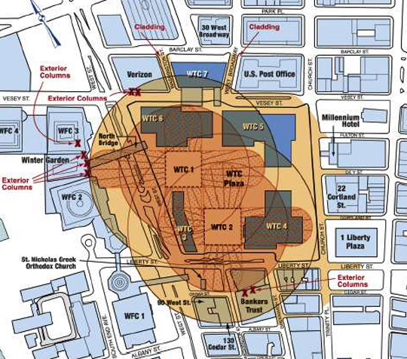

NIST’s Estimate of damage to WTC 7’s south and southwest sides
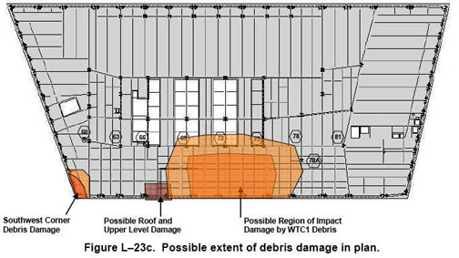
Note that the following two photos may correspond only to the relatively minor “Possible roof and upper level damage” described in the diagram above. They may not show what is believed to be more serious damage below.
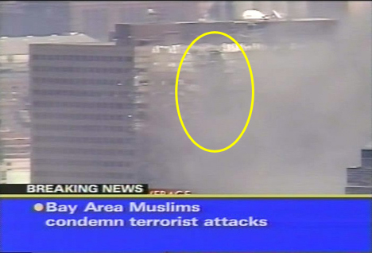

WTC 7 South face damage further down
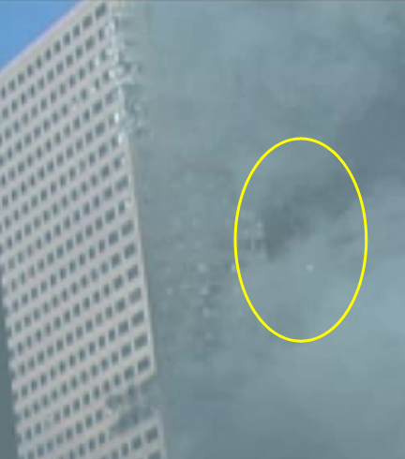
Still from video linked above.
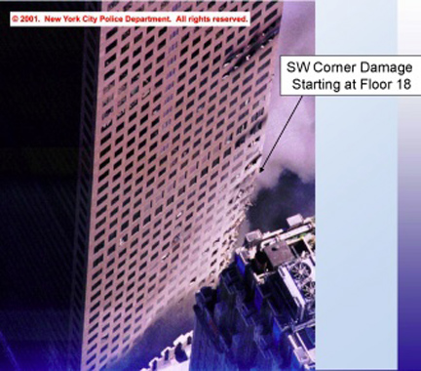
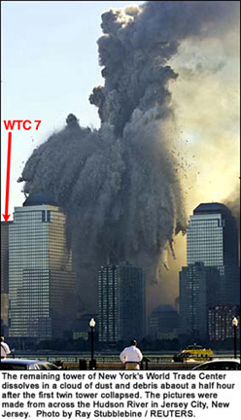
From the video September 11, 2001: What We Saw
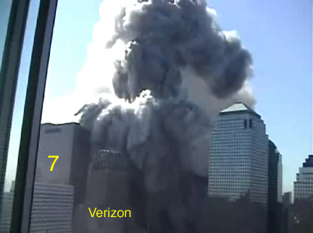

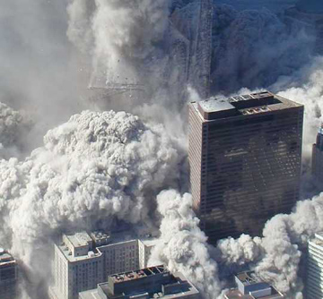

Looking south towards WTC 6 and 1. 7 is at left. Photographer is nearly 200 meters from WTC1.

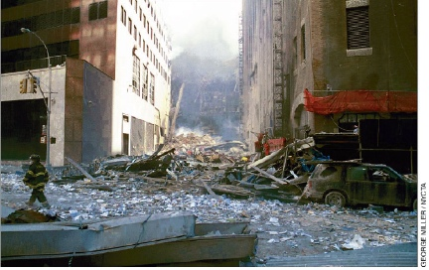

A closer look down Washington St. to WTC 6. WTC 7 stands at left, Verizon bldg. at right.
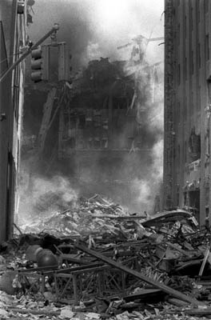
Shepard Sherbell

Photo taken directly in front of the south side of WTC 7, looking west, before it collapsed.
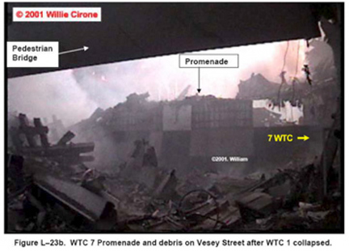
“Scholar for Truth” Steven E. Jones’ Thermite/Thermate Claims
A commonly repeated 9/11conspiracy theory is that an incendiary, thermite or thermate, rather than an explosive, was used to cut the huge steel columns, causing the WTC buildings to collapse. Steven E. Jones, a (former) physicist at Brigham Young University in Salt Lake City, and (former) co-chair of the 9/11 conspiracy-promoting “Scholars for Truth,” is the chief proponent of this theory.
In his paper “Why Indeed Did the WTC Buildings Collapse?” Jones shows a startling propensity for abandoning the scientific method in favor of jumping to unsubstantiated conclusions. As with his “evidence” that Jesus Christ visited the Americas (a Mormon tenet), in his 9/11 work Jones promotes faith over intellectual rigor.
For example, in this rambling defense of his theories, Jones cites an EPA report by Erik Swartz as evidence of the presence of thermite at the WTC: “Large amounts of 1,3 diphenylpropane strongly suggests the high-tech thermite arson used on the WTC buildings...” (bolding mine).
Swartz’s EPA report says nothing of the kind:
One molecule, described by the EPA's Erik Swartz, was present at levels "that dwarfed all others": 1,3-diphenylpropane. "We've never observed it in any sampling we've ever done," Swartz said. He said it was most likely produced by the plastic of tens of thousands of burning computers. http://tinyurl.com/rp7xg The report abstract is here: http://tinyurl.com/qvzd7
In it, Swartz says, “In addition, the compound 1,3-diphenylpropane- [ 1',1'-(1,3-propanediyl) bis-benzene] was observed, and to our knowledge, this species has not previously been reported from ambient sampling. It has been associated with polystyrene and other plastics, which are in abundance at the WTC site.”
Steven Jones claims to have found traces of thermate (thermite with a small amount of sulfur and a large amount of barium nitrate added) on a piece of steel from the WTC. This claim is baseless. Jones found some sulfur and other trace metals, and nothing could be less surprising. Sulfur-based drywall was the third most-used construction material at the WTC. Thousands of gallons of fuel oil containing sulfur was spilled beneath the rubble piles, along with numerous other sulfur-containing inflammables. Thermate typically contains only 2% sulfur, so if the sulfur Jones detected was from thermate, we would expect to see the reaction byproducts of its main ingredients, iron oxide, aluminum, and barium nitrate, in proportionally greater amounts. The qualitative chemical analyses performed on sulfidated steel from WTC 7, 1, and 2 shows no signs of the presence of the incendiaries Jones says were used. http://www.fema.gov/pdf/library/fema403_apc.pdf
Of course, no evidence of cuts made by thermate or thermite was found on a single piece of WTC steel.
NIST’s informative FAQ covers this issue (excerpt):
Separate from the WTC towers investigation, NIST researchers estimated that at least 0.13 pounds of thermite would be required to heat each pound of a steel section to approximately 700 degrees Celsius (the temperature at which steel weakens substantially). Therefore, while a thermite reaction can cut through large steel columns, many thousands of pounds of thermite would need to have been placed inconspicuously ahead of time, remotely ignited, and somehow held in direct contact with the surface of hundreds of massive structural components to weaken the building. This makes it an unlikely substance for achieving a controlled demolition. (bolding mine)
Analysis of the WTC steel for the elements in thermite/thermate would not necessarily have been conclusive. The metal compounds also would have been present in the construction materials making up the WTC towers, and sulfur is present [approx. 19% by weight] in the gypsum wallboard that was prevalent in the interior partitions.
An excellent paper by chemist Frank Greening discusses sources of sulfur at the WTC site and examines the sulfidation observed in some steel found in the debris pile: http://911myths.com/Sulfur.pdf
A common CT claim is that the angled column in the photo below is evidence of a cut made by thermite / thermate. Until recently this photo was prominently featured on the “Scholars for Truth” website and in Steven Jones’ papers. It still is featured on the page of another website promoting a debate challenge by the Scholars on teamliberty.net ( I have accepted the debate challenge, and as of this writing the debate the debate may be moved to my alma mater, Franklin Pierce College in New Hampshire.)
Had these CTs taken a minute to enlarge the photo, as I have done below, they would have seen that the column shows obvious blowtorch marks, and slag sitting on top of the loose debris. Ironworkers used oxyacetylene torches to cut the WTC steel.
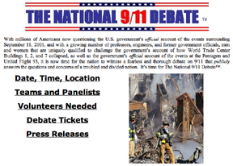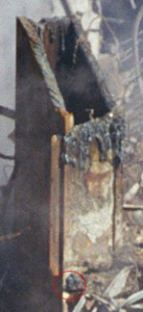
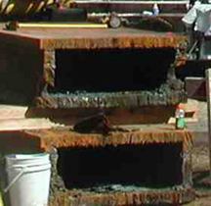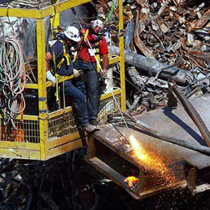
None of the hundreds of photos I have of Ground Zero show any sign of steel being cut by incendiaries or blasted by explosives. Thermite/thermate cuts vertically, with gravity. For example, the military uses thermite to disable materiel to prevent it being used by the enemy. A thermite grenade placed on the horizontal hood of a truck will melt straight down through the engine block.
Therefore, to attack a thick vertical steel column with thermite, a large, complex, and extremely durable (capable of withstanding temperatures of 4000 °F) apparatus would have to be attached to each column to hold the thermite against the steel throughout the cutting process. And equally durable ignition devices (timers / wiring / radio receivers: take your pick) would need to survive the aircraft impacts/debris impacts and raging fires, and work perfectly when needed.
The huge thermite/ate devices would have to be attached to many columns, for redundancy, because the “conspirators” would not know exactly where the planes or debris would hit. Obviously, it would be highly suspicious if the building collapses initiated in an undamaged area.
Needless to say, no such devices were found in the 1.6 billion pounds of debris that was meticulously sorted by FBI investigators and NYPD detectives at Fresh Kills Landfill, and no evidence of thermite/ate use at the WTC has ever been found. Professor Jones simply ignores the many possible sources of the trace chemicals he found on steel, and he neglects to mention that he did not find traces of some of the most common byproducts of thermite/ate. Nor does he have a chain of custody for this steel that would rule out other sources of contamination.
I’ve only delved this far into this subject to show how quickly the CT claims unravel when examined in the light of the facts. Thanks to “Huntsman” at the JREF forum for his enlightening posts regarding his military experience with explosives and incendiaries.
For now, perhaps we should leave the final word on this issue to Brent Blanchard of Protec, from his paper A Critical Analysis of the Collapse of WTC Towers 1, 2 & 7 from an Explosives and Conventional Demolition Industry Viewpoint:
Dr. Jones acknowledges that his investigation is still in the research phase and that questions regarding the viability of his theory remain unanswered. For example, it is unknown how thermite’s destructive process could have been applied and initiated simultaneously on so many beams – in several buildings – undetected and/or under such extreme conditions. It is also unusual that no demolition personnel at any level noticed telltale signs of thermite’s degenerative “fingerprint” on any beams during the eight months of debris removal. http://tinyurl.com/z6zyc

Silverstein reaps huge insurance profit on WTC 7?

What about an insurance motive? Professional conspiracist and radio host Alex "New World Order” Jones claims that Silverstein walked away with a profit of $500 million after building 7’s insurer, Industrial Risk Insurers, paid its $861 million policy!

This shouldn’t need to be said, but the fact that IRI didn’t dispute the $861 million claim should make it perfectly clear that Silverstein didn’t “admit” to destroying his building.

And lest you think that IRI’s management somehow benefited by turning a blind eye to Silverstein’s “crime,” consider that IRI did contest Silverstein’s lawsuit over his Twin Towers insurance claim.
No. Insurance companies have a funny way of making sure that insured parties don’t destroy their skyscrapers, collect the claims, and drive into the sunset with a truckload of cash. A clause in Silverstein’s WTC 7 policy required him to begin rebuilding within two years, and lenders required that the new building have as much square footage as the old (and they complained mightily when the plans came up short in that department). The cost of the new building? Over $700 million.
Hey, that still leaves Silverstein with a tidy profit of around $161 million, right?
No. There was the small matter of the existing $489.4 million mortgage, which Silverstein paid off with the insurance settlement, leaving him with a shortfall of $328 million heading towards construction of the new building.
The City of New York, desperate to see rebuilding begin downtown, saved Silverstein a bundle in financing costs by offering over $400 million in tax-exempt Liberty Bonds, which the Bank of New York guaranteed.
That move gave Silverstein and his backers the freedom to do something unheard of in recent New York real estate history: start construction of a skyscraper without a major (or minor) tenant on board. And when the building opened in 2006? Still no major tenants. In May, WTC 7 finally got its first possible major tenant when Moody’s Investor’s Service signed a nonbinding letter of intent to occupy 15 floors. More recently, other sizable tenants have signed on.

Sources: “Even as Construction Begins, a New Trade Center Tower Faces Obstacles” New York Times, January 16, 2003. “7 World Trade Center Gets a Major Tenant” Official World Trade Center Site The Building Everyone Will Date But No One Will Marry

Molten metal in the basement was caused by demolitions materials?

There is anecdotal evidence of molten metal in the basements of WTC buildings 1, 2, 6, and 7 in the days and weeks after 9/11. CTs often call this “molten steel,” although the metal in question was never tested and its composition is unknown. Infrared spectrometer readings taken shortly after the collapses showed temperatures near the surface of up to 1375 F: hot enough to melt aluminum. It was at least that hot at points within the pile that were away from the hottest zones. William Langewiesche, the only journalist who was allowed to go with the engineers in their explorations beneath the debris, writes in “American Ground: Unbuilding the World Trade Center” of a subterranean parking lot:
Along the north side, where the basement structure remained strong and intact (and was ultimately preserved), the fire had been so intense in places that it had consumed the tires and interiors, and had left hulks sitting on axles above hardened pools of aluminum wheels.
I don’t think the terrorists were placing thermate on the car wheels. It was simply that hot.
The presence of molten metals is not an indication of planned demolition work. Explosives do not produce pools of molten metal, and incendiaries like thermite burn themselves out in seconds even in the absence of oxygen and would not be available for weeks as fuel. A long-lasting source of fuel was available within the well-insulated piles: the contents of the buildings.
NIST weighs in on the “Molten steel” question:
NIST investigators and experts from the American Society of Civil Engineers (ASCE) and the Structural Engineers Association of New York (SEONY)—who inspected the WTC steel at the WTC site and the salvage yards—found no evidence that would support the melting of steel in a jet-fuel ignited fire in the towers prior to collapse. The condition of the steel in the wreckage of the WTC towers (i.e., whether it was in a molten state or not) was irrelevant to the investigation of the collapse since it does not provide any conclusive information on the condition of the steel when the WTC towers were standing.
NIST considered the damage to the steel structure and its fireproofing caused by the aircraft impact and the subsequent fires when the buildings were still standing since that damage was responsible for initiating the collapse of the WTC towers.
Under certain circumstances it is conceivable for some of the steel in the wreckage to have melted after the buildings collapsed. Any molten steel in the wreckage was more likely due to the high temperature resulting from long exposure to combustion within the pile than to short exposure to fires or explosions while the buildings were standing. http://tinyurl.com/pqrxt
In his paper “Why Indeed Did the WTC Buildings Completely Collapse” and in his lectures, Steven E. Jones says of the photos below, “Workers evidently peering into the hot ‘core’ under the WTC rubble.”
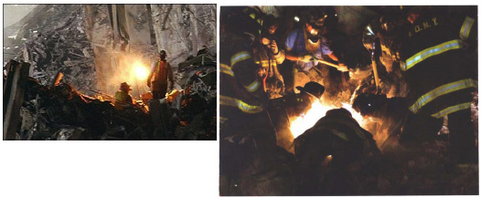
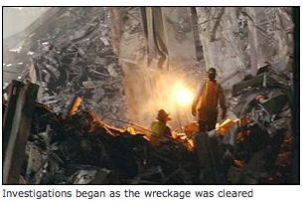
However, the photo at left depicts ironworkers using a blowtorch to cut metal at the base of one of the towers. The caption on the site where Jones found the photo indicates that it is of wreckage being cleared.
The photo at right does not depict workers with their faces over a hole that’s as hot as a steel furnace. That would kill them. The photo’s color has been altered. The firemen are attempting a rescue or recovery using artificial light.
Here’s the photo as it is supposed to look:
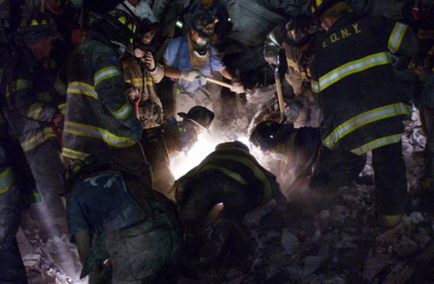

No evidence of explosives use on exterior columns
Contrary to some CT claims, the outer columns of WTC 7 that are visible in debris photos do not show signs of being sheared by explosives.
First, a photo that shows WTC 7 perimeter column construction.
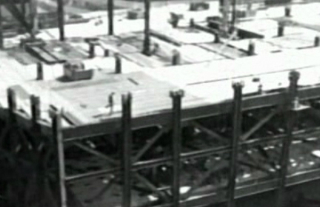

Now, how were those columns joined to make long vertical columns?
“Typical core column splices were shown on available erection drawings. The adjoining surfaces of columns were specified to be milled. The splice plates were welded to or bolted to the outsides of the column web and flanges. ...Perimeter column splices were similar to the core column splices. “ http://tinyurl.com/rmbsj

Here’s what was seen in building 7’s rubble pile:
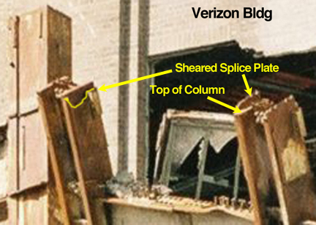

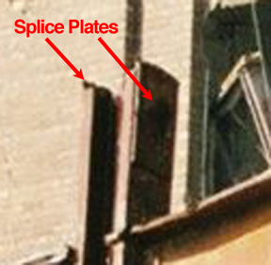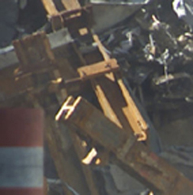
The columns separated at their splices. Nothing nefarious or mysterious going on here.

Did diesel fuel for WTC 7’s emergency generators feed the fires?
Short answer: we don’t know. Perhaps the final NIST report will shed more light on this issue, which is an important one.
Across the country, diesel-powered generators are used in buildings like hospitals and trading houses, where avoiding power outages is crucial. Partly for that reason, a definitive understanding of what happened in 7 World Trade Center is vital to investigators, said Jonathan Barnett, a professor of fire protection engineering at the Worcester Polytechnic Institute.
– “Diesel suspected in WTC 7 collapse” James Glanz, New York Times, November 29, 2001.
WTC 7 contained up to 43,000 gallons (162,273 liters) of diesel fuel for its emergency generators. It is believed that at least some fuel pumps did kick on after the Con Edison power plant went down at 9:59 (see FEMA, NIST reports), perhaps fueling the fires, although this remains speculation.
7,000-gallon tankers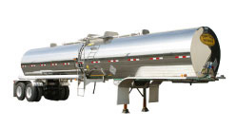
Controlled demolition of a building that’s damaged and engulfed in fire?
How would conspirators know that WTC 7 was going to be hit by huge amounts of debris from WTC 1? After all, they couldn’t just blow up a building that was standing there for seven hours unharmed, right? Just look at how 130 Liberty Street (Banker’s Trust / Deutsche Bank) was hammered by debris from WTC 2 and received an 18-story gash, but only had small fires (Its damage was not as severe as that done to WTC 7, but it was severe enough that the building is being torn down).
Aha! CTs reply with the explanation that fires were set in building 7 as “cover” for the demolition operation. As mentioned above, this makes no sense whatsoever. If CTs want to claim that the WTC demolition looked just like a controlled demolition (CD), they cannot also claim that it did NOT look like a CD.
In addition, claiming that the fires were set to throw investigators off the track of the real cause of WTC 7’s collapse is to admit that fires can bring down steel buildings. They can, and do, all the time. I suggest that doubters look into the Kader Industrial Toy Factory fire of 1993, in which three large multistory (un-insulated) steel-framed buildings quickly collapsed, without being severely damaged beforehand. http://tinyurl.com/l8qz2
A building prepped for controlled demolition. The yellow lines are detonation cord.
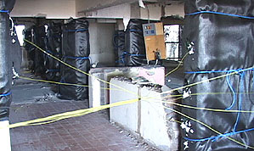

The “No modern steel skyscraper” argument
“But wait a minute!” cry the CTs. “Before 9/11, no modern steel-framed skyscraper had ever completely collapsed due to fire!”
To which I reply: every modern steel-framed skyscraper that was subjected to these conditions has completely collapsed:
- Severe structural damage.
- Damage to the thermal protection on its structural steel.
- Enormous uncontrolled fires on multiple floors.
According to NIST, those are the three interdependent reasons that the Twin Towers collapsed. If any one of the three conditions didn’t exist, NIST says that the towers probably wouldn’t have fallen. As mentioned earlier, NIST’s final report on WTC 7 is due out in 2007.
Can office fires cause large steel columns to buckle?
The CT’s aren’t convinced yet. “Office fires, even if they’re started by jet fuel, can NOT get hot enough to cause huge steel columns to buckle!” (If the CTs have a mantra, it is this. Actually, they almost always use the strawman statement “to melt steel.”)
CTs, you are dead wrong.

In WTC Building 5, this large column and beam buckled
on floor 8 of 9. The fire was fueled by office materials only.
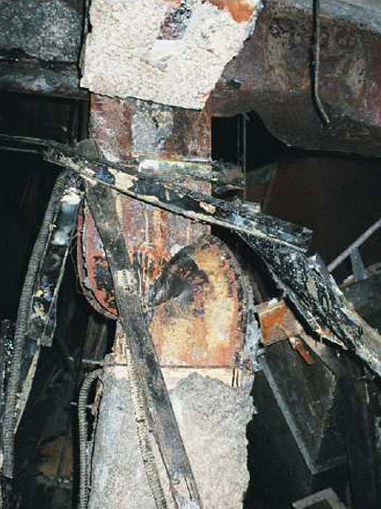
Source: FEMA report on WTC 4, 5, and 6, page 15. http://tinyurl.com/m489x
Imagine if this floor had also been hit by an airliner traveling at 400-500 knots, destroying and weakening surrounding columns and blasting the fire protection off the steel. Now imagine another 200 million pounds (90,718,000 kg.) of building resting on this damaged foundation.
Another way of looking at this is, if office fires can’t get that hot, why is it the law in New York City that all steel-framed buildings over 1 story tall must have fire resistant coatings applied to their structural steel? http://tinyurl.com/j2abl

Jonathan Barnett, PhD, a fire protection engineer who investigated its collapse, says of WTC 7,
“It doesn’t take that much fire protection to be removed for the steel to fail.”
–The History Channel: Modern Marvels: Engineering Disasters #13

As Frank Brannigan states in his Building Construction for the Fire Service text, there are still some misconceptions that steel construction and steel buildings are safe when attacked by fire. This is as far from the truth as you can imagine. http://tinyurl.com/fw69y

Below: missing fire protection and fire-induced buckling on a 23rd-floor column at 90 West St. This 9/11 fire was fueled by office contents only. Fire was fought and extinguished using lines run from a fireboat on the Hudson River. Columns on the on the 8th floor also buckled.
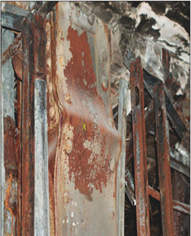
Source: FEMA

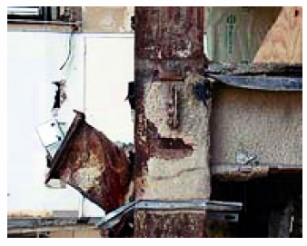
Fire protection knocked off column & beam inside 130 Liberty St. by debris from the south tower. WTC 7 & 130 Liberty may have sustained similar damage, but the latter had only minor fires in its basement, which were extinguished.

Relatively small proportional losses of fire protection material are required before significant reductions in fire resistance are realized.
–From abstract, “A study of the effect of partial loss of protection on the fire resistance of steel columns.” Fire Technology, Feb. 2005 (Full article is purchase only)
Steel without thermal protection can fail extremely quickly in a fire:
One of the most common structures today is the strip mall built with steel bar joists and metal deck roofs. A serious fire in one of these structures should be expected to produce roof collapse in as little as 5 to 10 minutes. Firehouse.com Sept. 1998
But protected steel, even without prior structural damage, presents its own hazards:
Class 1 (fire-resistive) buildings typical of high-rise construction usually are designated as having three- or four-hour fire resistance ratings. In the past, that was taken to mean that they would never be a serious collapse threat. While this is usually the case in the completed structures, it is not a guarantee, particularly in the steel-framed high-rise that relies on some type of spray-on or membrane fireproofing to protect the steel. The 1 Meridian Plaza fire in Philadelphia proved that these can be severe dangers under the wrong set of circumstances. Firehouse.com Sept. 1998

To advertise their products, the Concrete Alliance uses the example of Madrid’s Windsor Building fire, in which all the structural steel in the fire-affected area collapsed, leaving the concrete core standing. Fire protection for the Windsor’s structural steel was in the process of being upgraded, but that work had not reached the upper levels. Arup, the fire protection engineering firm, says that the steel would likely have failed even if it had been fire-protected.

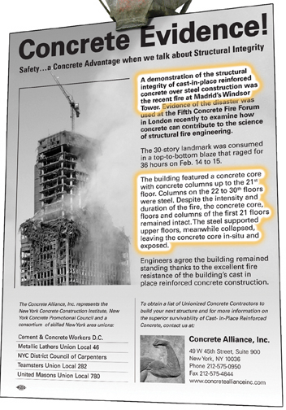
How absurd are the CT arguments? CTs often use the Windsor Building to support their claim that the WTC buildings should not have collapsed, completely ignoring the fact that fire destroyed the Windsor’s steel. The WTC buildings had cores of steel, not concrete.
Features of the new WTC 7
Besides the fact that it is the first NYC skyscraper to be LEED “Green” certified, there are two notable features of the new, 52-story WTC 7: a concrete – not steel – core that houses the safety systems, stairwells, etc.; and very thick fire resistant coating on its structural steel.
I took the following photos on the 45th floor of the new WTC 7 in September, 2006
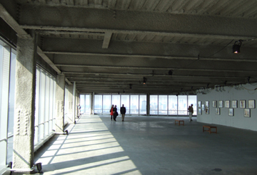

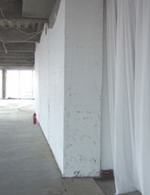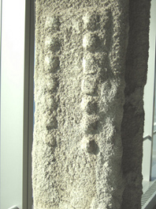
Concrete Core Sprayed-On Fire Resistant Coating
More about the fire-resistive coating in the new WTC 7: http://www.na.graceconstruction.com/custom/toplevel_pages/featured_articles/pdf/Fire-resistive_materials.pdf

Some links to studies and examples of the behavior of structural steel in fires,
and to reports recommending ways to improve structural fire safety.
Unprotected steel fails in Madrid's Windsor Building fire, concrete core stands.
Three multistory steel-framed factory buildings quickly collapse due to fire
Unprotected steel truss roof quickly fails in fire at McCormick Place, Chicago
Fire damage to protected steel in One Meridian Plaza, Philadelphia
Noises in steel buildings during fire equals danger!
NIST: Fire Protection of Structural Steel in High-Rise buildings (white paper)
Underwriters Labs post-9/11 WTC fire testing, ASTM E119 standard
The discipline of structural fire protection after 9/11
Performance of unprotected steel and composite steel frames exposed to fire (Master's Thesis)
Effect of Support Conditions on Steel Beams Exposed of Fire (Master's Thesis)
Fire safety engineering forum (numerous papers)
Eurocode: Introduction to Structural Fire Engineering (Powerpoint presentation)
Determination of fire induced collapse mechanisms of multi-story steel framed structures
Some interesting thoughts on WTC fire protection, steel vs. concrete, redundancy, new materials
Restrained fire resistance ratings in structural steel buildings
Fire Protection Engineering: The future of fire simulation at NIST
NIST early WTC fire simulation experiments and photos
(Posted again) NIST WTC 7 Interim Report June, 2004
FEMA Report 403, Appendix C: Limited Metallurgical Examination of WTC Steel
NIST best practices for reducing the potential for progressive collapse in buildings (draft)
NYC Dept. of Buildings WTC Task Force recommendations report
NIST NCSTAR1-1C Maintenance and Modifications to WTC 1, 2 &7 Structural Systems
Links to several fire studies from Peter, an architect with experience in designing high-rises
WTC 7 fell into a “tidy pile” in its own footprint?
What about the claim that only a controlled demolition could cause building 7 to fall into such a “tidy” pile? This comes up often, and it’s wrong in several ways. First, it’s wrong to say that this claim describes a “controlled demolition.” That’s the term CTs use, and it’s inappropriate. A true controlled demolition is done to minimize damage to surrounding structures. Next, here’s the “tidy pile” created by the collapse of WTC 7:
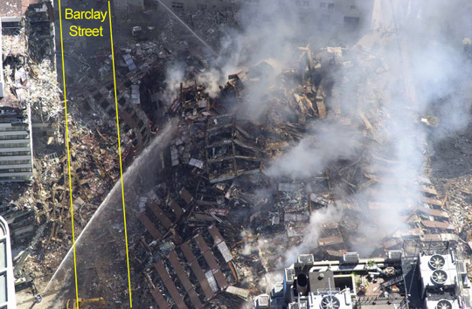
WTC 7 ravaged 30 West Broadway to the north, which is being torn down in 2006 due to the damage.
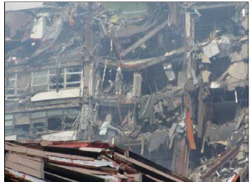
30 West Broadway, damaged by the collapse of WTC 7
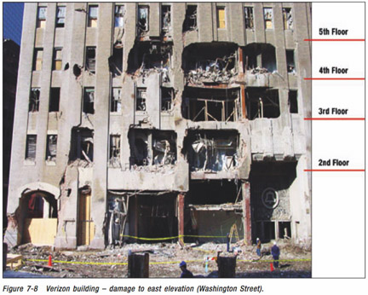

Damage to Verizon Building from WTC 7. Source: FEMA

Below: Looking east along Barclay St. from Washington St. Some street clearing had been done. Most of WTC 7 is at right.
Note how high the debris is piled against 30 W. Broadway at left.

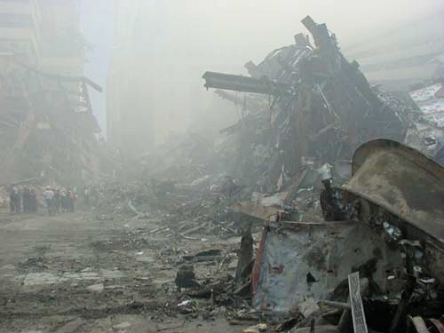
Did the collapse of WTC 7 resemble a controlled
demolition to observers on the scene?

The video Loose Change quick-cuts between WTC 7 collapsing and a building being demolished.
This building is the Beirut Hilton. Play the original video with your computer’s sound on and find out why the creators of Loose Change don’t want you to hear the audio: http://tinyurl.com/oufj3

Watch and listen to another demolition, Schuylkill Falls Towers: http://tinyurl.com/j8mdy
And another: Landmark Tower demolition http://tinyurl.com/fmf9e
And another: Southwark Towers, Philadelphia: http://tinyurl.com/qr2x8

In each case we hear the initiation charges, then the larger primary charges. Keep in mind that the buildings above underwent extensive structural weakening before their demolition. Absent such weakening, using explosives to bring down the WTC buildings would require charges of far greater magnitude. The use of such explosives would have been immediately apparent to everyone in the area, as well as to audiovisual and seismic recording equipment.
No explosive sounds like these were reported or recorded when WTC 7 collapsed.

Here’s an audio clip from a NYC news radio interview with a medical student who saw WTC 7 collapse and describes what it sounded like. http://tinyurl.com/q6xr4

What about those “explosive squibs” coming from WTC 7 on video?
Steven E. Jones, among others, promotes that idea, and it’s as silly as 9/11 conspiracy claims get.
Squibs (horizontal puffs of smoke and debris) are observed emerging from WTC-7, in regular sequence, just as the building starts to collapse. (SEE: http://tinyurl.com/7drxn) Yet the floors have not moved relative to one another yet, as one can verify from the videos, so air-expulsion due to collapsing floors is excluded. I have personally examined many building demolitions based on on-line videos, and the presence of such squibs firing in rapid sequence as observed is prima facie evidence for the use of pre-positioned explosives inside the building. ...I conclude that the evidence for pre-positioned explosives in WTC 7 (also in towers 1 and 2) is truly compelling. http://tinyurl.com/jpe9s
I encourage everyone to read the whole page from which the Jones quote is taken. But don’t play “spot a false statement: drink a shot of Jack” – you will die. Jones’ “observations” and conclusions wouldn’t pass muster if they came from a junior-high school student. Note in particular his “experiment” in which he drops a block of concrete on another from a height of 12 feet and concludes that it’s “nonsense!” that concrete could pulverize when a billion-pound, quarter-mile high building crashes down! Can Jones, a physicist, possibly be that ignorant? Is he putting us on?
Here’s a still from the cropped, low-quality video that Jones wants us to see (http://tinyurl.com/7drxn)
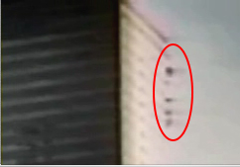
Is there some reason that Steven Jones doesn’t want us to see a good quality video of this event, which is just as easy to find on the internet as a poor-quality video? Judge for yourself: http://tinyurl.com/qbvl6
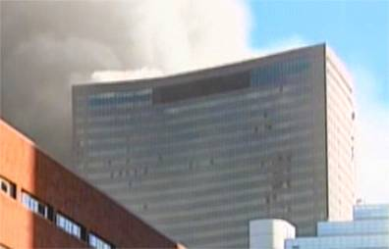

There are a few things that Jones neglects to show us with his highly selective video:
- That the area where Jones sees “squibs” was already badly damaged and open to the elements. Smoke, loose debris, and window and façade panels may all show movement in that area during collapse.
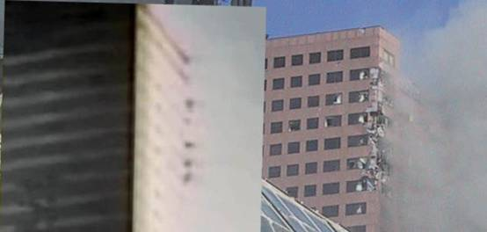
Comparison courtesy http://www.debunking911.com/
- That absolutely no explosive blasts are coming out of the building as Jones claims.
- That the “squibs” somehow stick to the side of the building.
- That the “squibs” appear 10 seconds after the collapse of the east penthouse began.
- That a huge smoke cloud is coming from WTC 7’s south and east sides and blowing southeast.
- That windows and granite panels are cracking all over the building. Remember this quote from above: “As we were walking, we had to actually get a little closer to Seven. So we turned and looked at Seven, and that's when all the marble siding started popping off the side because it was starting to go down.” –Firefighter Thomas Donato
- That the entire roof of the building has already fallen due to loss of support from below – first the east penthouse, then the center, then the west, just prior to global collapse. So much for the floors not moving “relative to one another.”
I’d love to hear Jones explain why he thinks the crack WTC 7 demolition team chose to plant a few “charges” in the southwest corner of the building...at the top.
In Jones’ presentations to live audiences, he actually uses the Southwark Towers demolition video linked above, which shows huge, high-velocity jets of debris shooting out before the buildings collapse. WTC 7 looks nothing like that. What does Jones omit from that video? The audio, of course.
One thing I’ll give Steven Jones credit for: an elegant demonstration of the conspiracist modus operandi :
Download a single poor-quality video of an event.
Crop and enlarge it.
Remove the audio.
Completely misinterpret it and ignore evidene that’s contrary to your claims.
Declare your observations “compelling” and “science-based.”
Have your “work” cited by numerous “truth-based” organizations.
Start a club for the dissemination of your wisdom.
Start a website for the “publication” of your findings, because they won’t pass peer review.

Demolitions experts saw WTC 7 fall, say no sign of explosives

Whom should we ask to find out if WTC 7’s collapse resembled an explosive demolition? How about asking the explosive demolition experts who were on the scene on 9/11?

Brent Blanchard of Protec:
Several demolition teams had reached Ground Zero by 3:00 pm on 9/11, and these individuals witnessed the collapse of WTC 7 from within a few hundred feet of the event.
We have spoken with several who possess extensive experience in explosive demolition, and all reported seeing or hearing nothing to indicate an explosive detonation precipitating the collapse.
As one eyewitness told us, "We were all standing around helpless...we knew full well it was going to collapse. Everyone there knew. You gotta remember there was a lot of confusion and we didn't know if another plane was coming...but I never heard explosions like demo charges. We knew with the damage to the building and how hot the fire was, that building was gonna go, so we just waited, and a little later it went." http://tinyurl.com/m5kf5

Video including east mechanical penthouse collapse
CTs often show video from street level and remark about how quickly the building fell (6.6 seconds, according to an estimate by BYU professor Steven E. Jones and his students, although since much of the collapse is obscured by other buildings and by the dust and smoke thrown up by WTC 7, it’s impossible to tell exactly when the collapse ends).
However, in this video http://tinyurl.com/z66rz (download and play it in full-screen mode) it’s obvious that the collapse takes at least 13.5 seconds from the first movement of the east mechanical penthouse, a structure about 115 x 130 feet (35 x 40 meters) in area, until it disappears behind the foreground buildings. NIST and FEMA posit that the penthouse collapse was due to collapses on floors at the lower levels.
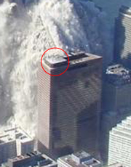

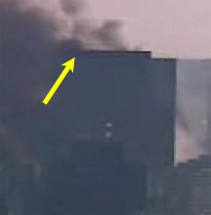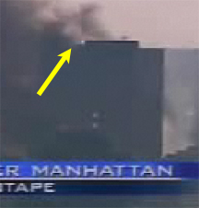
Videos of smoke billowing from the south side of WTC 7

Just as they choose to ignore the mountains of evidence that contradict their theories, 9/11 conspiracy buffs hate to show the south side of the WTC 7, which shows smoke billowing out of nearly every visible floor.
If you still think there wasn’t an inferno in WTC 7, click here: http://tinyurl.com/f3tvd
And here: http://tinyurl.com/zg4un

WTC 7, late afternoon, from behind the WFC From West & Vesey Streets, Verizon bldg. at left.
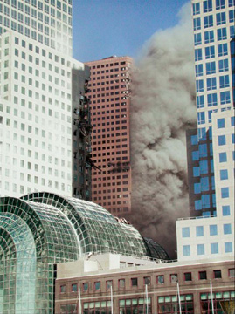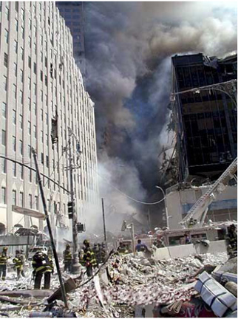

MSNBC Video: “What we’ve been fearing all afternoon...”
In another video clip, Ashleigh Banfield of MSNBC is interviewing a woman when WTC 7 collapses in the background. Banfield: “This is it!” Newsman Brian Williams: “What we’ve been fearing all afternoon has apparently happened. We’ve been watching number 7 World Trade, which was part of the ancillary damage of the explosion and collapse of the other two.” Watch it here: http://tinyurl.com/o58sa

We’ve now read many reports from professionals on the scene about the condition of WTC 7. All of these firsthand reports are in agreement that the building was in imminent danger of collapse due to the damage and fires it sustained. We’ve also seen that WTC 7’s collapse did not look or sound like an explosive demolition, and we’ve seen still photos and videos that show an immense amount of smoke pouring from the building’s south and east side. We’ve seen evidence that contradicts the claim that specific WTC 7 steel showed signs of being cut with explosive charges, and we’ve read the opinion of NIST about the plausibility of using thermite or thermate do destroy the building. Finally, we’ve (hopefully) read the NIST’s interim report on WTC 7 to better understand how the building was constructed and why it may have collapsed as it did. Here’s the report again: http://tinyurl.com/klmvd

Conspiracist Claims Revisited: Steven Jones, Dylan Avery, Les Jamieson
To close this chapter, let’s take a look at how the condition of WTC 7 on 9/11 is represented by CTs, and how they incorporate the evidence that I’ve presented above. I’ll focus on the claims made by Steven E. Jones, because other CTs believe his science credentials give him credibility in this area; by Dylan Avery, writer and director of the most popular 9/11 CT video, and by the group NY911truth.org, because I‘ve heard hundreds of their claims in person.

In his February, 2006 presentation at Utah Valley State College, Dr. Jones spends a good deal of time discussing WTC 7’s condition and playing videos of its collapse. Here’s a slide he uses as an overview. Keep two things in mind here: Jones is a scientist who surely must know how the scientific method works, and Jones presents this as being representative of WTC 7’s condition:
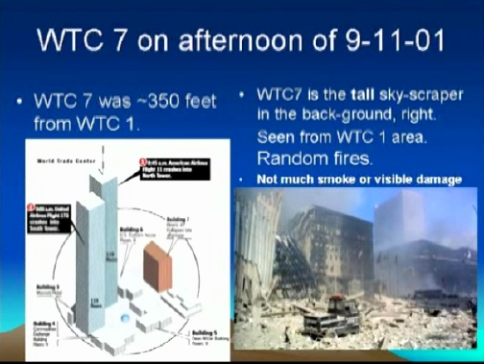
Above the photo it says, “Not much smoke or visible damage.” First, this photo was not taken in the afternoon from the area of WTC 1, as Jones claims. It was taken in the morning, shortly after the towers collapsed, from Church Street at the southeast corner of the site, as far from WTC 1 as it’s possible to be and still be in view of the site. How can we tell it’s a morning shot? The sun is strong on WTC 7’s east face, and the south face is in shadow. Debris from tower 2 is at left, WTC 4 is at center, and WTC 5 is at right. Why does this anger me? Because, as we read in the eyewitness accounts, the fires in WTC 7 did not spread extensively until the afternoon. Steven Jones deliberately chose a photo that was taken before WTC 7 was heavily involved with fire.
Once the fires developed, according to eyewitness accounts I’ve compiled (Those who claimed to be sure of the floors where they saw fire) and those cited in the NIST investigation, flames were seen on at least 14 floors: 3, 4, 6, 7, 8, 9, 11, 12, 13, 17, 21, 22, 29, and 30.

Steven Jones continues about WTC 7:
“It's not an inferno, certainly.”
“Fires were random, not particularly large, and certainly not an inferno.”
“Here in this photo you see the fires in building 7. A close-up and you see a little bit of fire in there. Not much.”
“Now here are photos seen in the late afternoon. Not a lot of fire here, or damage.”

What does Jones display to prove these assertion? A photo of the NORTH side of WTC 7. Here it is in the late afternoon, with the red border:
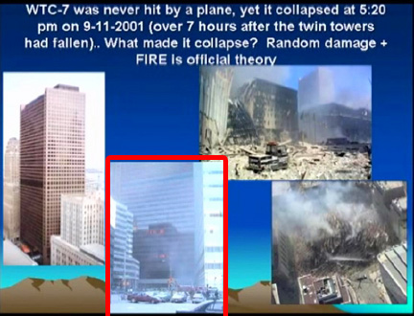

At about the same time, the south side of the building looked like this:
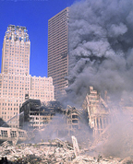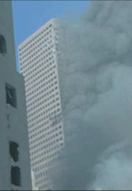
Steven Jones, scientist and Mormon, is deliberately misrepresenting the events of 9/11.

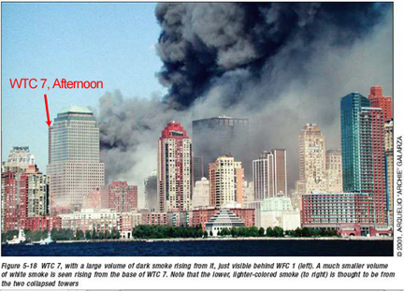
Again, the videos of WTC 7 burning are far more impressive than the still photos above: http://tinyurl.com/f3tvd http://tinyurl.com/zg4un

Update: as of September 7, 2006, Steven Jones has been removed from his teaching position at BYU (after classes had started for the new semester). He is on paid leave pending investigation into the nature and legitimacy of his 9/11 claims. Update 2: Jones has elected to take early retirement from BYU.
"BYU has repeatedly said that it does not endorse assertions made by individual faculty," the statement said. "We are, however, concerned about the increasingly speculative and accusatory nature of these statements by Dr. Jones."
"BYU remains concerned that Dr. Jones' work on this topic has not been published in appropriate scientific venues," the university statement said.
"It is a concern when faculty bring the university name into their own personal matters of concern," she said. http://tinyurl.com/g3ugq

In addition, in August the Scholars for Truth’s (ST911.org) membership secretary left the organization after making accusations of improper behavior against Steven Jones and Jim Fetzer. An excerpt from a scathing email she sent:
What this means is that Jones is perfectly willing to LIE about credentials to pad the roles of ST911, and Fetzer is perfectly willing to ACCOMMODATE those lies even after he has been informed in no uncertain terms that that is EXACTLY what they are.
This puts in stark relief the noteworthy lack of integrity that informs the work of ST911. That is, if there is not even an INTENTION to maintain integrity in the membership roles, how can anyone trust there is integrity anywhere else? As I have said more than once, Scholars for 9/11 TRUTH cannot succeed when founded on a pack of LIES.
The entire email, with responses from Fetzer, is here: http://tinyurl.com/makgr

* * * * * * *
Dylan Avery, writer and director of Loose Change, in an interview on The Edge AM radio, May 13, 2006:
“The strongest piece of evidence I would have to say would be the collapse of World Trade Center building 7. This was a 47-story office building, 300 feet away from the north tower. At 5:20 p.m. on September 11th this building fell straight down into its own footprint in six seconds, which if you do the math, is basically in absolute free-fall.
I’ve shown that to be false.
I mean, this was a controlled demolition. I mean, there's no way of avoiding it, I mean, the simple fact is, how could al Qaeda, or anybody else, have rigged building 7 for controlled demolition, which is a process that takes months of planning?
Excellent question. Avery just needs to take the next mental step.
“...Barely even in the damage range...It wasn't hit by a substantial amount of debris.”
I’ve shown that to be false.
Dylan Avery, in an interview on Black Ops Radio, May 14, 2006, explaining what facts are on his “side”:
Galileo's Law of Falling Bodies, Building 7, the Pentagon, basically, the obvious physical and scientific evidence that nobody can refute.

Korey Rowe, producer of Loose Change, interviewed on Air America Phoenix, April 15, 2006:

Caller: What is the objective to be accomplished by placing bombs in the towers, other than a complete collapse, if plane impacts are sufficient to be considered an attack on America, the justification for war?

Rowe: Well, supposedly those bombs weren't there. According to the official version, there was never any charges placed inside the World Trade Center. And it's a question of why they would they be in there, and why you would want to bring down the World Trade Center themselves. I mean, the World Trade Center was built in 1973 with asbestos and other dangerous materials that aren't allowed in today's building world. I mean, they received numerous citations to clean up the buildings. And to clean up those materials would have cost over a billion dollars. So, I mean, yes, running planes into the buildings would have been sufficient enough as an attack, but it wasn't the overall goal of Larry A. Silverstein, who owned WTC Building 7 and leased the rest of the buildings. It wasn't enough for him. I mean, now he's got prime real estate in downtown Manhattan, and after a 220 million investment turned into a two billion dollar profit.

Utter hogwash. The WTC buildings were highly profitable. And by the way, WTC 7 opened in 1987, and did not use asbestos for fireproofing.
* * * * * * *
Here’s how WTC 7 is presented in the literature that’s handed out to thousands of people at Ground Zero by NY911truth.org. I’ve highlighted some of the false and misleading statements.
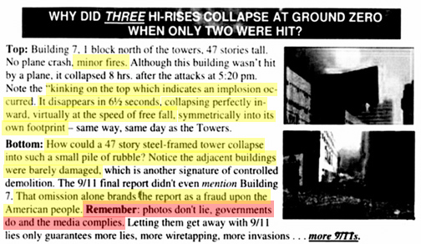
I count 9 false statements, several misleading statements, and several logical fallacies in that small selection.
Note the bottom picture on the pamphlet, which Les Jamieson, the author of the pamphlet, says depicts the “small pile of rubble” left by the collapse of building 7. And note the indignant phrase “photos don’t lie, governments do...” Well, we’ve seen that photo before:
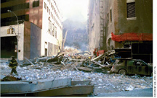
WTC 7 hasn’t collapsed. It’s standing at the left. The rubble is from WTC 1 and 6. Governments do lie, and so does the “Truth” movement. They want you to believe that WTC 7 collapsed into a pile eight feet high. When I pointed out this egregious error to Les Jamieson at Ground Zero (although I had already done so in May in my written critique of his pamphlet), he denied that he had used this photo, because “I know what photos I put in my literature.” Then Abby Scott pulled out his pamphlet and showed him. New pamphlets have since been printed.

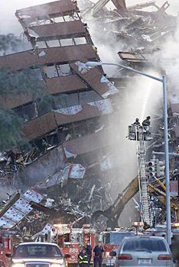
We’ve already seen an aerial view of the “small pile” left by WTC 7 and the damage it did to 30 West Broadway. Here’s a view from the ground. Keep in mind that WTC 7’s basement was 5 stories deep.

As for the crackpot contention that the 9/11 Commission report is invalidated because it didn’t mention building 7, why should it have? The Commission was empanelled to determine why the attacks happened, how they could have been prevented, and to make recommendations to prevent future attacks. Theirs is not an engineering report, and it does not discuss ancillary damage to buildings.

The accusation that the 9/11 Commission suspiciously avoided mentioning building 7 seems to have been popularized by theologian David Ray Griffin in his book The New Pearl Harbor. It is often mindlessly repeated by CTs. Here’s “Scholars for Truth” co-chair Jim Fetzer, from the Alan Colmes show quoted above: “The 9-11 Commission for example, was so blown away by Building 7 they don’t even mention it in their report.”

Remember that top experts in the relevant disciplines continue to gather as much knowledge as possible about WTC 7’s collapse. Their final report is expected to be complete in early 2007.

* * * * * * *

One last time, for the leaders of the “Truth Movement”:

FDNY Chief of Operations Daniel Nigro, on WTC 7:
The biggest decision we had to make was to clear the area and create a collapse zone around the severely damaged building. A number of fire officers and companies assessed the damage to the building. The appraisals indicated that the building’s integrity was in serious doubt.

* * * * * * *

“For my part, whatever anguish of spirit it might cost, I am willing to know the whole truth; to know.. it -- now.”
Excerpt from Patrick Henry’s “Give me liberty or give me death” speech,
misquoted by Steven E. Jones in “Answers to Questions and Objections”

Conspiracists, the evidence is before you, as it has been for years. Arguments from incredulity will never bolster your claims. You have a choice to make. You can draw conclusions by rationally reviewing all the available evidence, or you can continue making baseless, irresponsible, cruel accusations. Which will it be?

Won’t it feel good to once again show respect for the people who would enter the maw of hell to save you? Do they deserve anything less?

Consider this: if you were falsely accused of a serious crime, wouldn’t you insist that rumor, innuendo, and pandering to fear be rejected as evidence against you?

If so, then hold yourselves to that standard and reject the fear-mongering and falsehoods of Alex Jones, Les Jamieson, Loose Change, Steven Jones, and others who disdain standards of evidence, expertise, and rational thought.

These “Truth Movement” leaders have become what they say they are fighting against: people who lie for political reasons.

– Mark Roberts

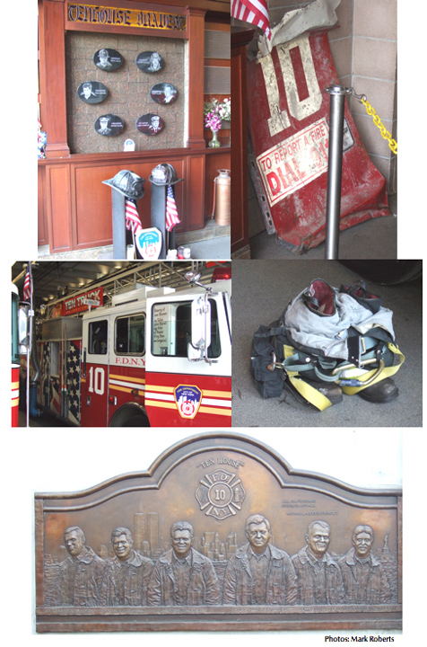
FDNY Ten House, across Liberty Street from the World Trade Center
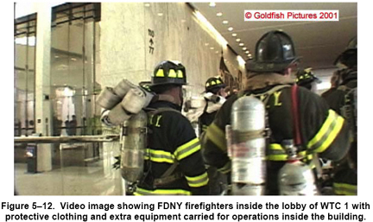
Source: NIST NCSTAR 1-8

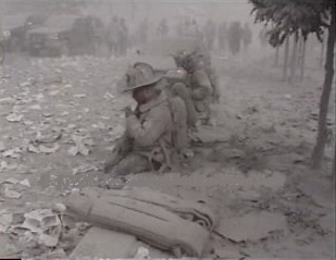

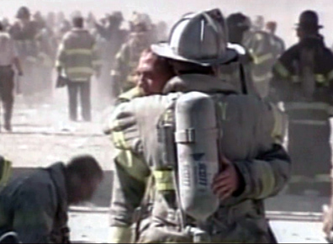

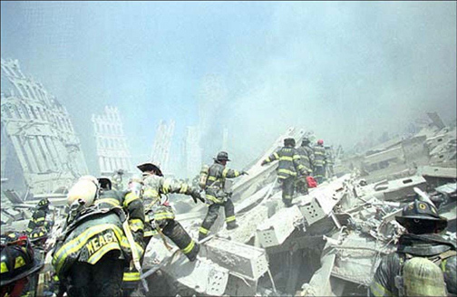

FDNY fatalities from the terrorist attacks of 9/11 page 1 of 3

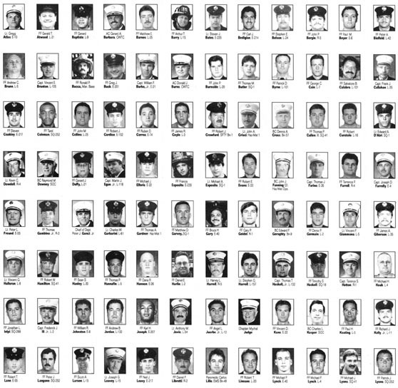

FDNY fatalities from the terrorist attacks of 9/11 page 2 of 3

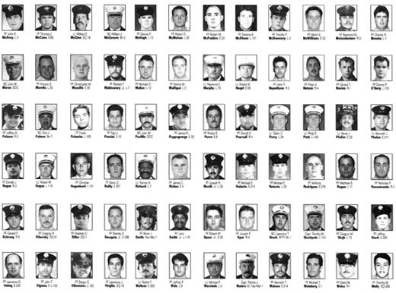

FDNY fatalities from the terrorist attacks of 9/11 page 3 of 3

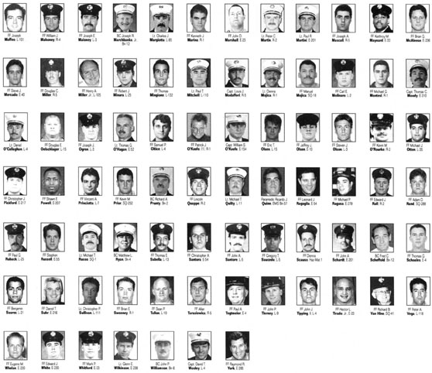

NYPD fatalities from the terrorist attacks of 9/11

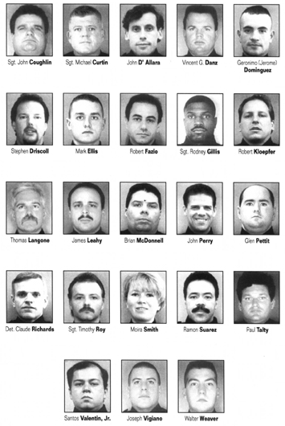

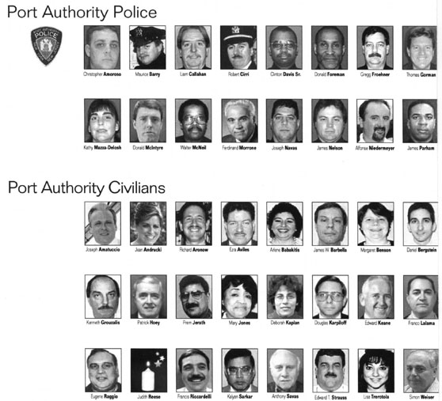

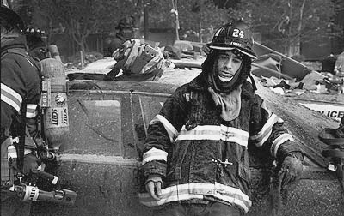
Neville Elder

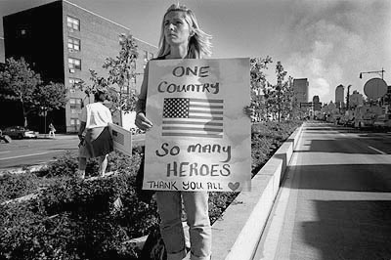
Neville Elder
Appendix

Eyewitness Accounts of the Condition of WTC 7 on 9/11/01
 |  | Specifics |  |  |  | Mentions
 |  | About | Mentions | Mentions | "Pull" = | Collapse
EYEWITNESS | TITLE | 7 Fires | Damage | 7 pullback | Withdraw | Expected

Banaciski, Richard | Firefighter FDNY | 1 | 1 | 1 | 2
Banfield, Ashleigh | MSNBC-TV Reporter |  |  |  |  | 1
Beltrami, Dean (see note) | Firefighter FDNY |  |  |  | 1
Bergman, Christopher | P.O. PAPD |  |  | 1
Blaich, Peter | FDNY Firefighter |  |  | 1 | 1
Boyle, Chris | FDNY Captain | 1 | 1 | 1 | 1
Brandies, Butch | FDNY Firefighter |  | 1 | 1
Burke, Timothy | Firefighter FDNY |  |  |  |  | 1
Cahill, Joseph | Paramedic (E.M.S.) |  |  | 1
Carbonaro, Daniel | Lt. PAPD |  |  | 1
Cassidy, Tiernach | Firefighter FDNY | 1 | 1 | 1
Castellano, Pete | Firefighter FDNY |  |  | 1
CBS-TV News Reporter | http://tinyurl.com/ebtoy |  | 1 |  |  | 1
CBS-TV reporter | http://tinyurl.com/jlwx7 | 1 |  |  |  | 1
Protec Bldg 7 Witnesses | http://tinyurl.com/m5kf5 | 1 |  | 1 |  | 1
Claes, Marcel | Firefighter FDNY | 1 |  | 1
Congiusta, Frank | Battalion Chief FDNY |  |  | 1 |  | 1
Connors, William | P.O. PAPD | 1 | 1
Cook, Louis | Paramedic (E.M.S.) | 1 |  | 1
Coyle, John | Fire Marshall FDNY |  |  | 1
Cruthers, Frank | Chief FDNY | 1 | 1 | 1
Currid, Michael | FDNY President, UFOA |  |  | 1
DeFilipis, M | P.O. PAPD | 1 | 1 | 1
Delgado, Manuel | Paramedic (E.M.S.) |  | 1
Donato, Thomas | Firefighter FDNY | 1 | 1 | 1 | 1
Donovan, Michael | Captain FDNY | 1
Drury, James | Assist. Commiss. FDNY | 1 |  | 1
Farrington, Francis | Lieutenant FDNY |  |  | 1
Fellini, Frank | Chief FDNY | 1 | 1 | 1
Felton, Jarjean | E.M.T. (E.M.S.) |  |  | 1
Ferrell, Nicole | E.M.T. (E.M.S.) |  | 1
Fitzpatrick, Brian | Firefighter FDNY |  |  | 1
Fortis, Joseph | E.M.T. (E.M.S.) |  |  | 1 | 4
Franklin, Tom | Photographer |  |  | 1
Fredrickson, Todd | Firefighter FDNY |  |  |  | 3
Giammarino, P. (See note) | Firefighter FDNY |  |  |  | 2
Goldbach, Ray | Captain FDNY | 1 | 1 | 1
Gribbon, Frank | Deputy Fire Commiss. FDNY |  |  | 1 | 1
Guarneri, Lawrence | P.O. PAPD |  |  | 1
Gysin, Chris | P.O. PAPD |  |  | 1
Hayden, Peter | Chief FDNY | 1 |  |  | 4
Henricksen, John | Captain FDNY |  |  | 1
Hering, Thomas | P.O. PAPD |  |  | 1
Holzman, George | Firefighter FDNY |  |  | 1
Howe, Kevin | Firefighter FDNY | 1 |  | 1 | 1
Jennings, Barry | NYC Housing Authority |  | 1
Jezycki, Stephen | Lieutenant FDNY |  |  | 1
Johnson, Thomas | P.O. PAPD |  |  | 1
Kelly, Kerry | Chief Med. Officer FDNY |  |  | 1
Kelty Jr., Eugene (10) | Firefighter FDNY | 1 |  | 1 |  | 1
Kennedy, Edward | Firefighter FDNY |  |  | 1
Kohlmann, Kevin | P.O. PAPD
Larocco, Robert | Lieutenant FDNY | 1
Lowney, Joseph | Lieutenant FDNY |  |  | 1
Lynn, Thomas | Firefighter FDNY | 1
Mancini, Thomas | P.O. PAPD |  |  | 1
Mancuso, Anthony | Lieutenant FDNY |  |  |  |  | 1
Marsilla, Fred | Firefighter FDNY |  | 1 | 1 | 2
Massa, Richard | Firefighter FDNY |  |  | 1
Massa, Vincent | Firefighter FDNY | 1 |  | 1
McAdams, M | P.O. PAPD |  |  | 1
McCarthy, Thomas | Chief FDNY | 1 | 1 | 1
McClain, John | P.O. PAPD |  |  | 1
McGlynn, James | Lieutenant FDNY | 1 |  | 1 |  | 1
McGovern, Kevin | Firefighter FDNY | 1 |  | 1
McQuade, Edward | P.O. PAPD | 1 |  |  |  | 1
Mecner, Edward | Firefighter FDNY |  |  | 1
Melarango, William | Lieutenant (E.M.S.) |  | 1 | 1
Mendez, John | Lieutenant FDNY |  |  | 1
Metzger, Peter | Firefighter FDNY |  |  | 1
Meyers, Harold | Deputy Chief FDNY |  |  | 1
M.J. (See note) | Employee, 45 Broadway |  | 1 |  |  | 1
Modica, Steve | FDNY Firefighter | 1
Monchery, Alwish | E.M.T. (E.M.S.) |  |  | 1
Moriarty, David | Firefighter FDNY |  |  | 1
Moribito, John (10) | Firefighter FDNY |  |  |  |  | 1
Murray, Christopher P. | Firefighter FDNY |  |  |  |  | 1
Murray, John | Fire Marshall FDNY |  |  | 1
Muschello, Dominick | Firefighter FDNY |  |  | 1
Myers, Harry | FDNY Assistant Chief | 1
Nigro, Daniel | FDNY Chief of Operations | 1 | 1 | 1 |  | 1
Norman, John | FDNY Battalion Chief |  | 1 | 1
Oorbeek, William | P.O. PAPD |  |  | 1
Palmieri, Vincent | Firefighter FDNY |  | 1
Palone, Michael | Firefighter FDNY |  |  | 1
Patton, Thomas | P.O. PAPD |  |  | 1
Pfeifer, Joseph | Battalion Chief FDNY |  |  | 1
Piccerill, Steve | Firefighter FDNY |  |  |  |  | 1
Pilla, Steven | Paramedic (E.M.S.) |  |  | 1 |  | 1
Prezant, Dr. D. (see note) | Dep. Ch. Med. Officer FDNY |  |  | 1 |  | 1
Quinn, Kevin | Firefighter FDNY |  |  |  | 1
Quinn, Paul | Firefighter FDNY |  |  | 1 |  | 1
Rodriguez, Ricardo | Firefighter FDNY | 1 |  | 1
Rohan, Glenn | Lieutenant FDNY |  |  | 1
Rosie, Peter | E.M.T. (E.M.S.) |  |  |  |  | 1
Russo, Brian | Firefighter FDNY |  |  | 1 | 1
Ryan, William | Lieutenant FDNY | 1 |  | 1
Salerno, Anthony | Firefighter FDNY |  | 1 | 1
Scaringello, Patrick | Lieutenant (E.M.S.) |  |  | 1
Scott, Howie | Firefighter FDNY |  |  | 1
Silverstein, Larry | Owner, WTC 7 |  |  | 1 | 2
Smith, Thomas | Firefighter FDNY |  |  | 1 |  | 1
Spinard, Thomas | Firefighter FDNY |  |  | 1
Stone | Sgt. PAPD |  |  | 1
Stroebel, Russ | Lieutenant FDNY |  |  |  |  | 1
Suarez, Edgard | E.M.T. (E.M.S.)
Suden, Gerald | Firefighter FDNY | 1 |  | 1 |  | 1
Sudnik, John | Battalion Chief FDNY
Sweeney, Frank | Firefighter FDNY |  |  | 1
Unidentified speaker | http://tinyurl.com/hrq27 |  |  |  | 1
Unidentified speaker | http://tinyurl.com/hrq27 |  |  | 1
Vallebuona, Frank | Battalion Chief FDNY | 1
Varriale, Anthony | Captain FDNY | 1 | 1 | 1
Vaskis, Frank | Firefighter FDNY
Vasquez, Paul | Firefighter FDNY |  |  | 1 |  | 1
Versage, Patrick | P.O. PAPD |  |  | 1
Visconti, Nick | FDNY Chief | 1 | 1 | 1
Vitchers, Charlie | Superintendent, GZ | 1 |  |  |  | 1
Wallace, James | Firefighter FDNY |  |  | 1
Walsh, Adrienne | Firefighter FDNY |  |  | 1 | 1
Walsh, James | Lieutenant FDNY |  |  | 1
Weindler, Rudy (See note) | Lieutenant FDNY |  | 1 | 1 |  | 1
Weldon, Richard | Captain FDNY |  |  | 1
Whelan, Brendan | Lieutenant FDNY |  |  | 1
Williams, Vandon | Firefighter FDNY |  |  | 1
Wllliams, Brian | MSNBC-TV Anchor |  |  |  |  | 1
Wright, Decosta | E.M.T. (E.M.S.) | 1 |  | 1
Video http://www.youtube.com/watch?v=sYlVmTHjHe8 | Firefighters |  |  | 1 | 1 | 1
 |  |  |  |  |  | Mentions
 |  | Mentions | Mentions | Mentions | "Pull" = | Collapse
 |  | 7 Fires | Damage | 7 pullback | Withdraw | Expected
 | Totals | 35 | 25 | 93 | 29 | 29

FDNY accounts are here: http://tinyurl.com/7e62l PAPD reports are here: http://tinyurl.com/bg3fr
Notes
- The column "Mentions Collapse Expected" includes reports that do not specifically mention the WTC 7 fires, damage or withdrawal.
- Dean Beltrami's account refers to being pulled back due to a suspected gas leak.
- Peter Giammarino's account refers to being pulled out because of the danger of collapse of other buildings on the site.
- M.J. provided proof that he was employed at 45 Broadway. He wrote to me about his 9/11 experience.
- David Prezant heard Chief Haring order the collapse zone evacuated.
- Rudy Weindler heard Chief Coloe order the collapse zone evacuated.

About me: I’m a tour guide in New York City. I think the events of 9/11 should be portrayed accurately.

FAIR USE NOTICE: While this document consists of significant amounts of original content, in order to explore and advance understanding of the events surrounding 9/11, it has been necessary to reference some material that is copyrighted. Such use falls under the 'fair use' provisions set out in section 107 of the US Copyright Law. Equivalent provisions exist in EU law. Thus, in accordance with Title 17 U.S.C. Section 107, the material on this site is distributed without profit to those who have expressed a prior interest in receiving the included information, specifically for research and educational purposes.

For more information go to: http://www.law.cornell.edu/uscode/17/107.shtml. If you wish to use copyrighted material from this site for purposes of your own that go beyond 'fair use', you must obtain permission from the copyright owner

